Knowsley Metropolitan Borough Council

REQUEST FOR QUOTATION (RFQ):

Artist for Prescot Gateways - Single Investment Fund

Section 1: Executive Summary

Introduction
Knowsley: the borough
Knowsley is situated in the North West of England. Its superb motorway and rail connections place it just 15 minutes from Liverpool City Centre and 30 minutes from Manchester. The Borough has three distinct town centres - Prescot, Kirkby and Huyton and boasts outstanding green spaces.
It is one of six districts that make up the Liverpool City Region, a functional economic area with an economy worth £28bn. This makes City Region partnerships vital and Knowsley plays an active role working with the Combined Authority and Local Enterprise Partnership to deliver large-scale strategies on transport, housing, economic development and skills.
The Borough is fully engaged in the on-going discussions with government to implement the City Region’s devolution agreement: this has unlocked additional funding of over £1bn to promote growth and development locally and will enable decisions in key areas to be taken locally by those best placed to do so.
Knowsley: the story of place
There have been significant improvements in quality of life for Knowsley residents in recent years: unemployment has reduced from a high of 8,800 in 2012 to 5,000 in 2016; debt levels amongst residents have reduced from a high of £13.5m in 2012 to £4.2m in 2016; and, the average weekly wage has increased from £396.60 in 2008 to £474.90 in 2016.
Challenges do however remain that continue to impact on individual lives and our communities. People are living longer with complex care needs increasing demands and costs on health and care services. With reducing resources, the focus must be on intervening early and helping to delay and, where possible, prevent people’s wellbeing deteriorating.
The age structure of Knowsley’s population is broadly similar to that of Merseyside, the North West and the UK average. The working age population (age 16-64) is a little smaller than the national average, while there are a slightly higher proportion of residents in the 0-15 age groups than regionally or nationally. As is the case in many parts of the UK, the number of older people (particularly over 75 years old) in the borough has steadily increased over the last 20 years.
There are a number of other notable characteristics of the borough’s resident population.
They include:
- A comparatively small black and minority ethnic population, representing under 3% of the population;
- Higher than average proportions of lone parent households, which are particularly concentrated in North Huyton, North and South Kirkby.
- A lower than average proportion of single person households.
Knowsley's population is concentrated in the following areas:
- 41,000 in Kirkby
- 56,200 in Huyton
- 20,100 in Halewood
- 28,400 are distributed throughout smaller towns and villages including Prescot, Whiston, Cronton, Stockbridge Village and Knowsley Village.

The Strategy for Knowsley

This strategy marks an important milestone on Knowsley’s journey to become the Borough of Choice by 2023. It sets out the Knowsley Partnership’s priorities for the next four years. It does not try to tackle everything but focuses on those areas that are most critical to the long-term sustainability of the Borough, and where there is potential to add significant value through working together. Having a clear view of Knowsley’s role in the Liverpool City Region and our local potential is important. Our co-operative principles will underpin this work, and we will see social value delivered. Our priorities are:

- Public Service Reform – maximising the impact of over £1bn public sector investment through collective working and alternative delivery models;

- Children and Families – improving outcomes for children and supporting families to realise their potential;

- Education – improving attainment to help children fulfil their potential and understanding the Partnership’s role in the future education offer;

- Health and Wellbeing – promoting healthy living, emotional wellbeing and mental health to create ‘a healthier, happier Knowsley’;

- Growth and Jobs – growing Knowsley’s business base and opportunities for residents to access good quality, well paid employment; and

Knowsley ‘the Place’ – delivering an attractive Borough where more people wish to live, work and visit

Background information about Prescot

History of Prescot, a Shakespearean market town

Shakespeare’s early career saw him working closely with players from the touring company, Stranger’s Men. They took their name from their sponsor, Ferdinando Stanley, Lord Strange, who was to become the Fifth Earl of Derby residing at Knowsley Hall on the outskirts of Prescot.

Stranger’s Men had also performed at Knowsley Hall (in Prescot) their home base. The story of the extraordinary blossoming of Elizabethan theatre, the Earls of Derby and the people of Prescot and Knowsley are interwoven at this point. Shakespeare may have written Richard III and Titus Andronicus for Stranger’s Men, together with The Taming of the Shrew and Love’s Labour’s Lost to honour his patron. A Midsummer Night’s Dream may also have been written to mark the wedding of the Sixth Earl of Derby, William.

Those who lived at Knowsley Hall were not the only ones to reap the benefits. A few miles away on the edge of the estate’s deer park, in the market town of Prescot, probably the first Elizabethan indoor theatre in Britain outside London, was built. This structure, a hugely significant development in the evolution of English drama, was simply called The Playhouse.

Shakespeare North Trust wants to celebrate this Elizabethan heritage and aims to bring Shakespearean theatre back to the area that has an important and often neglected place in the history of the Elizabethan stage.

Prescot has a rich and varied history. It is renowned for its watchmaking industry and was home to British Insulated Callenders Cables (BICC), which made and exported power cables across the globe. The town’s industrial past also includes coal mining, pottery and tool making and is home to many historic buildings with quality architectural features. With a ‘flat iron’ building and one of the narrowest streets in the country, there are many unique and fascinating attributes. In 2013, the town secured Heritage Lottery Funding for a £3.2million Townscape Heritage Initiative (Prescot THI) to sensitively restore and repair many buildings and spaces in the town centre for future generations to enjoy. Now almost complete, the Prescot THI kick-started a regeneration project with aims including:

- Growing the leisure and cultural sector to provide an improved visitor offer, develop a more diverse evening economy and change perceptions of Prescot.
- Consolidating the town centre’s retail offer by focusing activity and footfall in key locations, supporting independent retailers and exploiting the opportunities provided by new leisure development.
- Restoring and enhancing the town centre environment to showcase Prescot’s heritage assets, create a stronger sense of place and support further investment.
- Encouraging residential development in the town centre as a means to regenerate key sites and support local shops and services.
- Increasing the prominence, connectivity and accessibility of the town centre so that it provides an attractive and convenient destination for visitors.

Rebirth of the Playhouse

Knowsley Council is working in partnership with Shakespeare North Trust, to deliver the capital project to build a Shakespeare North Playhouse. The project’s potential regenerative impact is truly transformational.

This landmark facility will provide a setting for educational activity and the theatre industry in a shared environment. It will be a four storey building split into two parts.

The central building will be a 345-seat theatre, which will be a replica Jacobean court theatre based on a historical Inigo Jones design similar to the Sam Wanamaker Theatre at the Globe, London.
The surrounding building will form a ‘wrap around’ to the Jacobean centre. This ‘wrap around’ space will provide accommodation for front and back of house facilities, education and community facilities. This area will contain 140 seat multi-use space with ancillary facilities for the teaching of theatre practices, academic conferences, film screenings, professional and community performances. The ground floor will have a permanent exhibition space and the building will house a coffee shop, bar and small shop. The whole building will be accessible to visitors on all levels.

Outside there will be a secure garden, which will integrate with the building to provide a flowing outdoor/indoor performance area.

The Shakespeare North site lies in the core of the Prescot conservation area. Archaeological, cartographic and historical sources from the area show that the site was occupied by burgage plots which were first recorded in detail in the late 16th century but are clearly of earlier, medieval, origin. Proximity to the market place and the location between two of the early roads of the town make this archaeologically and historically an important area of the town.

Before construction even begins, the Playhouse is having a positive effect on investment in Prescot town centre. A number of new food and drink venues have opened. Planning permission has been granted for a Shakespearean themed boutique hotel opposite the railway station. 1,500 new homes are being built in the area by a number of national house builders and, following an award of Liverpool City Region Combined Authority funding, work has started on improvements to Prescot train station and pedestrian links/connectivity to town centre and playhouse.

Prescot public art - 3 Gateway art works

Knowsley MBC would like to commission an experienced public artist/ designer to develop gateway Public art work for three gateway sites in Prescot. This artwork is intended to welcome visitors and celebrate Prescot’s unique sense of place and heritage and we want to work with a public artist/ designer with the highest level of creativity and imagination to do this.
We are also interested in hearing from designers but the fee is for design, fabrication and installation.
Vision for the Prescot Gateways
Gateways are transitions between different areas of the community. By facilitating a sense of arrival, or departure, gateways also serve navigational and place making functions. The Gateway art works for Prescot will help support the town’s reputation as a cultural and vibrant destination. This Gateway project is an opportunity for unconventional ideas for what can define a place. There is an art in public spaces strategy for Prescot and a text strategy to ensure that art works, street furniture, gateways etc. work cohesively together as a family.
To create new gateways and linkages in Prescot Town Centre, the following interventions will be supported:
- New outer and inner gateways to give a sense of arrival.
- Improved connections from the town centre to the railway station and Knowsley Safari Park.
- Improved public transport services.
- New and improved signage for the town centre.

Site:
Please see the map below showing 1, 2 and 3 for the main gateway art work locations (the pink circles are the inner gateways, these are not part of this commission)

Site 1: L34 1NL (Liverpool Road)
Site 2: L34 6LB / L34 6HP (St Helens Road)
Site 3: L34 5SY (Prescot Station)

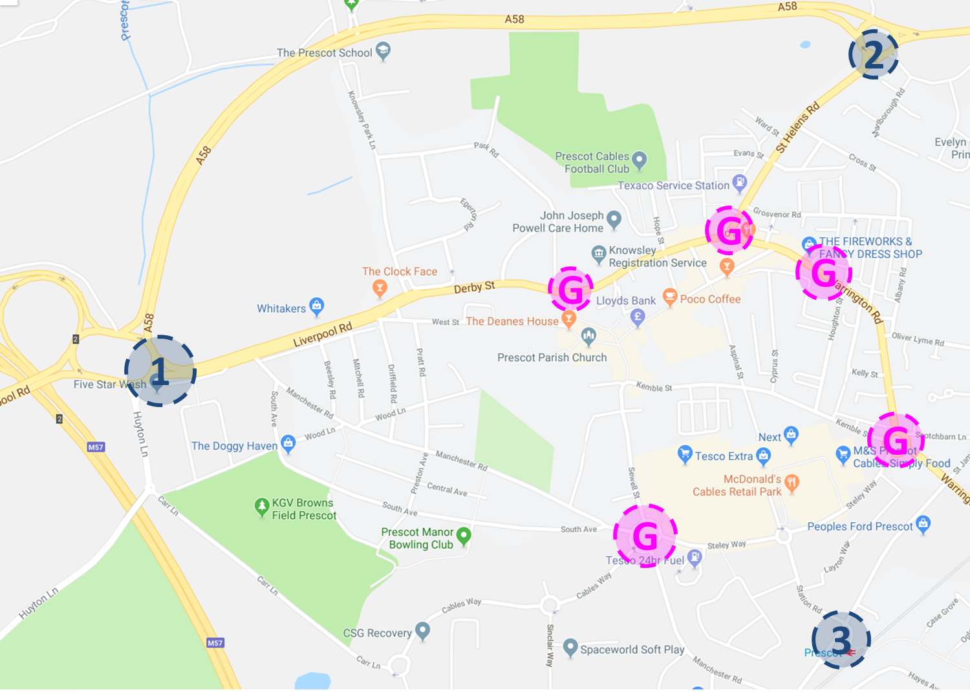
Budget

There is £30,000 for each location funded by the Specialist Investment Fund so £90,000 (inclusive of all costs).

We require:
- One artist delivering all three art works in all three locations - £90,000

The budget covers all artists’ fees including, design, fabrication, attending meetings, installation - including foundations, all expenses, transportation costs of art works, travel to meetings etc.

Outcomes:

The final artwork(s) will need to ensure the following outcomes are achieved:

- Celebrate the heritage and cultural offer of the town
- Provide a creative imaginative and stimulating welcome to Prescot’s town centre
- Need little maintenance
- Be fit for purpose, robust, secure and comply with relevant health and safety requirements
- Be original and of high quality, simple and striking
- Reflect and celebrate key themes around Shakespeare and the heritage of the area

The successful artist will be required to complete the following deliverables:

- Produce initial design ideas that can be fabricated and installed within budget
- Produce design ideas that are shared with stakeholders and the community
- To produce a budget inclusive of design fees and related costs, fabrication and transport costs
- To oversee the installation of the artwork
- Attend meetings with the Prescot Regeneration team (planners, highways etc.)
- Provide a detailed, costed maintenance programme for the artwork
- Any subcontractors employed by the artist to assist with fabricating and / or installing the work must be accredited professionals and be paid by the artist from their fee.
- Method statements must be provided prior to any installation

The successful artist will have previous experience of:

- Creating and installing public art
- Working with a variety of stakeholders
- Working to budget
- Working to deadlines
- Awareness and understanding of technical issues that may arise from creating and installing new art works
- Developing high quality and original ideas
- Creating low maintenance, fit for purpose art works

Insurances
The Lead Artist should hold public liability insurance to £5 million and professional indemnity insurance to at least £1 million. They should also hold employers liability if applicable.

Proposed payment milestones

Payment stage |  | Percentage payment | Time scales for scheme
Payment 1 | On signing the contract | 5%
Payment 2 | After research, development and initial ideas | 5%
Payment 3 | Upon presentation of initial costed design proposal | 10% | Costed design needed by October 2019
Payment 4 | Upon amends and detailing to design proposal | 15%
Payment 5 | Upon approval of design proposal | 25%
Payment 6 | Upon fabrication of the design proposal | 25%
Payment 7 | Upon installation of the art work | 15% | Art works due to be installed 29/05/2020

Attachments:

• Arts in public spaces strategy for Prescot
• Prescot Master plan

