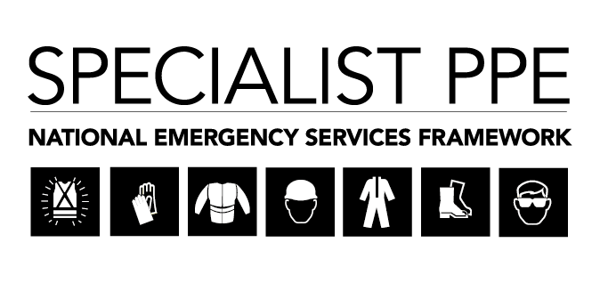
Provision of Specialist Personal Protective Equipment (PPE) Clothing – Supplier/Stakeholder Engagement Event
Wednesday 27 November 2019
QUESTIONS AND ANSWERS SESSION
No. | Provider Questions and FRS Responses
Q.1 | You mentioned in your technical presentation about life time warranty. What is life time?
Q.1 Response | It is a valid question and we are trying to have the conversation with providers. It might potentially mean the length of the Contract maybe eight (8) years, if we look at the after care and it is maintained the kit could last the length of the Contract; that is our thought process. We need a clear understanding of what fair wear and tear means and needs to be understood by all parties, the quality of the product and the quality of the materials.
Q.2 | How about kit used in the training environment?
Q.2 Response | We recognise that the training environment can be a harsh environment and this may be a different life time due to the high attrition rates.
Q.3 | You mentioned a four (4) year term; Will the Pricing Structure be refreshed after twelve (12) months?
Q.3 Response | We will consider reserving the right to review after two (2) years but the Commercial Group will need to further discuss and agree this issue, with an awareness of political issues that may affect our final decision.
Q.4 | Please re-clarify exactly when we need the final EN certification? If a company has worked for three (3) years now developing a product that will fit into one of these Lots, and are in the process of final testing and production and the EN certification will be ready in September 2020, does it mean we need to be ready by wearer trials stage?
Q.4 Response | Yes, confirmation that EN certification will need to be completed by wearer trials stage.
Q.4 continued | That will mean a supplier may be excluded from this whole process.
Q.4 Response continued | It would be unfair if a Supplier failed at the final hurdle (certification). Unfortunately this is a procurement process and there has to be an end date and we acknowledge this may mean us missing out on innovation or new products on the market place. However, in four (4) years the process will be restarted as a continuous iteration and will be refreshed, giving the Sector a continuous route to market.
Q.5 | Is there a technical refresh within four (4) Years?
Q.5 Response | If the Standards change, and there is a justifiable reason. then this will be looked into. We shall also endeavour to include technical refresh within final frameworks to allow for new innovations, provided these remain in scope of the original requirement. Otherwise we may have to retender the requirement.

