Lake District National Park Authority

Fix the Fells Upland Path Restoration Work

Greenup Edge and High Raise

Date
May 2022

Deadline for Submissions
27 June 2022

INFORMATION AND INSTRUCTIONS TO TENDERERS

Introduction and background
The Authority is seeking a contractor to design and build a mixed Stone Flag and Aggregate path along a 500m section of Bridleway on Greenup Edge - a remote location of the Lake District National Park, and to undertake additional 250m of Upland Path repair work, consisting mainly of landscaping, habitat restoration and path definition on a separate footpath in the immediate locality.
The route forms part of the Coast To Coast long distance path which is likely to be upgraded to a National Trail and the work will need to be carried out to the National Trails Quality Standards as set out in Appendix 3
The surrounding landscape includes ecologically important and sensitive habitats including areas of deep peat, and the successful contractor will need to demonstrate suitable knowledge and experience of working in these types of habitats and landscapes to ensure they are appropriately protected during and by the work .
The intention of this tender is to procure a contractor to source and supply materials, and undertake this work (using suitable machines) in Autumn 2022 (or at the earliest opportunity after that subject to further discussion post-bid and during evaluation).
The successful contractor will need to source and supply non-calcareous ex-mill floor stone flags/new sawn stone flags to the site which is a remote location at an altitude of c600m which is inaccessible by road.
The stone flags supplied will need to be transported to the work site by helicopter therefore the supplier must ensure that the quotation supplied takes account of all the organisation and costings associated with helicopter operations.
Access and egress to site for diggers will involve tracking in across 8km of remote upland terrain.
Access and egress to site for personnel will involve a 6-8km walk each way.
It would be highly desirable for the successful contractor to gather ariel imagery (via drone ) of the project, before , during and on completion of the works .

The Issue
The Lake District National Park was established in 1951, after Government enacted the National Parks and Access to Countryside Act in 1949. The Lake District National Park Authority (“the Authority”), established by the Environment Act 1995, has some of functions and powers of a local authority, although some statutory powers are different to other local government bodies. The long term strategic vision for the Authority is that the National Park will be an inspirational example of sustainable development in action. The National Park receives approximately 19 million visitors each year.
The Highway Authority (Cumbria County Council) is ultimately responsible for all Public Rights of Way in Cumbria. Since 1997 the Authority has had full delegated powers to manage aspects of rights of way network in the Lake District National Park, including maintenance, surveying and updating the legal records. This entails various duties to assert and protect the rights of the public to their use and enjoyment, prevent as far as possible their obstruction, improve access where possible and regulate their use as required. The Authority undertakes the additional responsibility of ‘protecting the landscape’, repairing eroded paths (over and above the necessary) to reduce the impact of usage on the environment and landscape.
The work will be part of a European Regional Development Fund project within the Fix the Fells partnership. The ERDF funded project runs until June 2023
Maps of the 2 paths where work is required, plus possible access and egress routes for machines, and possible helicopter pick up site for flags is provided in Appendix 1.
In order to carry out this work, we would like potential contractors to complete prices for each component of the work as set out in Appendix 2
The precise specifications for the 2 work packages will be drawn up by the successful contractor using these prices in conjunction with and to be agreed by, a Fix the Fells representative. The extent of the works may be varied depending on funding availability.
Rebuilding and restoring upland paths is highly specialised work, with exacting standards required if paths are to be effective and long-lasting in harsh environmental conditions. Skilled and experienced workers are required to achieve this outcome.

(PQQ) – Pre Qualification Questionnaire

Tenderers will need to be able to demonstrate experience, skill and competencies in all the areas outlined below. If a Tenderer is unable to demonstrate the required experience, skills and competencies in all the areas they are unable to proceed any further or submit a Tender for consideration.
Essential pre-qualifying requirements | Tick to confirm requirement is met
Experience - At least 3 years’ experience of working on Upland Fell paths in remote locations
Staff - Sufficient numbers of suitably fit, skilled and qualified staff (requiring walking up to 8km from nearest road to altitudes of 700m)
Skills and experience - Proven track record of repairing upland fell paths demonstrating compliance with best practice from both ‘Repairing Upland Path Erosion’ (Davies and Loxham) and ‘Upland Pathwork’ 3rd edition (Upland Path Advisory Group)
Specific experience of building mixed flag and aggregate paths in the Uplands

An accompanied site visit is essential to fully appreciate the opportunity and consider any challenges associated with the remote nature of the site. Fix the Fells Ranger Annie Duckworth will be leading a whole day site visit and project briefing on Thursday 16th June 2022 . To confirm attendance please telephone 07759799631 or email Annie.duckworth@lakedistrict.gov.uk.

Tender Objective
This tender is for the provision of a contractor to design and build a mixed Stone Flag and Aggregate path c 500m long on Greenup Edge - a remote location of the Lake District National Park, and to undertake an additional 250m of Upland Path repair work, consisting mainly of landscaping, habitat restoration and path definition on a separate path in the immediate locality.
The intention of this tender is to procure a contractor to source and supply materials, and undertake this work in Autumn 2022 (or at the earliest opportunity after that subject to further discussion post-bid and during evaluation) .
The work delivered must be of a standard in keeping with that which has been delivered in the past 15 years adhering with best practice from both ‘Repairing Upland Path Erosion’ (Davies and Loxham) and ‘Upland Pathwork’ 3rd edition (Upland Path Advisory Group).
Work will begin at the earliest opportunity after appointment (subject to further discussion post-bid and during evaluation) and must be must be finished by the end of April 2023
This is highly specialised work requiring a contractor with at least 3 years’ experience of similar work in similar environments . The range of activities required includes:
- Inspecting job sites to identify, survey and assess damage
- Producing site descriptions and designing work specifications
- Delivering specialist pathworks including drainage, waterbars, ditching, resurfacing, alignment and construction of paths (aggregate surfacing, soil inversion, aligning & defining, cut and fill, revetments, stone flags and stepping stones)
- Landscaping (transplanting vegetation, reseeding, fertilising, grading, deflection/desire lines and reprofiling peat hags )
The contractor must have significant experience of relevant logistics and safe working practices, including:
- Risk assessment, Construction Design and Management regulations
- Public safety
- Team/contractor welfare
- Personnel supervision
- Provision and safe operation of relevant machinery, tools and equipment
- Working with helicopters and heavy machinery
- Quantity assessments and procurement
- Environmental risk management

Experience/Skills/Competencies Required
The Authority wishes to contract with a single supplier for the procurement of materials (stone flags), the transportation of materials onto site and the successful design and build of a 500m mixed flag and aggregate path and to undertake additional Upland Path repair work on a separate path
This requires experience/skills/competencies across a number of areas. The successful Tenderer should meet all of the Essential Requirements listed below.

Excellence in assessment and design
- Extensive experience of assessing damage to upland paths, identifying causes and designing appropriate solutions
- Experience of path maintenance and incorporation of this into design and construction
- Experience of producing site descriptions and specifications for work in remote upland environments
- Experience of designing specifications that are ecologically and environmentally sensitive and take account of localised conservation priorities and biodiversity objectives
A track record of delivery
- Experience of delivering upland path restoration in protected landscapes
- Extensive experience of surfacing work on upland paths, including alignment and construction (aggregate surface, soil inversion, aligning and defining, cut and fill, revetments, stone flags and stepping stones)
- Experience of landscaping work including transplanting vegetation, reseeding, fertilising, grading, deflection/desire lines
- Experience of sourcing materials for Upland pathworks, including locally winning aggregates, soil and vegetation and procuring appropriate flags.
- Experience of procuring and managing helicopter ops to move materials onto site
- Demonstrable awareness and knowledge of ecological and archaeological issues and experience of working in Sites of Special Scientific Interest, Special Areas of Conservation and other designated habitats and landscapes.
- Experience of gathering ariel imagery of path construction works .
Effective logistics and safe working practices
- Fundamental incorporation of risk management systems, including generic and dynamic risk assessment, Construction Design and Management Regulations, working with helicopters and working in challenging environments
- Excellent personnel supervision with regard to lone working, motivation and organisation
- Systemic protection of workers, including First Aid qualifications, including provision of relevant qualifications for this type of work in this type of work environment,
- Personal Protective Clothing and equipment for mountain work sites and relevant kit for type of work
- Embedded consideration of team welfare, through provision of appropriate shelter, vehicles and work patterns
- Extensive experience and consideration of public safety in site management
- Access to all necessary and specialist tools and equipment
- Extensive experience of safe management and provision of appropriate machinery, including All Terrain Vehicles, tracked barrows, tracked and wheeled excavators
- Experience of working with helicopters, including loading and take-off/landing site management
- Track record of sourcing, locating and securing appropriate materials
- Experience of appropriate environmental risk management
Quality assurance
- Experience of implementing Quality Management processes, including ongoing monitoring and assessment to ensure that specifications are met
The key competencies above will guide our scoring when assessing applications.

Submission of the tender documents
What you need to do

Your submission should include:

- Summary of relevant skills, experience and proposed delivery. Table 1
- A firm price for completion of all items listed in Appendix 2 (i.e. a price that is not subject to variation).
- Two references (two sheets enclosed). Appendix 3
- Declaration of non-collusion (sheet enclosed to be signed). See Appendix 4

Tenders must be received by 12:00 27 June 2022. Tender documents received late, i.e. after the specified date and time, will not be considered.

How to return the tender

The tender is to be submitted in electronic format via The CHEST online procurement system at https://www.the-chest.org.uk. The system will notify you by email to acknowledge receipt of your submission. Please note that no tender document will be deemed to have been received unless an email receipt has been sent. In case of query relating to tender submission please contact Annie Duckworth (Annie.duckworth@lakedistrict.gov.uk ).
Opening of tenders

Tender documents will remain unopened until after the closing date, after which time they will be opened at one time, with witnesses, by independent officers of the Authority. All tenders submitted will be verified to ensure that the information requested has been provided. Once tender documents have been opened and signed they are then passed to the originating department for evaluation.
Timetable for this project

Our timetable for this project is:

Date | Activity
Monday 16 May 2022 | Publication of Tender Documentation
Thursday 16 June 2022 | Accompanied Site visit for potential tenderers
Monday 27 June 2022 | Tenders return deadline
WB 27 June 2022 | Tender evaluation and shortlisting
Friday 1 July 2022 | Notification to successful supplier
Monday 11 July 2022 | Contract Award (after 10 working day cooling off period)
Autumn 2022 | Work to be completed om Autumn / Winter 2022
Contact and information

For further information or any queries regarding the content of the tender please submit questions via The CHEST messaging system.

For feedback on your submission and receipt of your tender document please contact Annie Duckworth Annie.duckworth@lakedistrict.gov.uk or phone 01768 871408.

Lake District National Park Authority Northern Office, Old Station Yard Threlkeld, Keswick, Cumbria. CA12 4TT

Evaluation of tenders
Evaluation criteria
All tenders received will be considered based on the information they have submitted in their tender. The tenders will be evaluated upon the following criteria;

Criteria on which you will be evaluated | Potential Score | Weighting | Max Score
- Price | 1-5 | 8 | 40
- Previous experience undertaking similar work in comparable environments | 1-5 | 5 | 25
- Proven technical ability to complete the work to the required standards of quality , safety and environmental sensitivity | 1-5 | 5 | 25
- Overall quality of the submission (detail; presentation; clarity) | 1-5 | 2 | 10
Maximum Possible Score |  |  | 100
Questions on tender submissions
If tenderers have any questions they wish to ask the Authority, they must submit them to the Authority via The CHEST messaging system. Any questions received will be made anonymous and responses sent to all tenderers.
Award of tender
The Authority will decide to whom the contract shall be awarded based on the evaluation criteria outline above. The Authority does not bind itself to accept the lowest or any tender/quotation and reserves the right to accept the whole or parts of tenders/quotations. The Authority will notify acceptance of the tender to the successful tenderer as soon as is reasonably practicable.

TENDER INFORMATION
Confidentiality
The details of these documents and all associated documents are to be treated as private and confidential for use only in connection with the Tender process.
Freedom of Information
The Authority is committed to meeting its legal responsibilities under the Freedom of Information Act 2000. Accordingly all information submitted to the Authority may need to be disclosed in response to a request under the Act. If you consider that any of the information included in your tender is commercially sensitive, please identify it and explain (in broad terms) what harm may result from disclosure if a request is received, and the time period applicable to that sensitivity. You should be aware that, even where you have indicated that information is commercially sensitive, we may be required to disclose it under the Act if a request is received. Please also note that the receipt of any material marked ‘confidential’ or equivalent by the public authority should not be taken to mean that the public authority accepts any duty of confidence by virtue of that marking. If a request is received, we may also be required to disclose details of unsuccessful tenders.
Anti Fraud and Corruption Policy
The Authority has an Anti Fraud and Corruption Strategy which sets out the responsibilities of officers and action to be taken in cases of theft, corruption, irregularity, or when damage is suspected. The Confidential Reporting Code, (Whistle Blowing Policy), forms part of this Strategy which provides a mechanism for staff to report suspected wrong doings confidentially. In the event of such an issue, an investigation would be carried out and action taken as necessary.
Costs and expenses
The Authority will not be responsible for, or pay for, expenses or losses which may be incurred by a tenderer in the preparation of their tender. The Authority does not bind itself to accept any of the tenders as a result of the tendering process including the lowest tender.
Preparation of Tenders
For the preparation of their tender and entering into a contract with the Authority, tenderers must ensure that they have all the information required and must satisfy themselves of the correct interpretation of terminology used in these documents.
Queries on the tenders
If any points in these tender documents are considered by the tenderer as unclear, the tenderer should address their queries via The CHEST messaging system to obtain an explanation before sending their tender. Their query will be responded to via The CHEST, but it shall not be construed in a way that adds to, modifies or takes away from the meaning and intent of the contract and/or the obligations and liabilities of the contract.
Alterations
None of these documents may be altered by the tenderer. If the tenderer wishes to propose modifications to any of the documents (which they may consider would provide a better way to achieve the contracts objectives) they must provide details in a separate letter accompanying the tender response.

Prices
All prices must be net and, where applicable, carriage paid with all cash and trade discounts allowed for.
VAT
All prices and/or rates shall be exclusive of Value Added Tax.
Validity of tenders
Tenders shall be valid for a minimum of three calendar months from the closing date for receipt of tenders.
Sub-contractors
The level of sub-contracting and the processes for doing so must be pre-approved with the Fix the Fells Programme Manager to comply with the funding agreement and Public Contracts Regulations 2015.
Quality of goods / services
Tenderers must possess relevant professional qualifications and experience.
Conflict of Interest
The Authority requires all tenderers to confirm whether any actual or potential conflicts of interest that exist which may prevent them undertaking this work, and a description of measures they would adopt if a potential conflict of interest arose during or following completion of this work.
Treatment of tender
The acknowledgement of receipt of any submitted tender shall not constitute any actual or implied agreement between the Authority and the tenderer.
Debriefing
All unsuccessful bidders will be offered the opportunity to be given a debriefing. Requests for debriefing are to be made in writing.
The Authority’s use of Contract Outputs
The Authority may wish to publicly quote the Contract Outputs such as any policies, figures, training materials, risk assessments etc. Tenders are requested to confirm that the Authority may (at the Authority’s own discretion) do so without restriction.
Ownership
The intellectual property rights rests with the Authority, not the tenderer.

Table 1 :Summary of relevant skills, experience and proposed delivery

All sections to be completed

Previous experience

Describe your background in delivering this type of work, including specific jobs and clients.

Outline experience of relevant techniques, processes, and machinery/equipment.

Include relevant health & safety and logistical experience

Max 600 words

Qualifications/ experience of Key Personnel leading implementation of this work

Max 400 words

Ability to complete work to timescale

Max 150 words
Outline method statement

Summary of how you intend to do the work.

Risk assessment & health and safety

(outline matters you would consider for risk management and how you would manage these )

Max 400 words

Approach to deployment of workers locally

Summary of how you intend to accommodate and deploy workers locally in delivering this work.

Max 400 words

Local knowledge and experience

(summary)

Max 400 words

Specific example of similar work

Add photo, etc as required

Include site name/location, nature of works, customer, date, duration, scale

NOTE:

Appendices to your tender will be accepted to illustrate key points. These may include case studies, a proposed work schedule, photographs and a diagram of the proposed team structure. We would ask you to keep these concise and relevant, clearly referencing which section each piece of information relates to.

Appendix 1 –

Maps of the 2 paths where work is required.

Possible access and egress routes for machines and personnel

Potential helicopter pick up site for flags NY 318,133

Path  ( GR refers to midpoint ) | Approx. Length (m) | Notes
Greenup Edge to Lining Crag  NY284107 | 500m | Mixed stone flag/aggregate path  350m stone flag and 150m new sub strata reversal path
Greenup Edge to High Raise  NY 282100 | 250m | 250m path repair work, consisting mainly of landscaping, habitat restoration and path definition

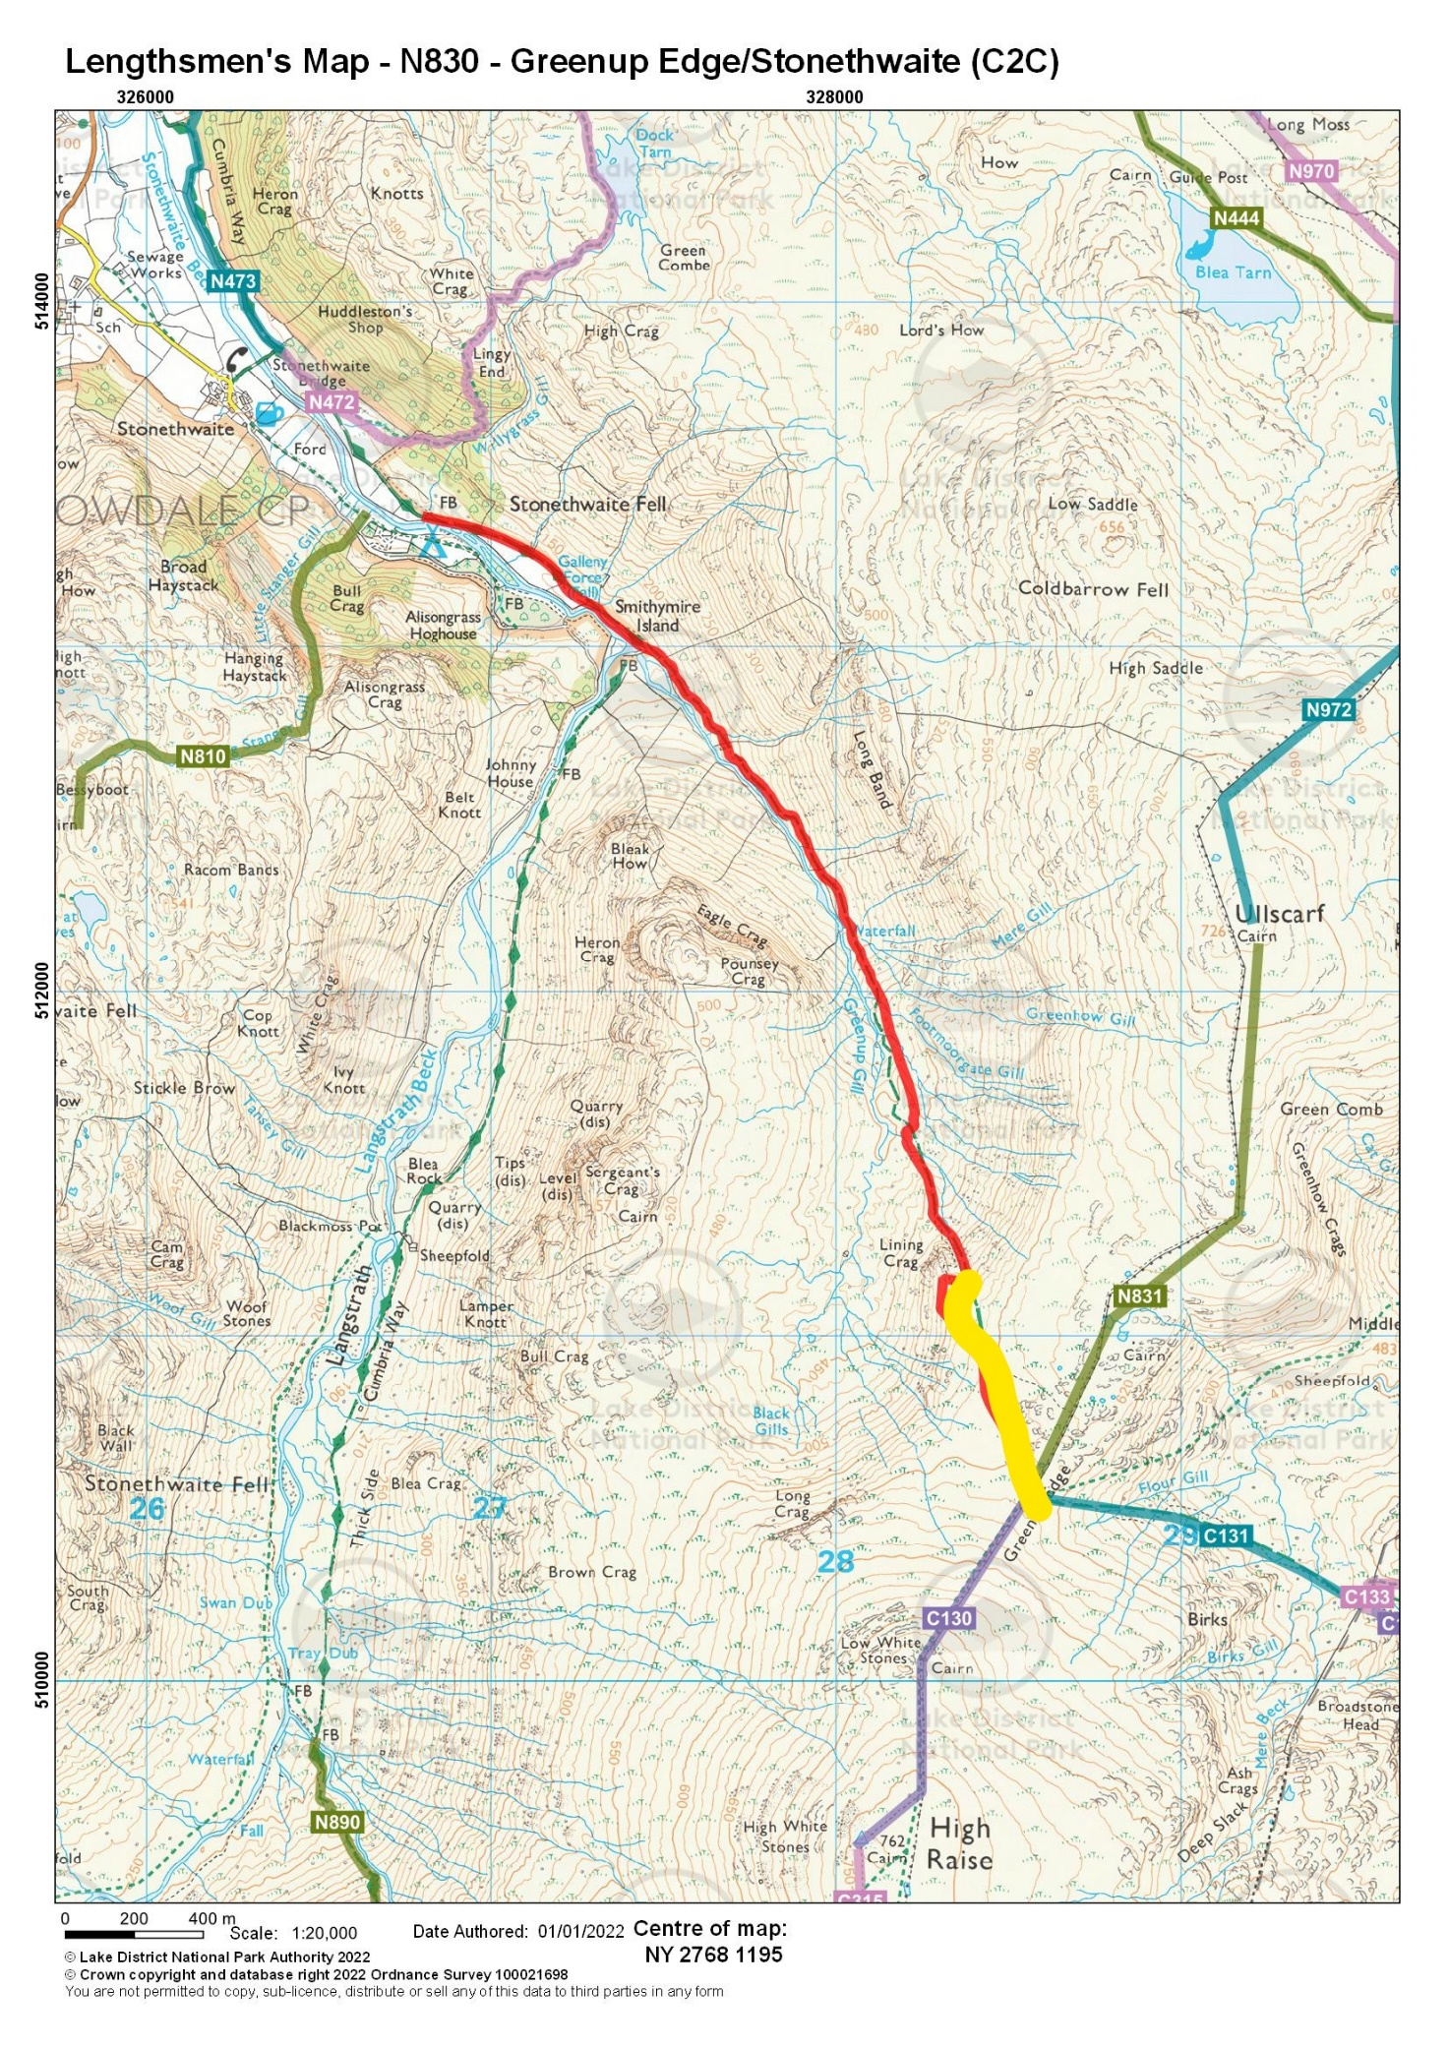

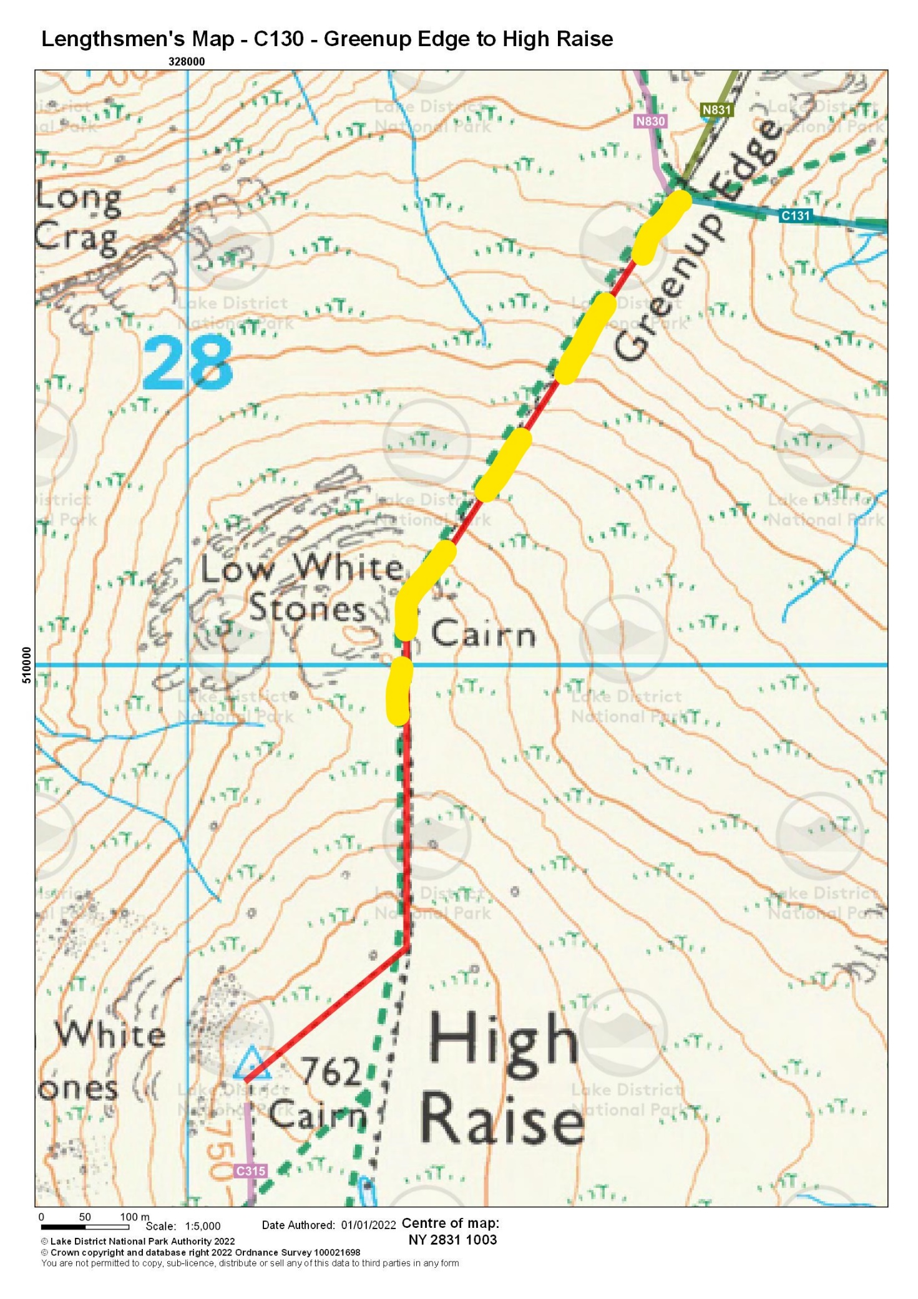

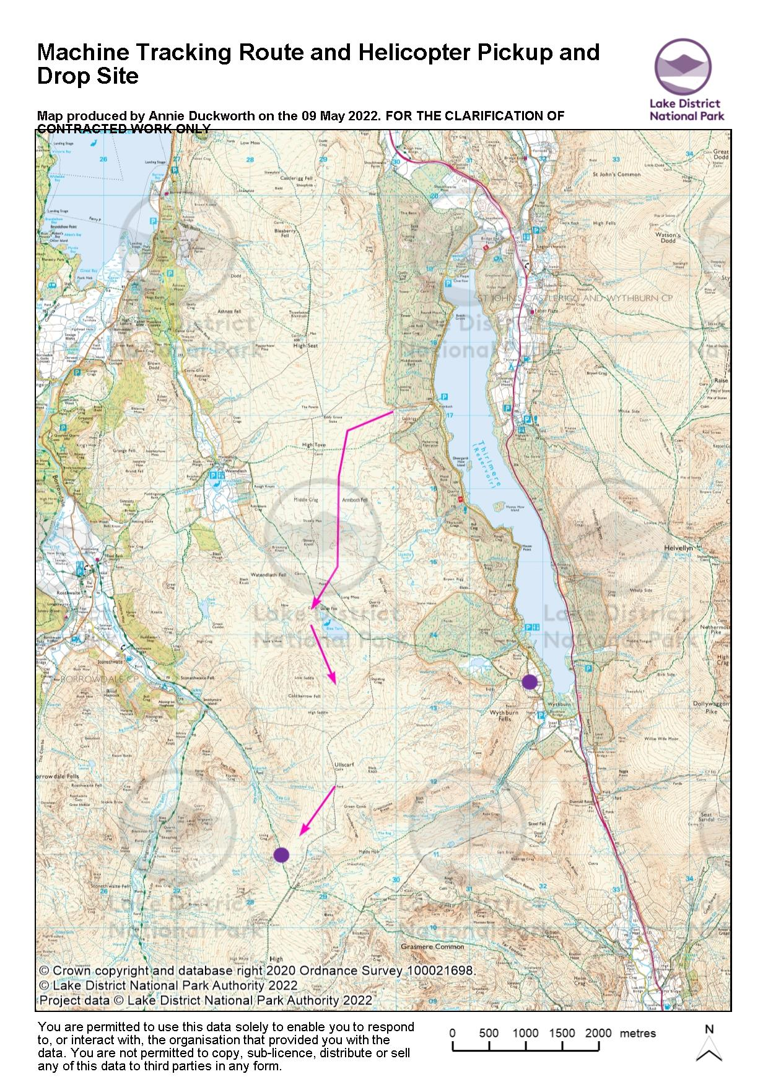

Appendix 2 – Pricing

 | Total price | Additional Notes
Source, and supply to site, sufficient ex-mill floor/ new sawn stone flags to construct 350m linear path *
Please ensure your price includes all 3 elements – procuring the stone flags , road haulage to Thirlmere and Flying to site. (Assume a 5km flight )
Construct 350m Stone Flag path and 150m new sub strata reversal pathworks with associated landscaping on Greenup Edge , plus 250m path repair work, consisting mainly of landscaping, habitat restoration and path definition on High Raise .
Please ensure your price takes account of the very remote and inaccessible nature of the worksite .
(Assume a 9km tracking in route via High Tove and Ullscarf )

Gather ariel imagery before, during and on completion of the works .

(Assume 3 days work in good weather and images to be owned by LDNPA )
Logistics and management time to plan and oversee the project
Total Cost
*Absolute Minimum size of the flags is 0.9m x 0.6m and minimum thickness 80mm.
The stone should be either worn/natural or treated to appear naturally riven. There should be no unworked cut/sawn edges. If the stone is cut from freshly quarried material one flat face should be treated to appear naturally riven.
The suitability of any stone intended for use must be agreed by a Fix the Fells representative prior to work commencing.
The flags are to be delivered to the site specified (please see location map in the supporting documents).
The flags are to be supplied on suitable lifting agents which will not collapse under the weight of stone and will be properly loaded and banded to ensure safe lifting whilst helicopter is in transit.

Appendix 3 – References

Potential suppliers are required to submit details of two organisations for which fell path contracts have been completed. This is so that references may be obtained. The Authority may wish to obtain an email/telephone reference for the successful tenderer prior to the award of the contract.
Reference 1 Comments
Organisation Name

Contact Name

Address

Telephone Number

E Mail address

Estimated contract sum

Reference 2 Comments
Organisation Name

Contact Name

Address

Telephone Number

E Mail address

Estimated contract sum

PLEASE NOTE THAT ALL INFORMATION WILL BE TREATED IN THE STRICTEST CONFIDENCE AND WILL BE USED PURELY AS A MEANS OF OBTAINING REFERENCES.

Appendix 4 – Declaration of Non-Collusion

To: Lake District National Park Authority

The essence of selective tendering is that the Authority shall receive bona fide competitive tenders from all firms tendering. In recognition of this principle, I/We certify that this is a bona fide tender, intended to be competitive and that I/We have not and will not (either personally or by anyone on my/our behalf):-

- Fix or adjust the amount of the tender (or the rate and prices quoted) by agreement with any other person.

- Communicate to anyone, other than the person calling for this tender, the amount or approximate amount or terms of the proposed tender (except other than in confidence, where essential to obtain professional advice or insurance premium quotations required for the preparation of the tender).

- Enter into any agreement or arrangement with any other person that he shall refrain from tendering or as to the amount or terms of any tenders to be submitted.

- Canvass or solicit any member, officer or other employee of the Authority in connection with the award of this or any other Authority contract or tender.

- Offer, give or agree to give any inducement or reward in respect of this or any other Authority contract or tender.

Signed (as in Tenders) duly authorised to sign | …………………………………………….. ……
For and on behalf of | ………………….. ……………………...……….
Date | …………………….……………………………..

