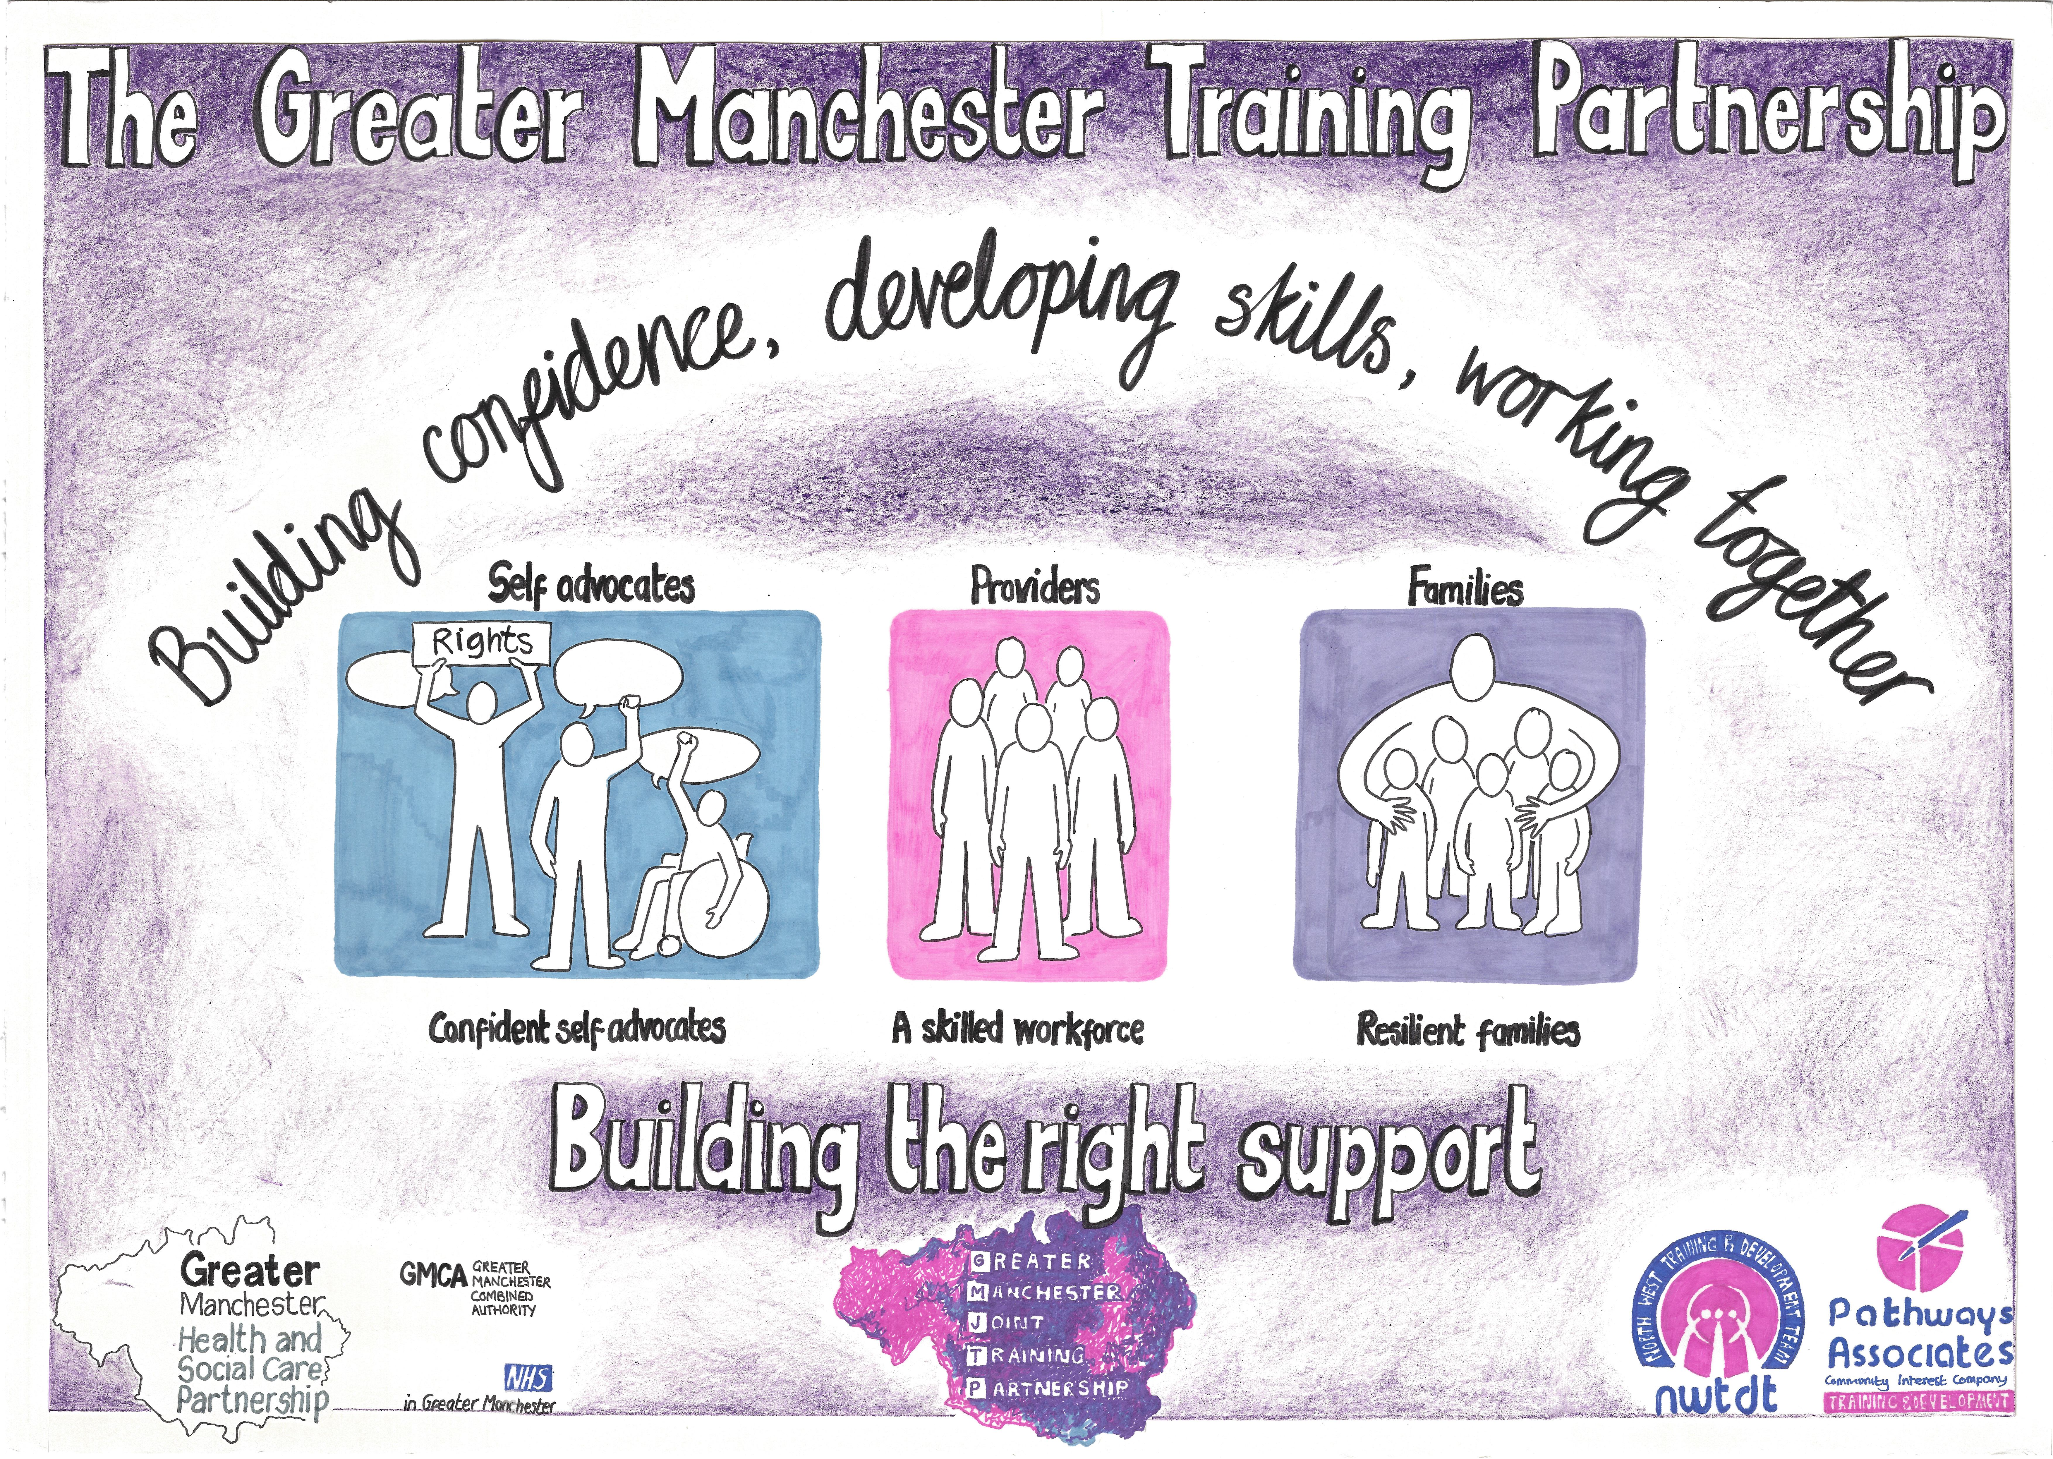  29th January 2018  Greater MANCHESTER JOINT tRAINING PARTNERSHIP (GMJTP)  Information Event  The Greater Manchester Joint Training Partnership has been formed by the Greater Manchester Health and Social Care Partnership and the Greater Manchester Transforming Care Partnership.  The ambition for Greater Manchester is to provide high quality services for its citizens. One of the ways to ensure that Greater Manchester is providing high quality support to people with learning disabilities, autism or both is through ensuring that providers have access to quality training. GMJTP are commissioned to offer Greater Manchester providers a range of training opportunities which have been subsidized by Greater Manchester Transforming Care Partnership.  The training provided by the GM JTP has been developed in response to feedback received from health and social care practitioners, commissioners, care providers, self-advocates, and their families.  At this event providers will be able to meet the team, meet health and social care commissioners and find out about new developments.  For more information or to book a place contact Kim Doolan or Danielle Johnson Email: events@GMJTP.co.uk | Find out about Greater Manchester Joint Training Partnership and its developments  ────  Find out how the Training Partnership works with the new Flexible Purchasing System  ────  Find out about the Greater Manchester Foundation level workshops  ────  Find out about the Greater Manchester Training Passport and Record of Achievement  Find out how the Training Partnership works with the Forensic Support Team  Venue - Trafford Town Hall  Talbot Road  Stretford  M32 0TH  Time: 9.30am – 12.00pm  Date: Monday 29th January

