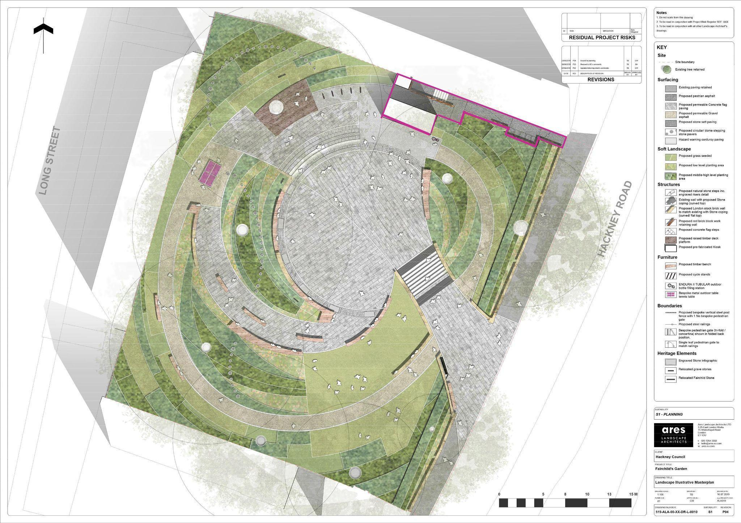

Specification for the delivery of
Class E (drinks and snacks) use in
Fairchild’s Garden Kiosk and ancillary buildings

Fairchild’s Garden Kiosk
Hackney Road
Shoreditch
E2 8HQ

INTRODUCTION

Background

  - Fairchild’s Garden, previously known as Hackney Road Recreation Ground, is a small park located on the busy Hackney Road. The site is a closed churchyard, the majority of which is vested in the Incumbent of St Leonard’s, Shoreditch. The site is managed and maintained by the Council’s Parks Service as a recreational ground, under the Burial Act 1853.

1.2 The site is currently undergoing a full refurbishment. The Council is currently transforming Fairchild’s Garden into a safe, welcoming, flexible space which meets the needs of the local community. The project budget is £700,000 (including the cost of £55,000 for the shipping container which will house the new kiosk) and will be delivered by April 2024. The project includes a landscaping scheme which will incorporate new paving, landscaping, planting scheme and the creation of a new lockable service access to Hackney Road. To view a video of the scheme please visit hackney.gov.uk/fairchilds-garden.

1.3 Within the transformed gardens will sit a new kiosk to serve users of the space and the local community. The small cafe kiosk will include loose outdoor seating and portable play equipment to encourage new users and to increase the overall attractiveness of the site to the local population. The addition of the kiosk will help to bring more people into the space and increase both positive use and natural surveillance of the park.

The Service

  - Hackney Council has a requirement for the provision of drinks and snacks from a kiosk in Fairchild’s Garden.

  - The kiosk’s footprint is approx. 15.3 sqm, and the interior is approx. 14.6 sqm. See Appendix B for floor plan with dimensions and photos of the unit.

2.3 The Council is seeking an operator to deliver a high quality healthy,affordable food and drink offer throughout the year.

2.4 Adjoining the kiosk will be an accessible toilet with full facilities. The operator will be responsible for the management of this toilet, including the control, maintenance and cleaning of the facility. The kiosk will include loose outdoor seating and portable play equipment which the tenant will be responsible for, to encourage new users and to increase the overall attractiveness of the site to the local population.

2.5 A five-year lease will be offered, with the option to extend the lease further for two years.

2.6 The Council is committed to doing everything within its power to deliver net zero emissions across Council functions by 2040. This includes working with our partners to reduce carbon emissions through their operation.

2.7 The Council will agree a set of KPIs with the successful Tenderer and these will be based on the information provided in this Specification and the Lease including Schedule 1.

2.8 The successful tenant must have public liability insurance of not less than £5,000,000.

Deliveries and Storage

  - All deliveries should be made via the new lockable service access to Hackney Road but deliveries will need to be transferred to the kiosk by hand. Consideration should be given to sustainable modes of delivery such as cargo-bikes / e-bikes or electric vehicles to reduce the use of combustion vehicles.

Parking

  - Due to the size of Fairchild’s Garden, there is no parking available.

STAFF MANAGEMENT

Rates of Pay

  - The tenant must pay staff the London Living Wage (as defined by the National Living Wage Foundation) as a minimum.

APPENDIX A: Location and demise of kiosk

Location and demise of building within Fairchild’s Garden
Demise outlined in pink on the plan below.

APPENDIX B: Kiosk Floor Plan with dimensions and photos

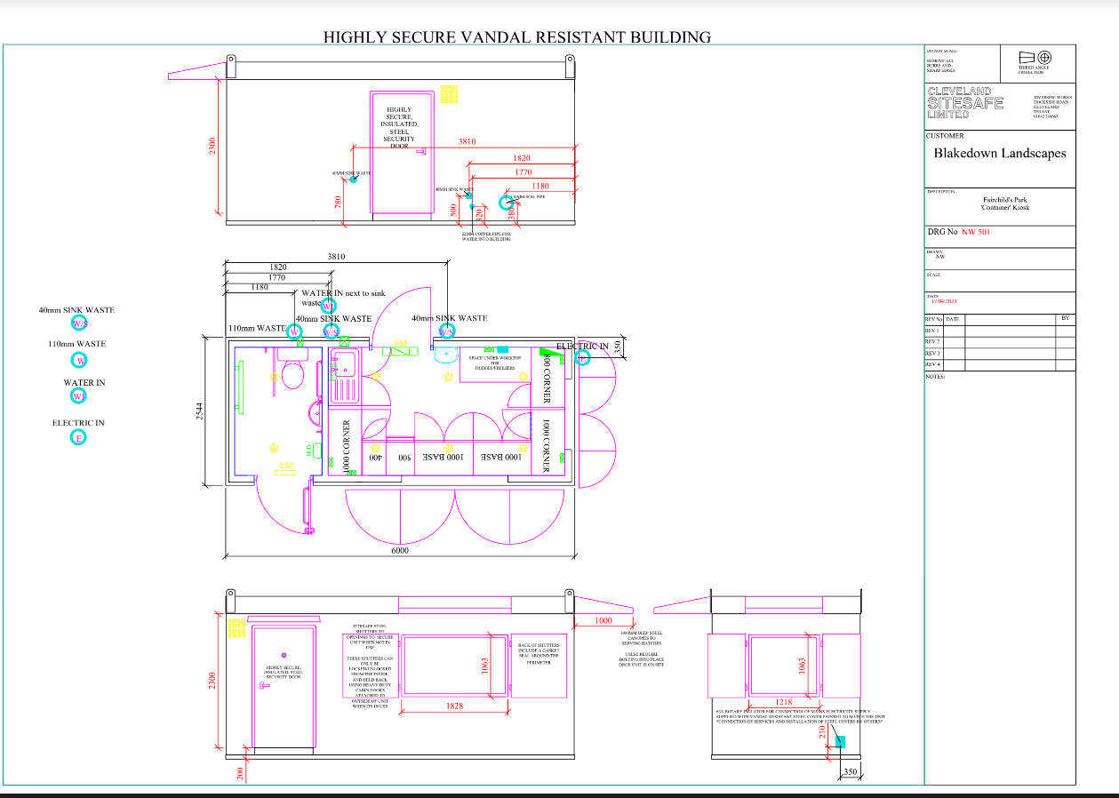

Floor plan with dimensions

Container photos - external and internal

