Appendix A
Introduction

Cumberland Council are seeking an operator partner for two town deal funded projects in Millom. This may be a single operator for both facilities, or two separate operators.

The Iron Line - a scheme that will see the uniquely beautiful sea wall and coastal lagoon off the coast of Millom sensitively enhanced to form an inspirational and fully inclusive route across RSPB Hodbarrow with upwards of 7km of walking and cycling routes to be enhanced as part of the project. A new welcome centre will be created, incorporating a café/bar, retail space and multi use events room alongside adjacent parking for around 80 vehicles.

The project’s investment objectives are to:
- To reactivate heritage and natural assets to maximise the potential of blue and green infrastructure as drivers of economic growth;
- Enhance the arts, culture and heritage offer in Millom and Haverigg to retain and attract spend and support quality of life;
- To raise the profile of Millom as a place to live, work, study, invest and visit;
- To strengthen active travel options to drive health and wellbeing improvements.

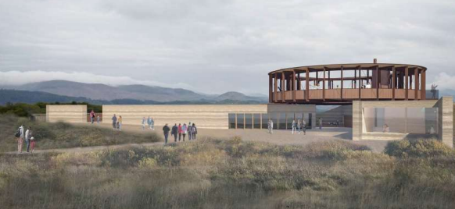

Arts and Enterprise Centre – part of the Reactivating Heritage Buildings projects will see the creation of an Arts and Enterprise Centre within the former NatWest bank building, which will include a cafe and exhibition space, a co-working space for businesses to collaborate and share knowledge, a makers market area, a retail display area, a start-up enterprise space, studios and workshops.
The project’s investment objectives are to:
- Re-establish the town square as a focal point for community, cultural, learning, commercial and tourism activity;
- Improve the quality of public places and spaces to drive footfall, dwell time and spend in the town centre ;
- Enhance perceptions and raise the profile of Millom as a place to live, work, study, invest and visit ;
- Reactivate key spaces in and around the town centre and maximise the potential of community, commercial and residential property as a driver of economic growth.
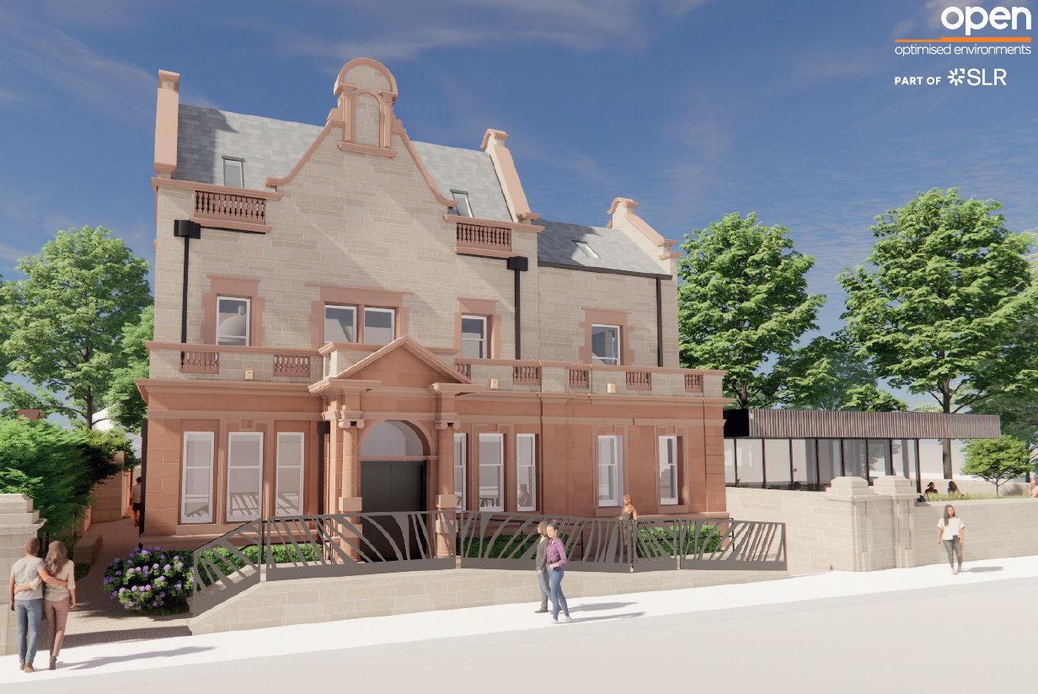

Supplier Questions

- Are you in interested in operating A) Both Facilities B) The Iron Line only C) Arts and Enterprise Centre only D) None. Please provide the reasons why. (Max 500 words)
- Giving consideration to the business case objectives, what may you be able to offer to the new facilities in Millom. (Max 500 words)
- Please provide some background information covering any experience you have in delivering similar services and facilities. (Max 500 words)
- What could the Council do to assist you in undertaking any potential future procurement exercise? (Max 350 words)
- What do you believe are the biggest opportunities and risks? (Max 500 words)
- Do you see any constraints with the proposals having an adverse effect on service delivery? (Max 350 words)

Key Documents

Planning application for The Iron Line – ref: 4/23/2249/0F1
Planning application still being determined – determination expected by the end of Summer 2024.
https://www.copeland.gov.uk/planning/application/42322490f1

Planning application for Arts and Enterprise Centre – ref: 4/23/2246/0F1.
Planning approved 9th April 2024.
https://www.copeland.gov.uk/planning/application/42322460f1

Millom and Haverigg Town Investment Plan https://www.copeland.gov.uk/attachments/millom-town-investment-plan

The process

In order for us to understand what the market can offer at this stage, we are asking a number of questions for suppliers to respond to during the early market engagement exercise.

Following the soft market testing the intention is to commence a formal procurement process. Please note that responding to this questionnaire does not guarantee any future work or progression in the tender process.

How to respond?

There are 3 options for sending your completed questionnaire back to Cumberland council including;

- the CHEST,
- email: procurement.capital@cumberland.gov.uk
- Post: Capital Programme Team, The Parkhouse Building, Baron Way, Kingmoor Park, Carlisle, CA6 4SJ

Please can all responses by received by 4pm on Friday 21st June 2024

