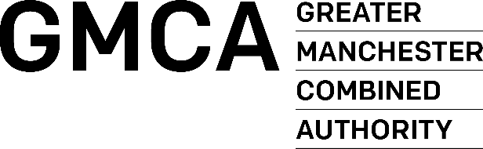

INVITATION TO TENDER

PART 3 – PRICING DOCUMENT

Well-being Support & Integration
Services

Contract Ref: GMCA 600 / DN671065

Closing Time & Date: 12 Noon on 22/06/2023

Contract Duration: 18 months with a provision to extend for 1 x 12-month period.

Name of Tenderer:

PRICING SCHEDULE
Please carefully read the instructions in this section regarding the completion of the Pricing Schedule.
Tenderers should ensure that all required relevant costs are included within the Pricing Schedule for years 1 & 2 They should be fully inclusive of all disbursements, expenses, and costs.
Tenderers should demonstrate an allocation in each yearly budget to the following:
- Lead provider,
- District Hubs and Delivery
- Specialist Support

Tenderers should also in year 1 highlight mobilisation costs.
Tenders priced on a different basis will not be considered.
All costs should be completed in pounds STERLING (£), EXCLUSIVE of VAT.
The terms and conditions of the GMCA will apply to all orders placed as a consequence of this process.
Payment terms are 30 days.

Year 1 July 23 to March 24
Description | Cost
Total

Year 2
Description | Cost
Total

I/We hereby offer to supply the above-mentioned services on the GMCA Conditions of Contract Services and confirm that we have read, understood and agree to be bound by the GMCA Conditions of Contract Services for all orders placed as a result of this process.

Signed
Name (Block Capitals)
Designation
For and on behalf of

