Frome Gateway Employment and Business Implementation Plan – Specification
Bristol City Council
November 2023

1. INTRODUCTION:
Bristol City Council Regeneration Team wish to procure a multi-disciplinary consultant team via the Homes England Strategic Research and Economic Analysis Framework to deliver an Employment and Business Implementation Plan for Frome Gateway by February 2024.
The Employment and Business Implementation Plan (EBIP) will develop key objectives set out in the Frome Gateway Framework, Employment Land Strategy and Housing Strategy and will incorporate the following four key strands of work as detailed in Section 3 below:
- Business Retention and Relocation Strategy (including cultural and community organisations)
- Employment Land Action Plan
- Workspace Design Codes
- Last-mile Logistics Hub – Feasibility/Capacity Study and Outline Business Case
2. BACKGROUND:
2.1 Frome Gateway
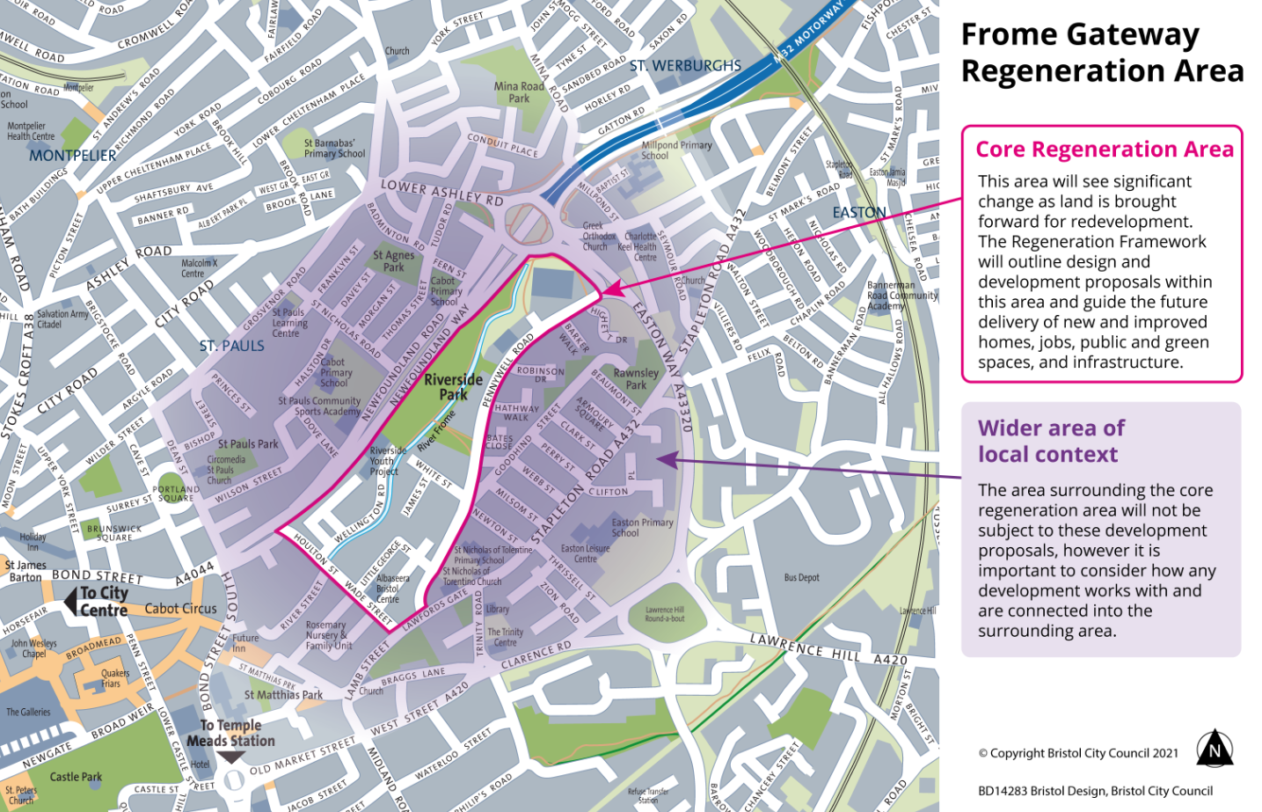
Frome Gateway is an identified regeneration area in Bristol. It covers the area between St Paul’s and St Jude’s and is located within 1km from the city centre. It is currently predominately industrial land (a mix of manufacturing and warehousing spaces) and also includes low quality park space (Riverside and Peel Park).
There are 32 landowners in the area and multiple businesses. However, while there is a diverse mix of employment types, employment is half of the theoretic capacity for the area.
BCC is currently out to public consultation on a spatial framework for the area. This can be found here: Frome Gateway Regeneration Framework consultation 2023 | Ask Bristol Consultation and Engagement Hub
This framework sets out the principles for regenerating the area to:
- Deliver about 1,000 new homes including a mix of larger family and affordable homes
- Provide a range of new work and employment space for businesses to thrive
- Bring about quality training and employment opportunities for local people
- Open and restore the River Frome to become a thriving wildlife corridor, and increase the amount of green space through a network of new pocket parks
- Provide safer streets for walking and cycling
- Support community and cultural organisations to grow their reach into the community including young people
- Improve public health and wellbeing and support more sustainable, active living
- Adapt to the impacts of climate change and support ecological recovery.

The spatial concept for the framework is as follows:
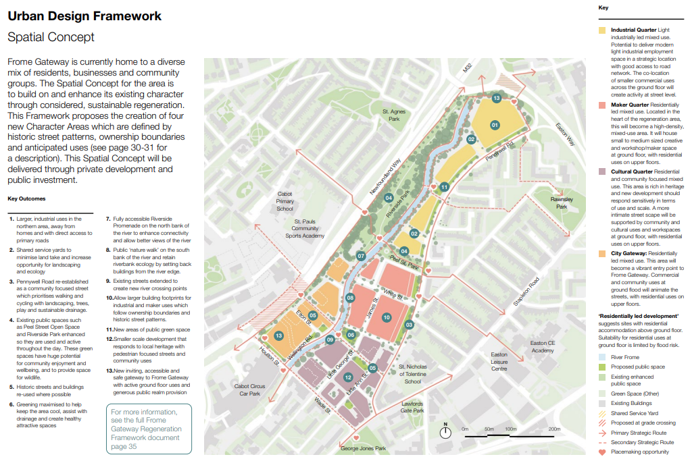

2.2 Inclusive Economy Strategy
As part of developing the framework, an inclusive economy strategy was also developed (this will be made available to the successful consultant upon appointment).
The inclusive growth aspiration for the area is as follows:
‘Evolving a green and inclusive economy which reflects local culture and diversity, enhances the prosperity and wellbeing of the Lawrence Hill community and positively influences the evolution of a fairer and greener Bristol’
At the highest level, the aspiration is to ensure that regeneration delivers a resilient and future-facing economy which provides tangible and meaningful benefit for local communities.
Outcome targets are as follows:
- Replacement of jobs as a minimum – but with an aspiration for growth
- Densified economy accommodating a more diverse mix of industrial, maker and workspace focused activities
- Retention of local business where possible alongside growth in local enterprise with new businesses taking root locally
- Frome Gateway is recognised as a place of good quality and fair work.

2.3 Overarching Employment Space Requirements
The research process has included technical analysis of the amount and types of employment space which should be targeted at Frome Gateway via delivery of the Regeneration Framework. The analysis concludes that the overall quantum of employment space should be significantly consolidated to accommodate:
- A greater mix of non-employment uses than is currently the case; and
- A more efficient and productive use of employment land. The aspiration should be to replace the current 1,000 jobs (minimum) and go beyond this if achievable with other regen objectives. It is anticipated that a minimum of 22,000m2 of employment space will be needed across the area to achieve this. The employment aspiration can be achieved through:
- A significant reduction in the amount of traditional light industrial space
- Consolidation of traditional industrial space to the north of the regeneration area
- Consolidation of some smaller industrial businesses in 'makerspace' typologies
- Consolidation of disparate office spaces in a more space efficient 'stackable workspace typology'. Re-provision of employment space should seek to retain and enhance its diversity to ensure it is attractive to growing parts of the city economy (e.g. digital services, creative production and more specialised activities supporting low carbon transition) and provide a greater diversity of employment pathways for the local community.
- The amount of community, cultural, leisure, and retail space should be broadly maintained / re-provided to meet the needs of the existing and new population.
- Existing businesses should be retained and accommodated where appropriate. However, it is likely there will be some displacement of businesses where these are not suitable for co-location with other uses.
- A degree of flexibility will be required to ensure that provision meets the needs of evolving market demand.
- Employment space should be provided from the earliest stages of regeneration to ensure aspirations to build a strong and resilient business ecosystem and create opportunities for residents are built in from the outset.

2.4 Housing Strategy:
To inform the Frome Gateway Framework, Homes England funded a housing strategy, which identified key strategic themes which require interventions in order to enable delivery at Frome Gateway. Through the Housing Strategy it was identified:
- An Employment Land Strategy is required to assist the market in delivering co-location of employment and residential.
- The co-location of employment and residential is a relatively untested approach to delivery and providing guidance on how this could be delivered will assist the market in delivery, and so release employment land for mixed used residential led development
- A business relocation strategy is required to unlock the early phases of delivery.

Frome Gateway Employment and Business Implementation Plan
In response to the theme’s identified in the Frome Gateway Housing Strategy, Homes England have provided Bristol City Council with funding to commission 4 additional workstreams with the following core purpose and aims:
- To ensure employment and businesses are diversified and consolidated in the area to free up land for residential led development in line with the Frome Gateway Framework.
- To ensure regeneration delivers affordable workspace to ensure inclusive growth and provide tangible benefits to existing communities.
- To define how employment and residential uses can be effectively co-located, whilst delivering high quality placemaking and keeping community infrastructure at the core
- To support existing businesses to re-locate (if necessary) either within the site or to an alternative location if appropriate.
- To set design standards for co-location of employment and residential uses to give certainty to the market that the use can be effectively delivered, and also to give certainty to residents and businesses that they can contribute to high quality placemaking and flourishing neighbourhoods.
- To have a robust feasibility study and business case for the first key employment site in the area, in order to unlock funding and kick-start change positively and effectively.

- SCOPE OF WORKS:
The appointed multi-disciplinary consultant will be required to deliver the following four outcomes:
- Business Retention and Relocation Strategy (including cultural and community organisations):
The Frome Gateway Inclusive Economy Strategy (attached) identifies that proactive partnership work is required between the council and current businesses, community, cultural groups and landowners in Frome Gateway to plan the business retention and relocation process, establishing at an early stage which businesses can remain in the area, and the mechanisms for achieving this.
An emerging Employment Land SPD (work being carried out separately) could, if approved and adopted, incorporate this as a formal requirement within the local planning process.
The Business Retention and Relocation strategy should include but not be limited to:
- Undertake engagement with businesses to seek clarity from them on their intentions in the light of the emerging development framework
- Identify the existing businesses that can comfortably be co-located with residential
- Identify the existing businesses that cannot comfortably be co-located with residential and their future space, location and design requirements
- Identify the extent of risk to business continuity through potential development phasing, and the possible timing of any risk crystallising
- Identify the need for and scope of tailored decant support for the businesses where there is likely to be a significant disruption and a risk to business continuity
- Map and identify which existing business, community and cultural groups suitable for co-location with residential could be accommodated within the different future typologies; Community and cultural spaces/ Makerspace/ Stackable workspace / Stackable Light Industrial
It is assumed that the strategy will be informed by the existing business data/evidence base previously gathered to inform the Frome Gateway Inclusive Economy Strategy but that at a minimum this workstream will include re-contacting each business owner / tenant(s) to discuss their long-term requirements to inform the strategy. In the area there are currently 51 businesses owners, 13 of which own their own freehold.
- Employment Land Action Plan:
To facilitate the residential led development of Frome Gateway in accordance with the emerging Local Plan and Frome Gateway Framework, it is envisaged that existing businesses will need to be relocated both within the framework area and elsewhere in the city. This will be considered, tested and confirmed through the Business Relocation Strategy (Workstream A).
Actions need to then be identified to ensure that existing businesses that are not suitable for co-location with residential within the Frome Gateway area remain in Bristol.
The city’s strategy for the provision of employment space is outlined in the draft Bristol local plan. In addition to Frome Gateway, bespoke employment land strategies have also been developed for a number of areas within the city including Whitehouse Street, Mead Street and the city centre, and early thinking on the topic is underway in regard to Temple Quarter and St Philips Marsh.
An action plan is required that considers the objectives of these strategies in the round, draws on evidence gathered to inform them and identifies measures that can be taken to encourage sufficient supply, where public sector intervention is required and how displaced businesses that can’t sit alongside residential will be accommodated within the city.
The Action Plan should include but not be limited to:
- Reviewing potential options for securing provision of employment space needed to meet the requirements of those strategies and how displaced businesses could be accommodated within the city
- Considering the role of the council and other public sector stakeholder assets in helping to meet need
- Identifying interventions or actions the council and its partners may take to ensuring supply can come forward
- Identifying potential funding sources to support those actions
- Making recommendations on how actions identified to enable supply can be matched to different interventions across council service areas to maximise positive impact. These can include employment and skills, transport/accessibility and measures to support a just transition.

The Employment Land Action Plan must align with the emerging Local Plan Policies, Affordable Workspace SPD and bespoke Employment Land Strategies for Temple Quarter, City Centre, Whitehouse Street and Mead Street.

- Workspace Design Codes:
To align with the spatial concept in the Frome Gateway Framework, produce Design Codes for the following typologies (see page 2 of this brief):
- Community and cultural spaces – which will consolidate community and cultural uses and groups. Ground floor and co-located with residential above.
- Makerspace – which will consolidate smaller industrial businesses. Ground floor and co-located with residential above.
- Stackable workspace - which will consolidate disparate office spaces in a more space efficient 'stackable workspace typology'. Ground floor and co-located with residential above.
- Stackable Light Industrial – to be informed by and to align with workstream D below.
- Consideration of design requirements for night-time economy uses

Informed by the Frome Gateway Framework, Employment Land Strategy and best practice, the Design Codes will set out design principles and guidance for the different typologies to include but not be limited to;
- Key Design features
- Typical Uses
- Detailed Requirements: Internal and external spatial requirements and size
- Landscape and public realm
- Environmental and technical requirements
- Typical layout
- Movement and access requirements
- Infrastructure requirements
The full content for the design codes is to be agreed as part of Stage 1 of the work.
The Design Codes should be practical, visual, and numerical wherever possible and include precedent images.
The Council is seeking to avoid over provision of flexible space typologies on the ground floor of development which risk later conversion to retail / amenity / or other non-employment uses. The Design Codes should seek to underpin place vibrancy and long-term commercial success of Frome Gateway.
Consideration should be given to how the spaces could meet the requirements of existing business, cultural and community groups within Frome Gateway where it is identified they can be co-located with residential (informed by Workstream A).
The target audience is developers, investors, and operators. The Design Codes will also be used by the Council to inform Pre-Application Planning discussions and freeholder negotiations. The aim of the Design Codes is to assist the Council in promoting the co-location of uses and set standards for how this should be done whilst simultaneously ensuring place vibrancy.
The emerging Employment Land SPD could, if approved, incorporate a registered list of providers who developers could work with to manage / operate the spaces using a social lease model. It is not envisaged the Council will lease these spaces once constructed.
- Last-mile Logistics Hub – Feasibility/Capacity Study and Outline Business Case
The Frome Gateway Framework has identified the area has the potential to accommodate a low carbon logistics hub, which serves the last mile logistics needs of the city centre in a more consolidated and efficient way and (in the future) delivering zero carbon approaches to moving goods around.
The Council has committed to exploring the redevelopment of the Universal House site as identified as site 1 on the Frome Gateway Area Plan attached into a Low Carbon Logistics Hub as part of a wider sustainable last mile logistics and distribution network.
This site, at the north end of Frome Gateway, is Bristol City Council owned and has great potential to support ‘last mile logistics’ into the Broadmead/ City Centre area via cargo bike or smaller electric vehicles.
This would see the co-location of some of the city’s larger logistics providers within new industrial space and would deliver strongly against the circular economy aspiration both for Frome Gateway and the wider city centre. An upgrade to the strategic cycle route running through Frome Gateway in the City Centre and associated infrastructure would need to be delivered to facilitate this.
The Universal House Capacity and Feasibility Study should incorporate the following:
- Engagement and consultation with logistic providers on the site design proposals
- Opportunities and constraints analysis
- Uses capacity sensitivity testing
- Site layout
- Height, scale and mass
- Movement and access requirements
- Ground Floor Active Frontage Strategy to align with Framework
- Opportunities for co-location with other appropriate uses, in particular night time economy or make spaces particularly, to align with placemaking focus of neighbourhoods to the south
- Opportunities to incorporate reverse logistics could also be explored (although this will ultimately depend upon the amount of space which is available). Ideally this would also incorporate scope for smaller scale e-cargo logistics operations.
- Accommodation schedule
- Viability testing market delivery
- High level costings

Informed by the capacity and feasibility study, the Outline Business Case must follow the WECA Outline Business Case Template (attached) and seek to test and confirm if there is an economic case for the following;
- Upgrading and or improving the strategic cycle route running through Frome Gateway in the City Centre in accordance with concept proposal set out in the attached plan (Frome Gateway/City Centre Logistic Hub/Strategic cycle route)
Engagement with the Council’s Strategic Transport Team and WECA Infrastructure Team will be required throughout to ensure the outline business case complies with WECA requirements and identify a suitable funding source.
The Frome Gateway Housing Strategy identifies an Employment Land / Workspace Strategy is required to assist the market in delivering co-location of employment and residential. The capacity study and business case for the mobility hub will assist in understanding how much employment can be redistributed to this site and assist in securing WECA funding to deliver the next stage of the project.
- REFERENCE DOUCMENTS
- From Gateway draft Framework - Frome Gateway Regeneration Framework consultation 2023 | Ask Bristol Consultation and Engagement Hub
- Frome Gateway Inclusive Economy Strategy
- Frome Gateway Housing Strategy
- Bristol Local Plan - Local plan (bristol.gov.uk), and emerging Local Plan Local plan review (bristol.gov.uk)
- Scope of Works for the Affordable Workspace SPD
- Frome Gateway/City Centre Logistic Hub/Strategic cycle route
- WECA outline business case template
- Frome Gateway Area Plan
All reference documents will be made available to the preferred consultant upon appointment.

- PROJECT PROGRAMME:
The project programme is determined by the Home England Funding Requirements, all the works must be completed and paid for by 15th March 2024. An indicative programme is set out please. A final programme will be agreed with the consultant upon appointment:
Task / project | Week
 | 1 | 2 | 3 | 4 | 5 | 6 | 7 | 8 | 9 | 10 | 11 | 12 | 13 | 14 | 15
Inception workshop / meeting
Background analysis / information
Employment Land Action Plan
Workspace Design Codes
Business Retention and Relocation Strategy
Last-mile Logistics Hub – Feasibility/Capacity Study and Outline Business Case
Issue drafts for review
Updates following review
Final issue

- BUDGET:
The work has a maximum budget of £120k.
It is assumed that the budget for each of the four workstreams is as follows:
- Business Retention and Relocation Strategy (including cultural and community organisations) - £15k
- Employment Land Action Plan - £35k
- Workspace Design Codes - £25k
- Last-mile Logistics Hub – Feasibility/Capacity Study and Outline Business Case - £45k
Consultants should illustrate how by delivering all strands of work they can deliver best value. It is assumed that there will be a lead consultant with supporting specialists. The cost for the management and leadership of the team and the strands is assumed to be included within the budgets set out above.
- PROJECT GOVERNANCE
A working group will be created for the project to ensure that the relevant BCC departments are able to contribute to the content and development of the work. This will include:
- Regeneration
- Property and Commercial
- Economic Development
- Employment, Skills & Learning

- MEETINGS:
Enough meetings should be allowed for to carry out the scope as set out in this brief, including meeting with the business owners and tenants in Workstream A and assuming fortnightly meetings/catch-ups with the Project Manager.

- CONSULTANT TEAM:
Specialists in the following areas are expected to make up the project team:
- Economic consultant with specialism in inclusive growth, workspace, business and employment
- Consultants specialising in commercial / light industrial site feasibility and business case writing – with a focus on new approaches to co-location
- Architects – specialising in employment (including light industrial), residential, public realm design and a particular experience in placemaking

We expect the project to be managed by a single point of contact in the consultant team to provide efficient and clear communication. Similarly, BCC will have a lead Project Manager as a main point of contact.

