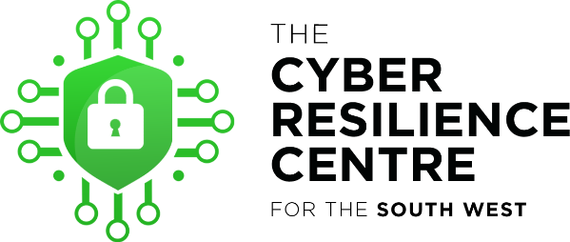

We are a police/ private not-for-profit partnership, funded by the Home Office, and covering the South West of the country. We are owned by regional policing, and run by regional officers and staff on a not-for-profit, full-time seconded basis. We offer free and inexpensive cyber services for local SME’s and third sector organisations; we’re not here to make money from our members.

Cyber – digital safety - is daunting for small businesses and sole traders. It’s hard to know where to start, services can be expensive, and it’s not always obvious who you can trust. The South West Cyber Resilience Centre aims to solve these problems locally. 32% of UK businesses were targeted last year, and we show them how to stay safer.

Businesses and charities can register with us for free core membership. We give them a package of nationally-produced guidance from the National Cyber Security Centre, which sets out very simply the key risks, and how to reduce them, and we follow it with a simple, bite-sized programme to coach them gently through. We follow this up with personal contact to make sure everything’s ok, including a free consultation with our cyber team, and a regular newsletter to keep them abreast of the latest scams and threats. So it’s a one-stop shop that helps them get safer, and stay safer.

If you need more bespoke advice, we employ top-quality undergraduates from local universities who are checked, trained, supervised and monitored by national experts. They can provide a number of services very inexpensively, from checking out publicly-available information which might compromise your safety, through to more detailed audits of your processes and systems. We can tell you if your website’s vulnerable, or if your systems are wide open, but we won’t be looking to sell you anything as a result of our findings.

For the most complex services, we have a network of ‘cyber expert partners’ who have the right national accreditations to demonstrate a level of technical competence to work with you. We can signpost you to them so that you know you’re using someone reputable.

As part of a national police-led network, we have centres covering the entirety of England and Wales, and with a consistent offering and ethos. We are supported at national level by household names like Microsoft, KPMG and the Very group, and down here we’re already looking after over 1600 businesses and charities. You can see more about us at www.swcrc.co.uk.
5

