AIMS AND OBJECTIVES

The Guinness Partnership (TGP) would like to engage with the Hard Facility Management (Hard FM) market with the aim to shape its outsourcing strategy in relation to the Asset Compliance requirements in communal areas of residential blocks.

This market sounding exercise aims to explore different outsourcing models, evaluating the risks and opportunities associated with each of them. As a result, TGP will design its Asset Compliance Category strategy and launch the necessary tender(s) to outsource their preferred model.

The main objectives of this market consultation are:

- To ascertain the number and types of suppliers interested in bidding for residential Hard FM services in communal areas, and understand their proposed delivery models
- To gauge their previous experience in the housing market, in particular social housing
- To explore different outsourcing models and identify the main risk factors and potential mitigating actions associated to each model (i.e. Specialist suppliers, Bundled services and Total Hard FM)

METHODOLOGY

This consultation will be staged into phases.

Phase I will consist of a simple questionnaire where suppliers will be asked to express their potential intertest in this opportunity and disclose information about their previous experience in the housing sector and their capability to deliver a series of services at a national/regional level and in-house or sub-contracted [Objectives 1 and 2]

Once Phase I is completed, and subject to the number of satisfactory responses, TGP will initiate Phase II of this consultation.

Phase II will consist of a more in-depth conversation with the market, which may take the shape of an initial questionnaire followed by one-to-one meetings if deemed appropriate. This phase will only take place if there are enough satisfactory answers to Phase I.

OVERVIEW OF THE GUINNESS PARTNERSHIP LIMITED

In 1890 philanthropist Sir Edward Cecil Guinness, the great grandson of the founder of the Guinness Brewery, donated £200,000 to set up The Guinness Trust in London. He wanted to help improve the lives of ordinary people, many of whom couldn’t afford decent homes. Today, The Guinness Partnership is one of the largest affordable housing and care providers in the country.

Our sense of purpose has not changed – we are here to improve people’s lives, and create possibilities for them. We do this by providing as many high quality new homes as possible and by providing great housing and care services: we are a customer service business.

We provide homes and housing services to around 65,000 homes across England, providing services for 120,000 customers and care services for 10,000 people. The estimated total annual spend in Hard FM is circa £33M.
Our core activities comprise housing for social and affordable rent, affordable home ownership, housing for older people and a range of care services, including domiciliary and extra care, supported and retirement living.
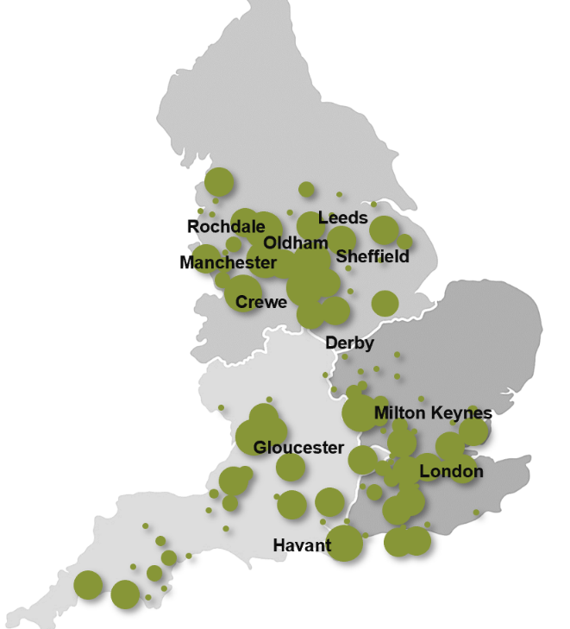

In particular, there are more than 3,000 blocks, which will require communal Hard FM services.
Our activities are regulated by the Homes and Communities Agency (HCA) and the Care Quality Commission (CQC).
The Guinness Partnership Limited (TGP) is a charitable Community Benefit Society No. 31693R. registered in England and is a Registered Provider of Social Housing (No. 4729).

Registered Office: 30 Brock Street, Regent’s Place, London NW1 3FG.

More details about The Guinness Partnership are available on our web site: www.guinnesspartnership.com

HARD FACILITY MANAGEMENT OVERVIEW

TGP are re-considering the current outsource delivery model for Hard FM services in the communal areas across its property stock. It is worth pointing out that the initial scope of this consultation does not include services inside flats, it is only in relation in the communal areas in residential properties. However, residential services may be discussed with prospect suppliers during Phase II.

Historically, Hard FM has been delivered by multiple specialist suppliers for individual services such as domestic boilers, ventilation, electronic security systems, legionella, lifts, fire equipment, etc. Most of these specialist contracts were further sub-divided into geographical lots, typically North, South and West.

As most of the current Hard FM contracts are expiring within the next 12 months, TGP would like to explore different outsourcing models. The typical models in the Hard FM industry are Sigle Services, Bundled Services or Total Hard FM. This consultation aims to attract suppliers who can deliver either of these models and to explore the pros and cons associated with each model.

TGP would like to adopt the most efficient and cost-effective manner possible. The overall objectives are to:

- reduce spend, increase control, increase quality and ensure compliance
- leverage and maximise our buying power
- incentivise good performance and maintain competitive pricing
- implement best practice and innovating ideas from other sectors

For reference, an indication of historic spend by selected services is set out below.

Component | Estimated Spend
AC and Ventilation Systems | £50,000
Asbestos Abatement | £700,000
Asbestos Surveys | £650,000
Electronic Security Systems | £2,200,000
Electrical Testing | £2,400,000
Lightning Protection and Working at Heights | £290,000
FRA (surveys) | £1,700,000
Fire Equipment Maintenance | £2,300,000
Fire Remedial Works | £1,900,000
Commercial Gas (maintenance and repairs) | £17,000,000
Laundry Equipment | £250,000
Lifts | £1,800,000
Playgrounds | £70,000
Pumps | £300,000
Renewables | £800,000
Water Safety | £2,000,00
Metering and Billing (maintenance) | £135,000

Proposed Timetable:

Advertise contract in OJEU | 04 June 2024
Phase I responses | 28 June 2024
Analysis Phase I responses | July 2024
Phase II launched (if required) | End of July 2024

PHASE I QUESTIONNAIRE:

Our market consultation, whilst confidential, is intended to be informal. The consultation is for information purposes only and will not be considered as part of any submission for any resulting tender.

If you are interested in this opportunity, please fill out the questionnaire below and submit your answers via ProContract by no later than 28/06/2024 at 5pm.

Question 1:

Please fill out the table below with information about your organisation.

Company’s Name
Company’s Address
Contact Name
Contact Email
Please choose the delivery model that best describes your organisation (tick as suitable)
Single Service | A specialist Company that covers one or two of the service lines included in the scope of this questionnaire
Bundled Services | A company that covers several of the service lines included in the scope of this questionnaire
Total Hard FM | A tier 1 company that can provide all or most of the services included in the scope of this questionnaire

Question 2:

Please provide examples of your previous experience in the housing sector.

Your examples shall include information about the client, the scope of the contract, the contract value, the contract term and the geographical location(s)

If you do not have experience in the housing sector, please provide an example of your most relevant experience.

Question 3:

Please provide information about the following service lines.

If you deliver the services in house (or partially in house) please detail the number of technicians currently employed.

If the services are sub-contracted, or partially sub-contracted, please identify the main sub-contractor(s) in your supply chain.

Also, please provide details of the geographical areas where you are currently providing these types of services.

Services that are not relevant to your organisation can be left blank or marked as N/A.

Service | In-House | Sub-Contracted | Geographical Coverage
AC & Ventilation, Ducks and Heat Recovery Systems
Asbestos Removals
Asbestos Testing
CCTV equipment
Door entry & security, access systems
Electrical Testing, EICR and remedial works
Fire Doors Inspections
Fire Equipment Maintenance
Fire Remedial Works
Fire Risk Assessments
Gas Services and Works [Commercial]
Gates, Barriers and Auto-doors
Laundry Equipment Maintenance
Lifts
Lightning Protection
Playgrounds Inspections
Playgrounds Remedial works
Renewables - Solar PV
TV Aerials
Waste, Drainage, Pumps and Septic tanks
Water Safety testing and Remedial Works
Working at Heights (inc. Access Equipment, Fall Arrest)
Metering and Billing

Question 4:

Please provide high level information about any additional Facility Management services that form part of your business proposition.

In particular, please provide information about Soft Facility Management services (cleaning, window cleaning, gutter cleaning, grounds maintenance, tree works, etc.).

