Finding Opportunities, Expressing an Interest (Registering an Interest) and accessing documents

Log in to the NEPO Portal (Portal) after registration has been approved and your details updated.
If you have received a notification from the NEPO Portal (ProContract) advising there is an opportunity, by selecting the link in the email you will be taken direct to the opportunity, follow

Finding Opportunities without a notification from the Portal.
From the home page select ‘Find Opportunities’
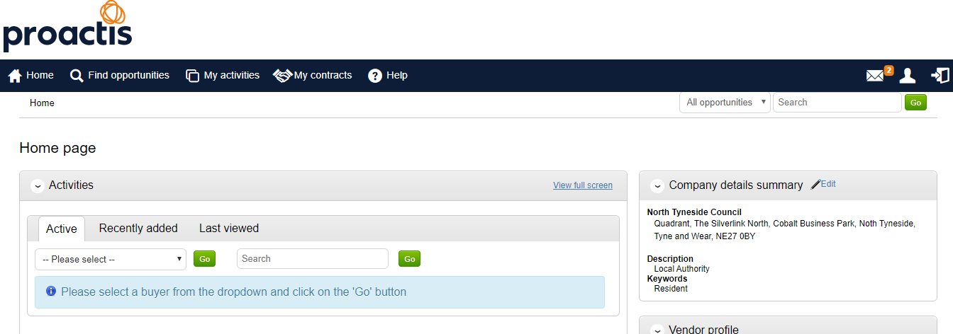
The following screen should open. You can either search the all the Portal Organisations (there are a lot) or filter to the one you would prefer to do business with either via Name/Category (type of services required) etc. as the Portal is a national system and a lot may be suitable to your location/work.
Filter the results by using ‘Narrow Your Results’. You can filter using any of the fields within this section and or using the free text ‘Search’ Field For this example we have filtered using ‘North Tyneside Council’ as we only offer services within this area and specifically for Construction.
Once you have found an opportunity you are interested in, select the title in blue and underlined and another screen should open.
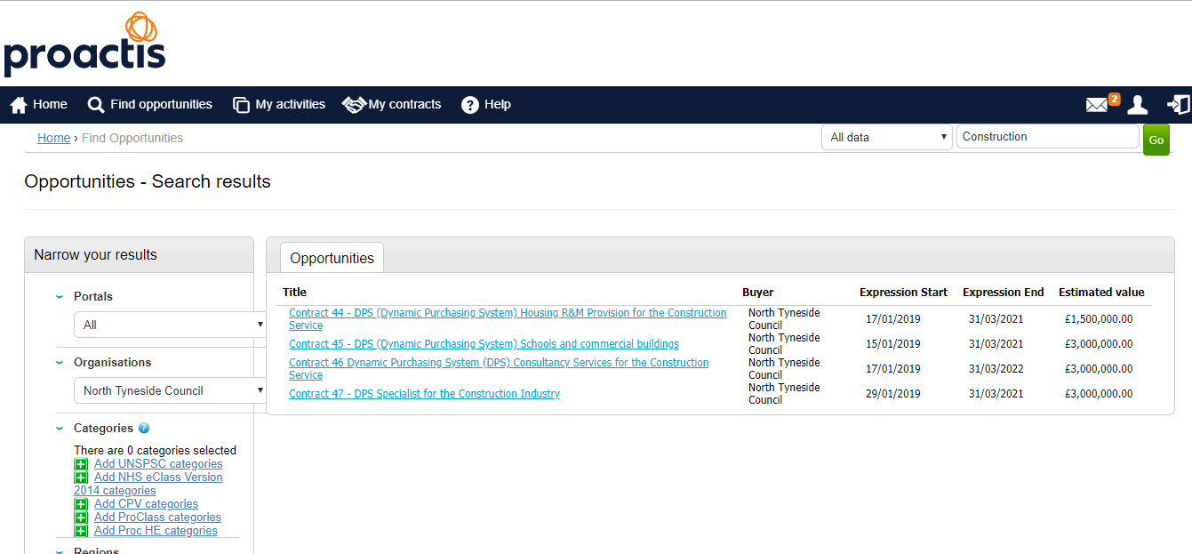

- Select ‘Register an interest in this opportunity’ once selected screen 2 should appear.
(if you have already done this and did not access the documents immediately go straight to paragraph 4).
- Select ‘To view this DPS (or Project/Tender) event now, click ‘here’ once selected screen 3 should appear.
- Scroll to the bottom of the screen to view all documentation and download to complete.
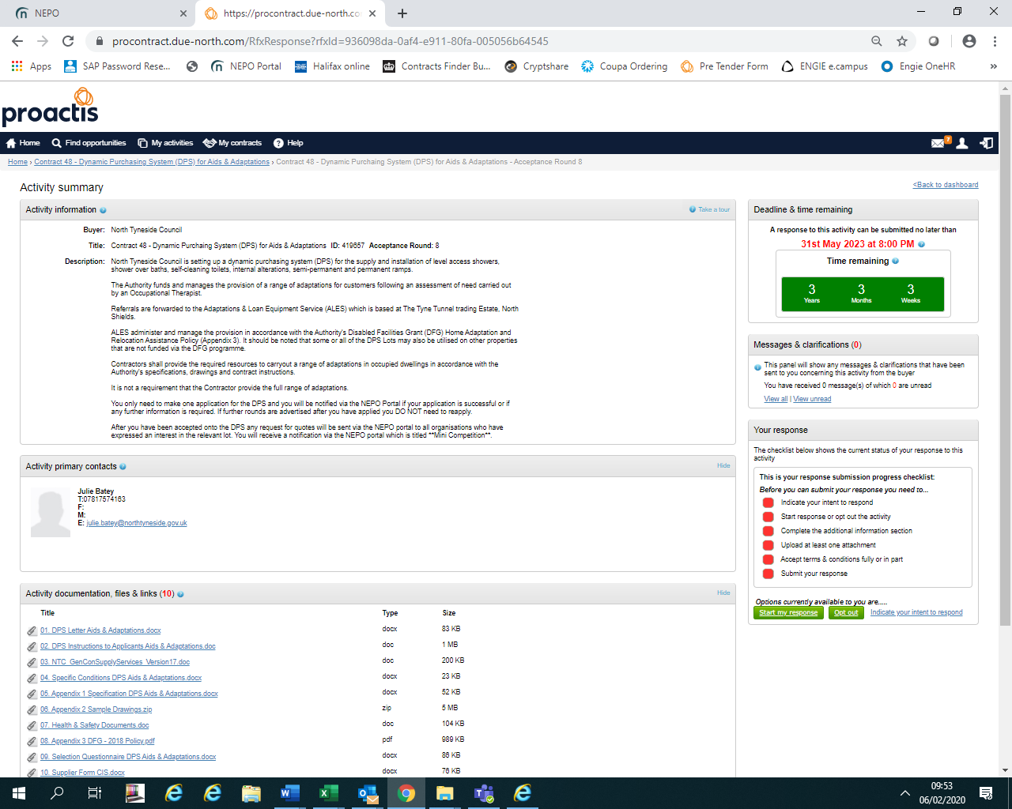

- SUPPLIERS WHOM HAVE EXPRESSED AN INTEREST ON THE NEPO PORTAL AND DID NOT VIEW DOCUMENTS IMMEDIATELY:-
If you log out after registering an interest/expressing an interest and did not select the option identified in paragraph 2 above at the time, follow these instructions until you are able to download the documents, use the ‘Help’ on the top of the screen if you have any difficulties which includes contact details of NEPO.
Once logged into the NEPO Portal, from the home page select ‘My Activities’. Follow the guidelines further below for further assistance.
- Screen 5a, using ‘Narrow your results’, filter to the Buyer, then select ‘Update’ and there is an option to reduce the list further either by searching using a word with the title and select ‘Go’, e.g. DPS which will reduce the list to ones only containing that word, alternatively, check page by page. Shown in screen 5b. Screen 5b shows the list of current activities once NTC and DPS had been selected, you can select the one you wish to view; anything underlined in blue is a link to another page in the Portal.
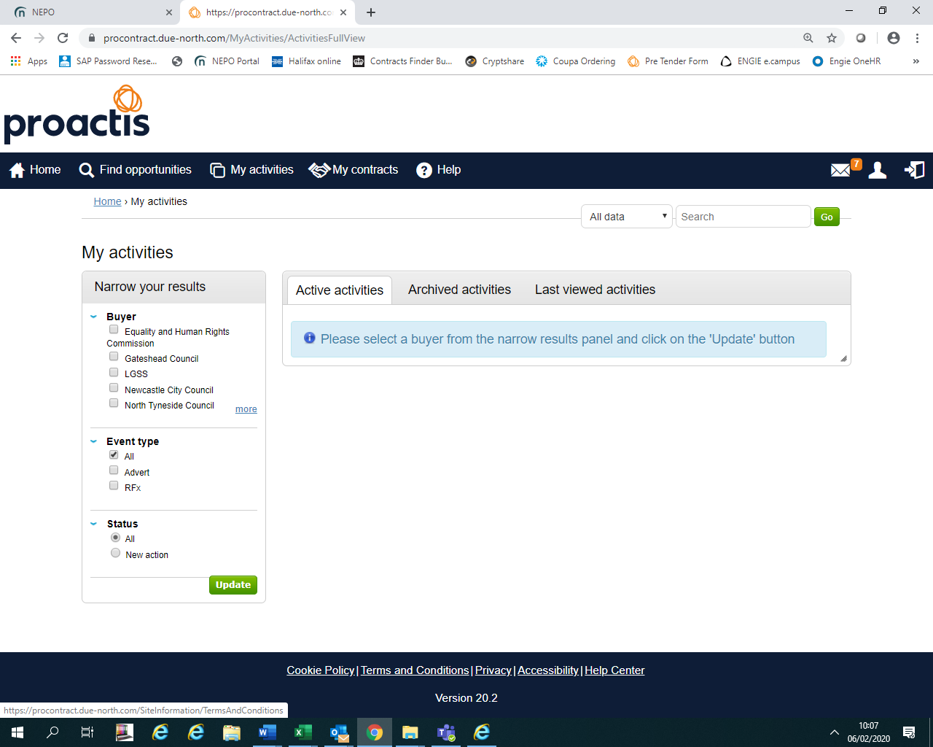
a

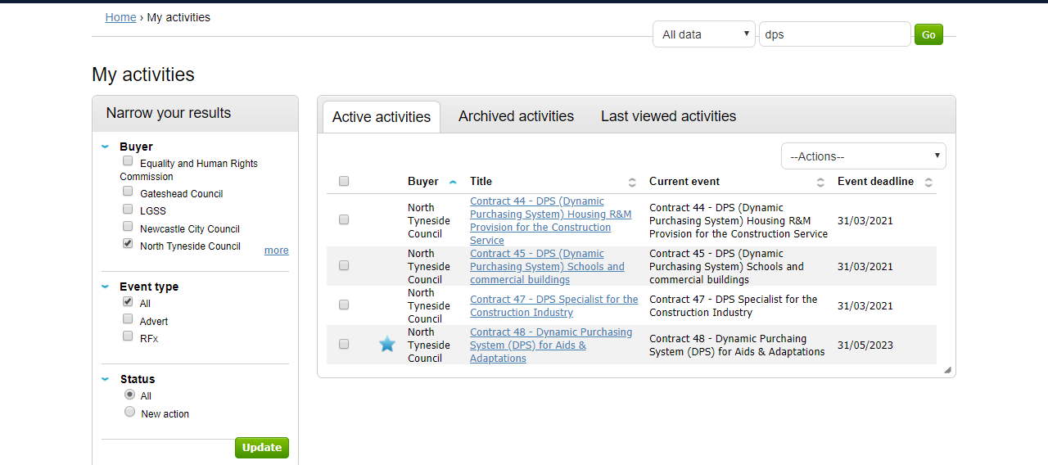
b

- Once you have selected the link to the opportunity, the following screen should open, select ‘open’.

DOWNLOADING THE DOCUMENTS
The opportunity should open in the next screen, showing the date for the deadline of submissions with a deadline clock, all the documents for fully completing and returning via the Portal are listed at the bottom of the screen.
NOTE – FOR DPS Frameworks:-
The sooner you apply the sooner you could be accepted and receive requests for services/works required.
Rounds are closed when the Authority receives an application, another Round opens automatically, you DO NO NEED TO RE-APPLY in another Round unless we specifically ask you to do so due to an issue with your application.

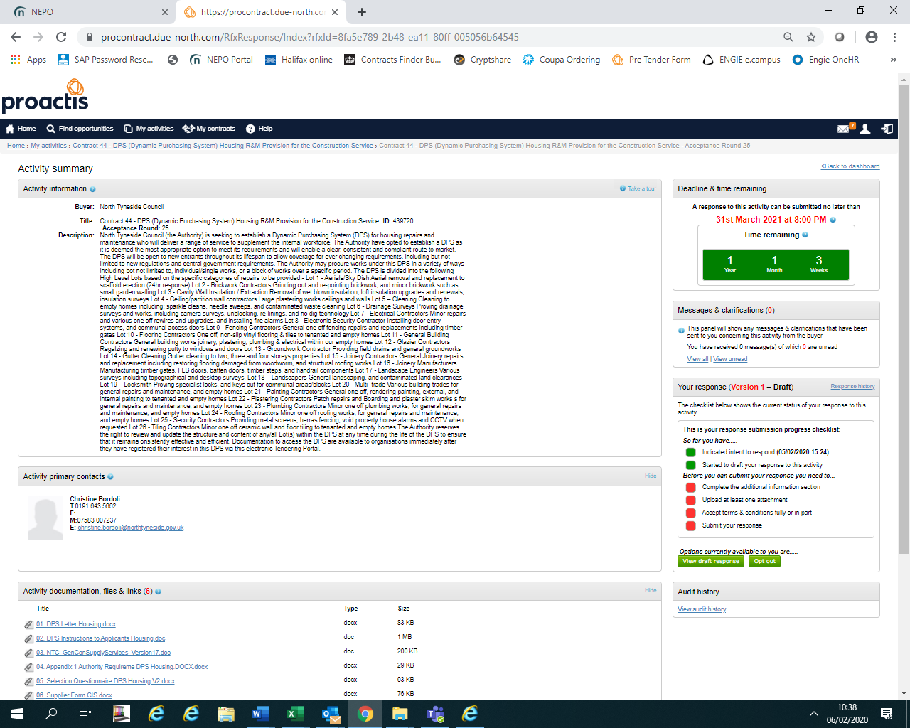

ALL OPPORTUNITIES :-

Ensure you read ALL the documentation including the Instructions.
Ensure you upload ALL the required documents FULLY COMPLETED including any supporting documents, BEFORE THE DEADLINE to avoid missing out.
QUERIES - If you have any queries in relation to the opportunity document, not the NEPO Portal. You can ask further information by using the messaging/clarification section which is similar to sending an email, however, there is an audit trail of all requests and responses and where necessary responses will be made public for all interested bidders to see.
A screen shot identifying where you can locate this section is below:-

MESSAGING/CLARIFICATION SECTION
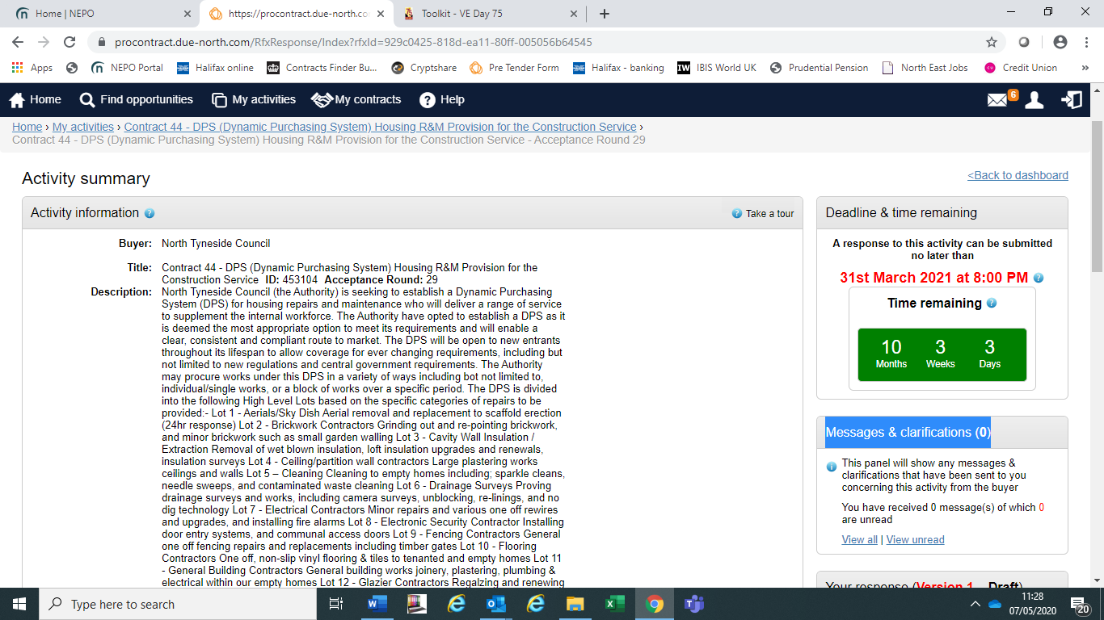

EXAMPLE ONLY

FURTHER ASSITANCE ON USING THE NEPO PORTAL SYSTEM OR ISSUES WITH THE NEPO PORTAL
If you need assistance in relation to the NEPO Portal please use the HELP section, there is also contact details for the administrators of the Portal within this HELP section at the top of the screen.

LOCATING OPPORTUNITY AFTER BEING LOGGED OUT.
If you log out at anytime follow the instructions below to gain access to your current opportunities
You will need to be logged into the system. Select ‘ My Activities’
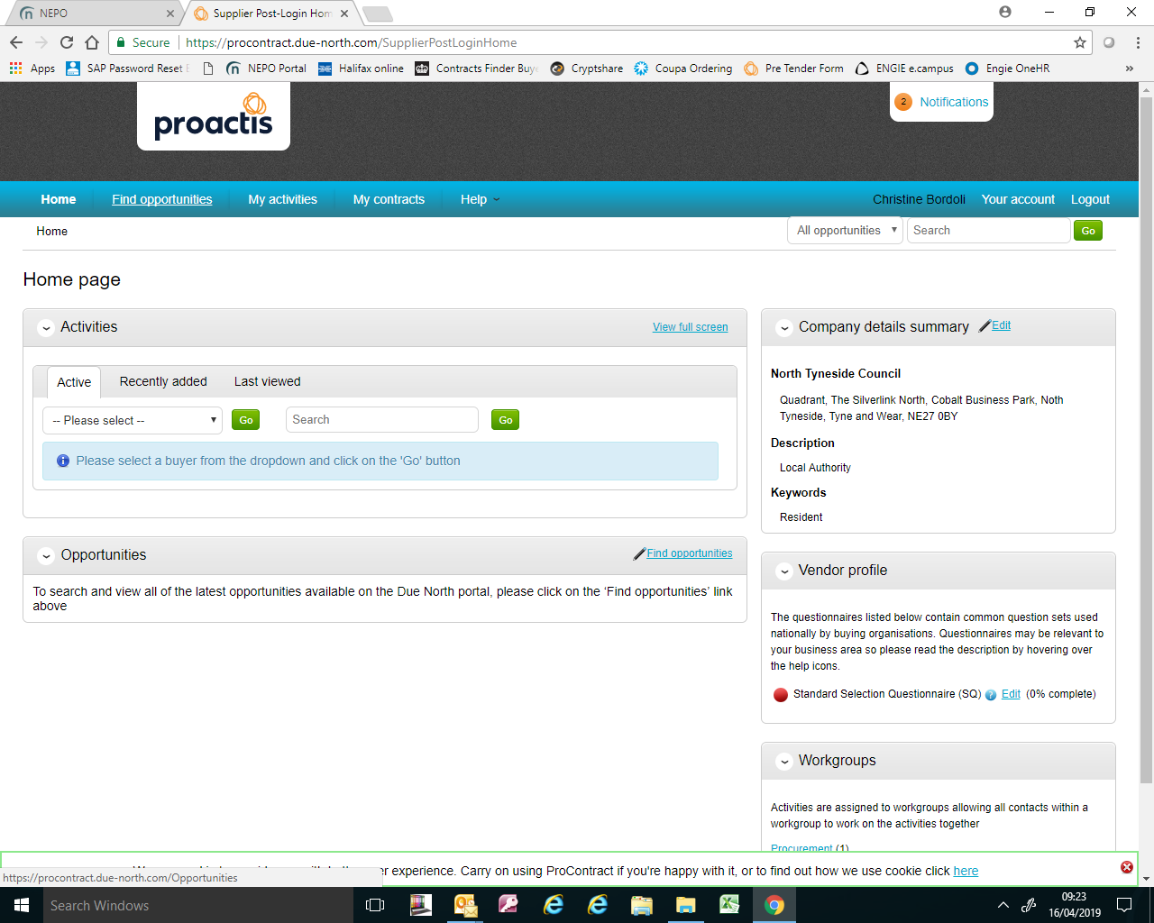

The following should appear, select ‘North Tyneside Council’, and ‘Update’
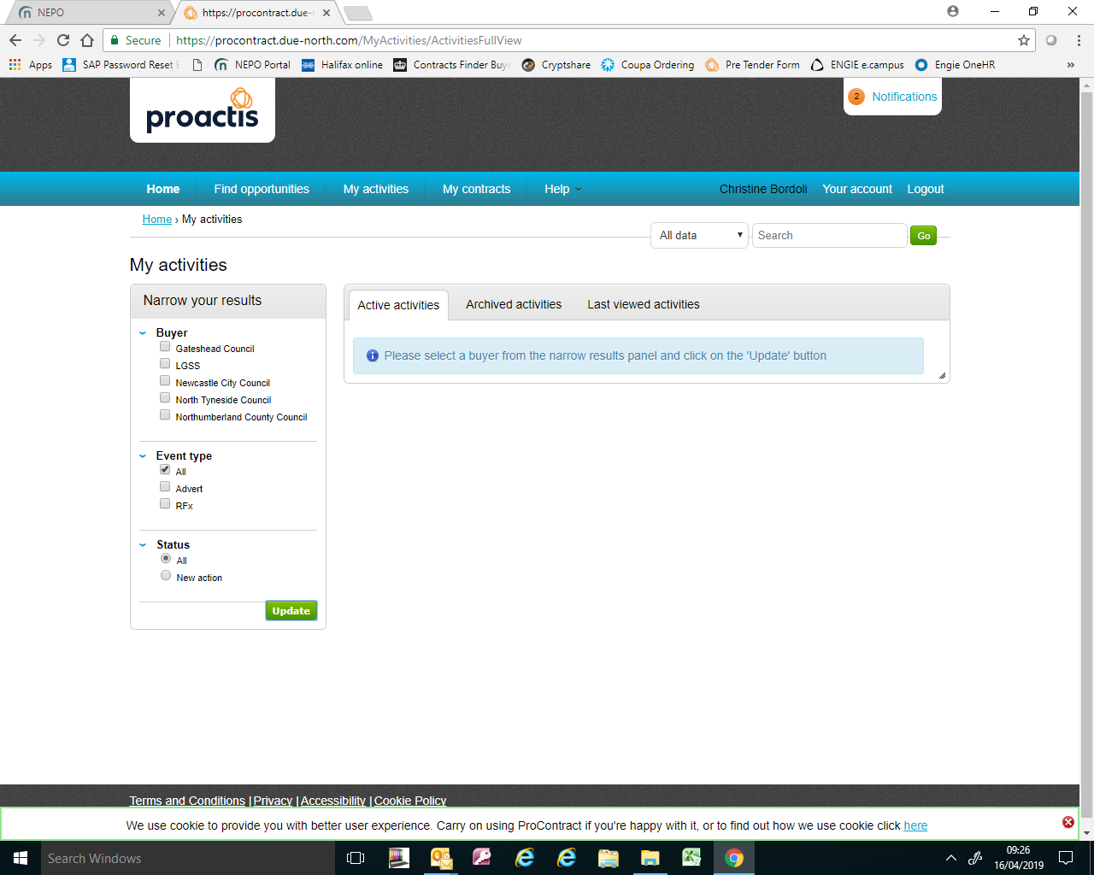

The following should appear, select ‘North Tyneside Council’, and ‘Update’.
Select the ‘opportunity’ you wish to view (either enter first part of the title in ‘search’ or via pages).
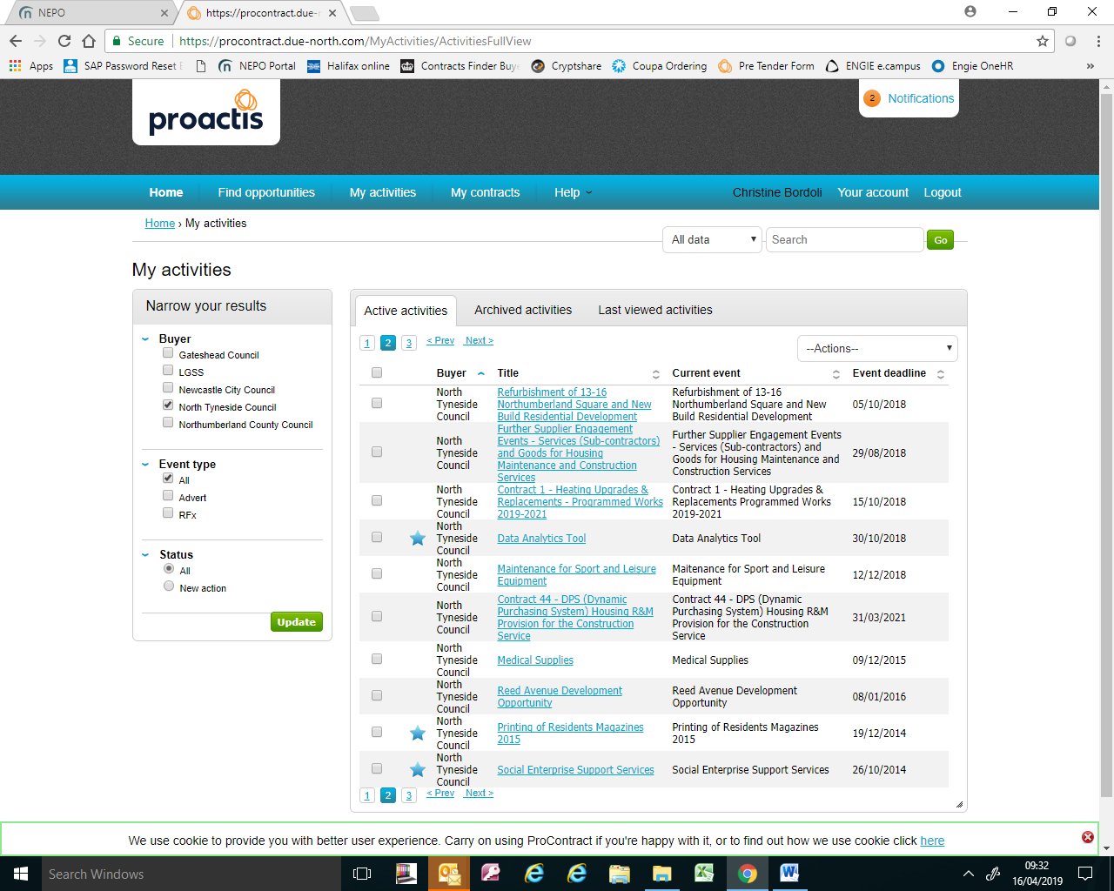

The following should appear, select ‘Start’.
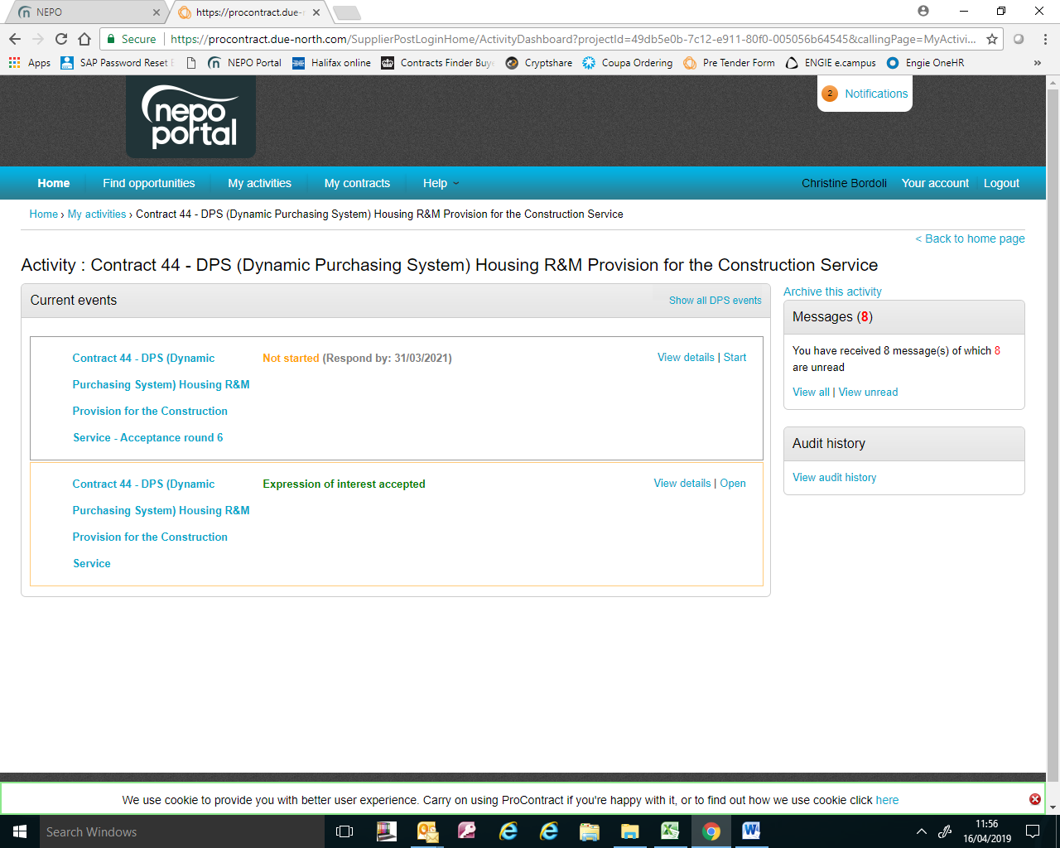
The following should appear, the documents which will require downloading for completing are at the very bottom of the page, ’
Please refer back to Downloading the documents or submitting a response
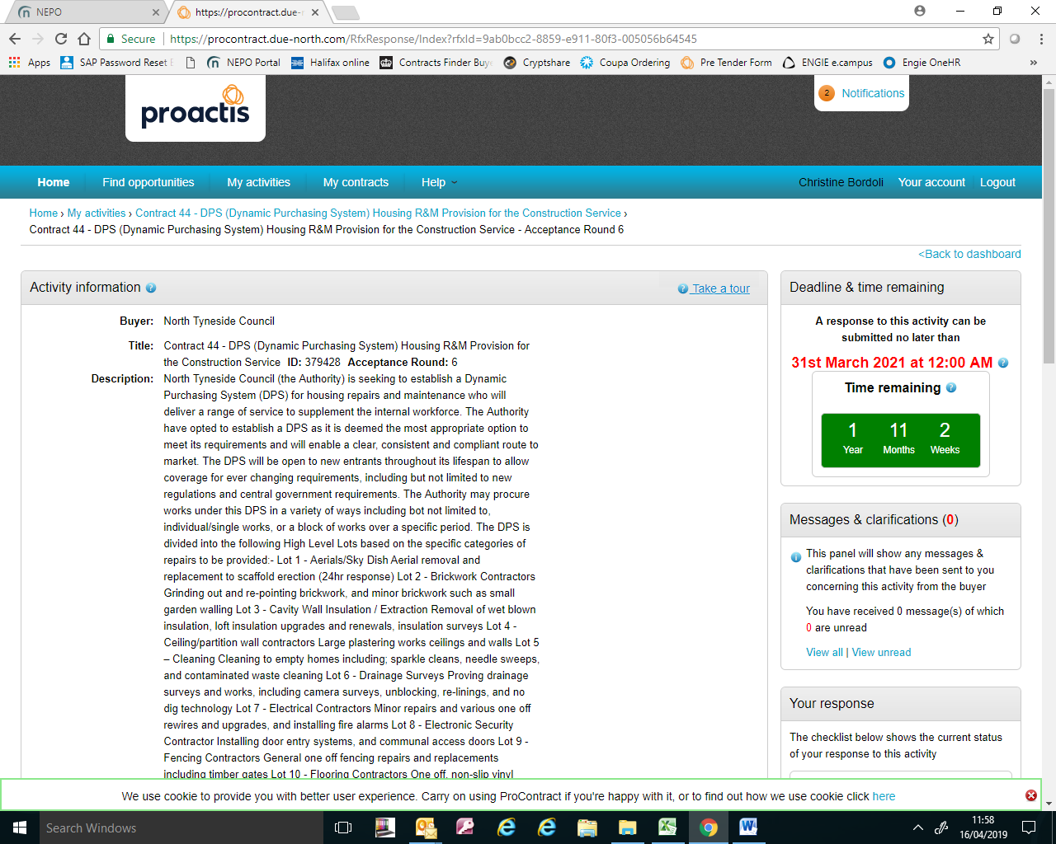

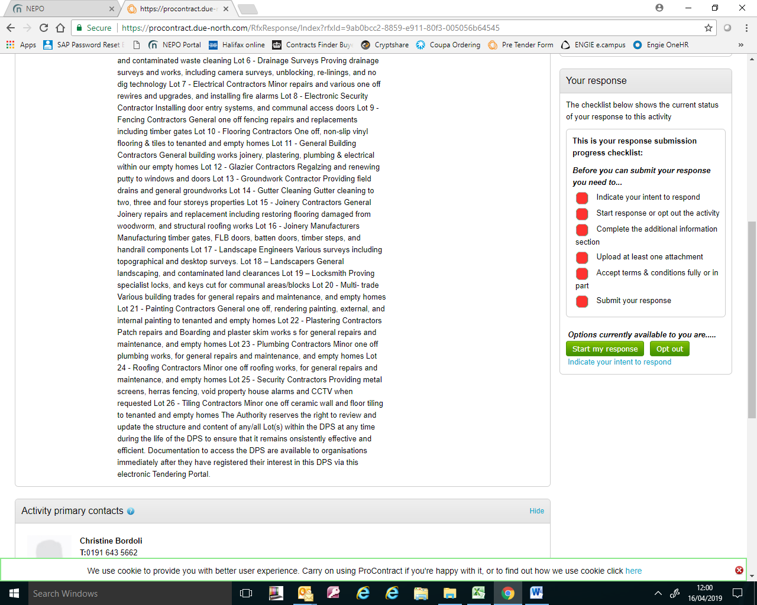
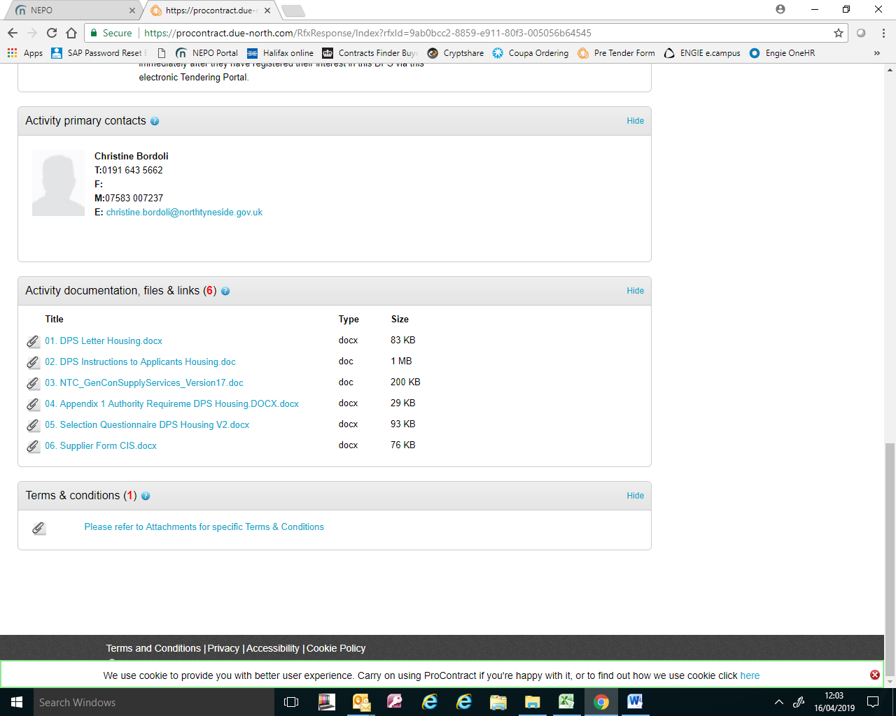
When you have fully completed the required documentation, refer to the ‘Instructions’, upload your completed response, including any supporting documentation requested, via this Portal by selecting ‘Start my response’. Select either accept/decline T&C’s. Only when all traffic lights have turned to GREEN, the option to ‘submit response’ can be selected.
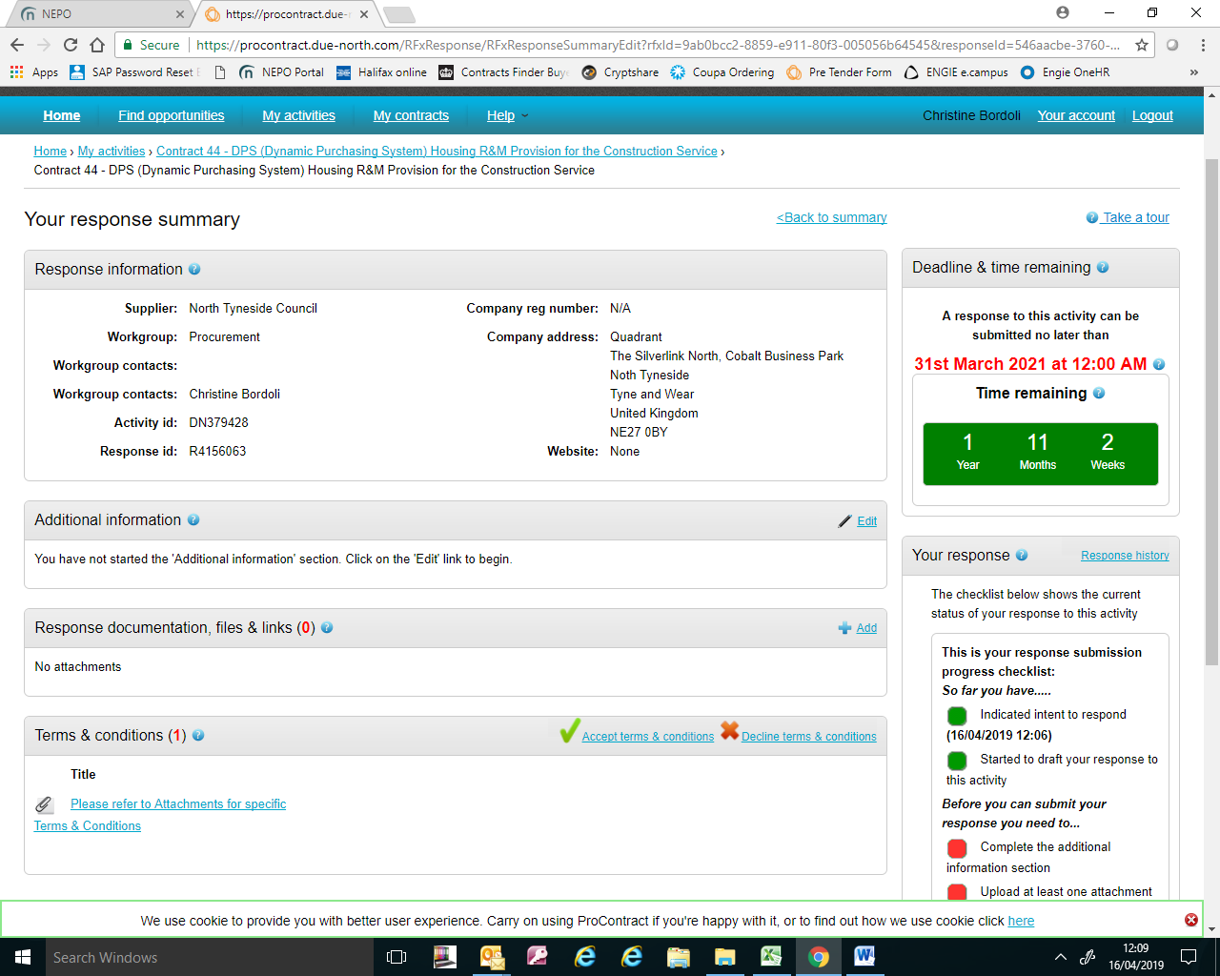

Unregistered suppliers will be directed to complete a Supplier Registration form before they can register interest.

There is a video tutorial available on the our web site to assist with the registration process.

