Site Name: Low Hall Sports Ground  Site Address: Lower, South Access Rd, London E17 8AX |  |  |  | Price (Ex VAT)
Main Hall |  | 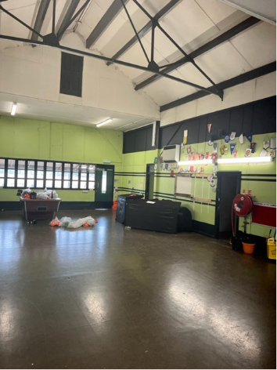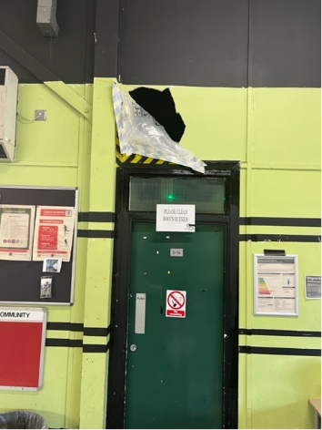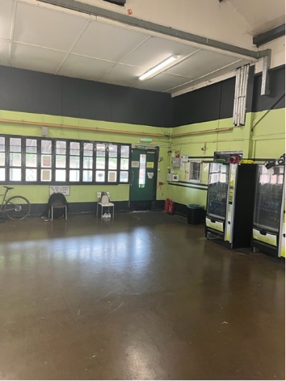 | Decorate throughout, repaint flooring, repaire damage to walls.
Small Kitchen |  | 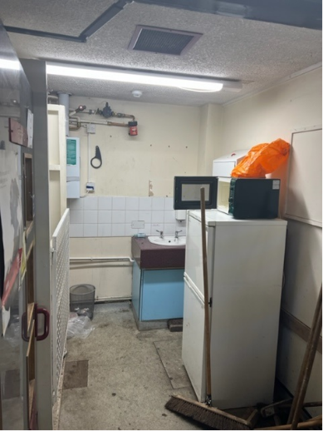 | Decorate throughout, repaint flooring.  Replace sink & taps
Lobby A (Left) |  | 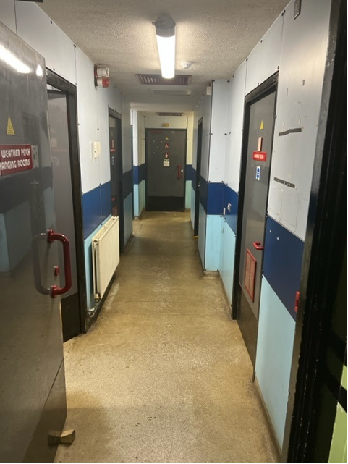 | Decorate ceiling, repaint flooring and wall panels
Male Toilets |  | 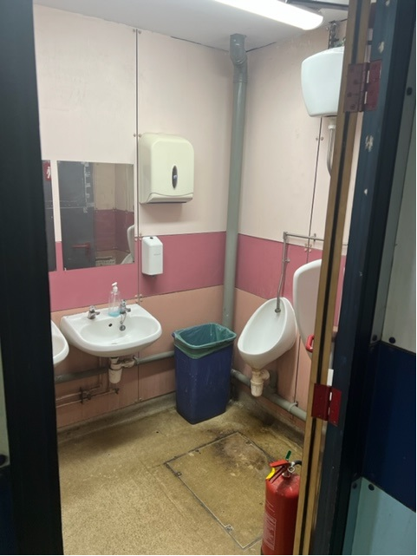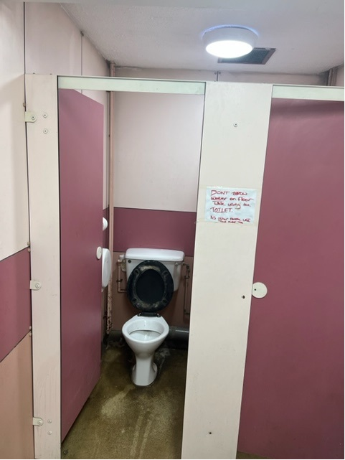 | Decorate throughout, repaint flooring. Deep clean of basins, toilets, urinals and cubicals.
Disabled Toilet |  |  | Decorate throughout, repaint flooring. Deep clean of basins, toilets
Female Toilet |  |  | Decorate throughout, repaint flooring & Deep clean of basins, toilets & cubicals
Changing Rooms  1-4 |  | 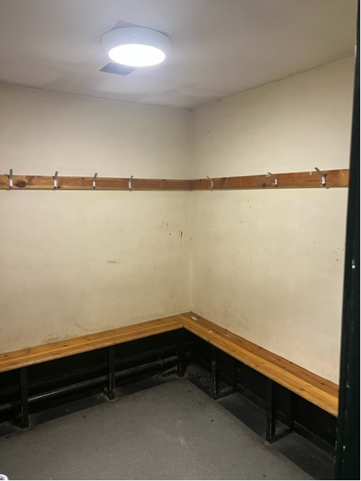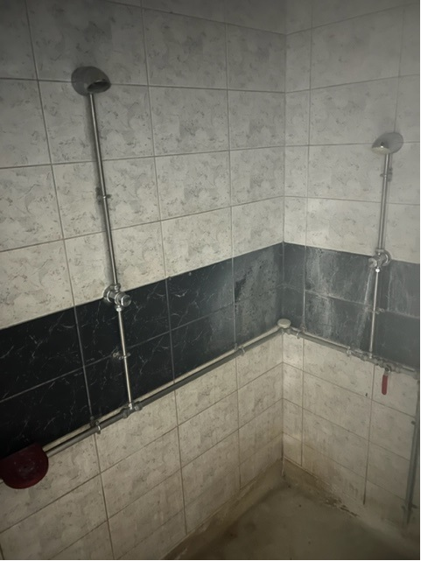 | Decorate throughout, repaint flooring. Deep clean of shower walls & heads.
Changing Rooms  5-14 |  | 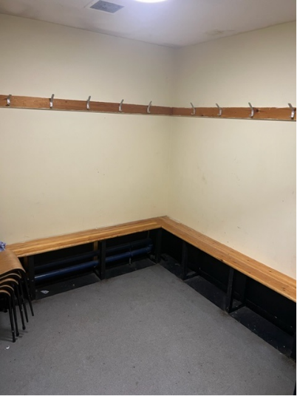 | Decorate throughout, repaint flooring.
Showers & Toilets A (Right Side) |  | 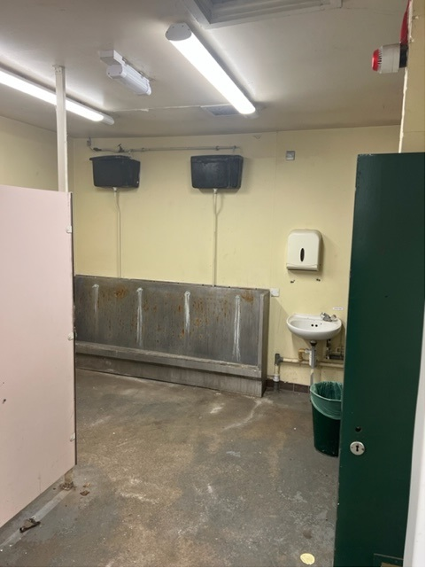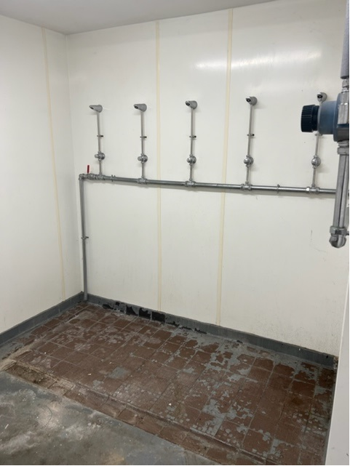 | Decorate throughout, repaint flooring.  Replace/deep clean 10 shower heads. Replace urinal trough, Deep clean basins, taps and toilets.
Showers & Toilets B (Right Side) |  | 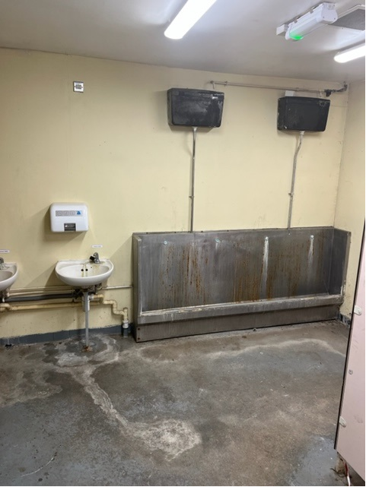 | Decorate throughout, repaint flooring.  Replace/deep clean 10 shower heads. Replace urinal trough, Deep clean basins, taps and toilets.
Lobby B (Right Side) |  | 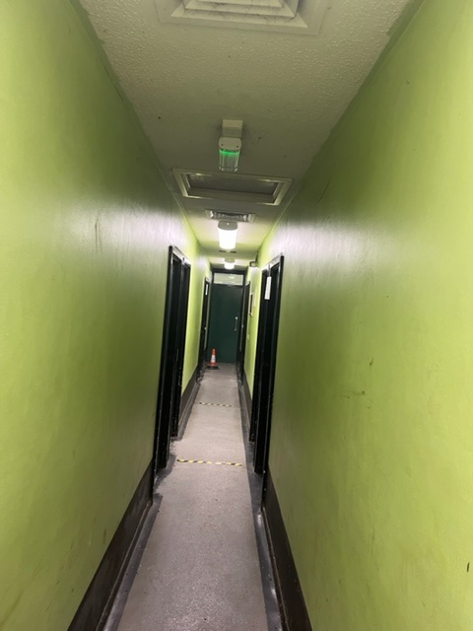 | Decorate throughout, repaint flooring
Lobby C (Right Side) |  | 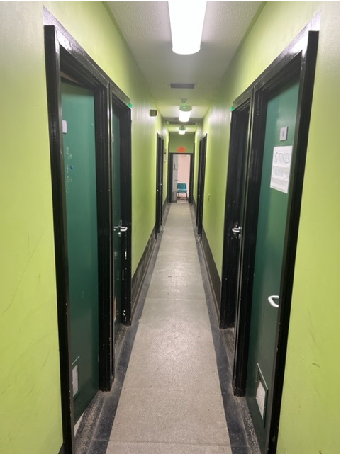 | Decorate throughout, repaint flooring
Changing Rooms  15-24 |  | 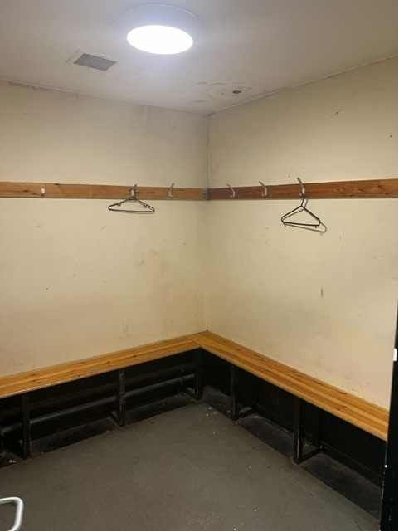 | Decorate throughout, repaint flooring
Additional Notes:
Decoration requires full preparation, undercoat, and topcoat (colour to be agreed with client)
Paint should be to a specification that is hard wearing, maintainable (suitable for wiping or washing down). Materials for intended use should be described in the tender and product sheets provided for review and evaluation.
Method statements should be supplied with the tender including any chemicals or processes used for deep cleaning, and all painting and decoration works.
Site visits can be arranged in advance

