INVITATION TO QUOTE

For access improvements at Kensington Meadows, Bath BA1 6AN

Supply the South West reference number: DN393558

Date of release: Friday 15th February 2019

Version No: 1.0

INDEX

Section 1 – THE REQUIREMENT

  - Introduction
  - Overview
  - Specification
  - Term of Contract
  - Contract Value
  - Dates
  - Background

Section 2 – INSTRUCTIONS TO SUPPLIERS

2.1 E-Quote System
2.2 Register Intent or Opt Out
2.3 Preparation of Quote
2.4 Price Schedules
2.5 Other Documents or Supporting Evidence
2.6 Submission Deadline
2.7 Quote Validity
2.8 Communication
2.9 Confidentiality
2.10 Disclaimer
2.11 Freedom of Information Act
2.12 Transparency
2.13 Procurement Timetable
2.14 Required Documents

Section 3 – QUESTIONNAIRE

A Notes for Completion
B Questionnaire

Section 4 – COMMERCIAL SCHEDULE

4.1 Pricing

Section 5 – EVALUATION AND AWARD

5.1 Evaluation
5.2 Recommendation
5.3 Contract Award

Section 6 – APPENDICES

SECTION 1 – THE REQUIREMENT

1.1 Introduction

Kensington Meadows is a semi-natural public open space owned and managed by Bath & North East Somerset (B&NES) Council.

The Council has been working with the local community to understand how best the open space can be improved. Access improvements have been identified as a priority. The existing public entrances are heavily used and need to be opened up to make them safer and more welcoming. The ground conditions at the Grosvenor Bridge and Morrisons supermarket entrances become very muddy and churned up in the winter. The ground at these entrances needs to be improved to reduce this problem.

The Council’s Parks and Open Spaces department now wishes to tender for access improvements, as detailed below.

1.2 Overview

The Council wishes to establish a Contract for access improvements including:

- Removal of vehicular gates and metal fencing and installation of wooden bollards at the Meadows Lane entrance

- Removal of vehicular gates and metal fencing and installation of wooden bollards at the Ringswell Gardens entrance

- Ground reinforcements at the Grosvenor Bridge entrance to improve ground conditions at this entrance pinch point.

- Ground reinforcements at the Morrisons Supermarket entrance to improve ground conditions at this entrance pinch point.

Entrances are labelled on site map 1 in Appendix 3

This is a Contract for goods and services.

1.3 Specification

1.3.1 Removal of vehicular gates and metal fencing and supply and installation of wooden bollards at the Meadows Lane entrance. (Review specification in conjunction with drawing in Appendix 3)

- Break out, remove and dispose of a 9.8 metre section of boundary consisting of metal gates, removable metal posts, concrete posts, redundant sign post and section of chainlink fencing - including all concrete footings.
- Install 5 wooden bollards and 1 monolith sign in a straight line at 1.4 metre intervals (centres), following the same boundary line. 2 bollards will be removable (set in metal ground sockets), 3 bollards and the monolith sign will be fixed permanently in place.
- The monolith sign (dimensions circa 200 x 100 x 1800mm) and 2 padlocks will be supplied by the Council. Bollards, ground sockets, handles etc. to be supplied by the contractor.
- Wooden bollards should be square planed timber with a diameter of at least 150mm made from either hardwood of softwood with a category 4 preservative treatment.
- Fixed wooden bollards should be set 400mm below ground level in secure concrete footings, with 800mm above ground level.
- Removable bollards should be within lockable steel ground sockets which are set in secure concrete footings and secured by a padlock. Each of the removable bollards should be fitted with 2 metal handles to aid removal.
- The monolith sign should be set 600mm below ground level in a secure concrete footing, with 1200mm above ground level.
- All of the concrete footings must be below ground level and covered with a minimum 50mm of soil
The site has been occupied illegally by travellers in the past so all bollards must be secured installed so that they cannot be easily removed.
Pedestrian and vehicular access to properties and business on Meadows Lane must remain open during completion of the works.

Make good all ground following works ensuring that the surface is left flat and any disturbed areas are re-seeded. A compound will be required to allow concrete to set and disturbed ground to re-establish before the entrance is reopened

    - Removal of vehicular gates and fencing and installation of wooden bollards at the Ringswell Gardens entrance. (Review specification in conjunction with drawing in Appendix 3)

- Break out, remove and dispose of a 5.2metre section of boundary consisting of gates, metal post and section of fencing- including all concrete footings.
- Install 3 wooden bollards in a straight line at 1.3 metre intervals (centres), following the same boundary line. 2 bollards will be removable (set in metal ground sockets) and 1 will be a monolith sign
- The monolith sign and 2 padlocks will be supplied by the Council. Bollards, ground sockets, handle etc. to be supplied by the contractor.
- Remaining requirements as per works at Meadows Lane entrance (above)
Vehicular and pedestrian access to properties on Ringswell Gardens must remain open during completion of the works.
Make good all ground following works ensuring that the surface is left flat and any disturbed areas are re-seeded. A compound will be required to allow concrete to set and disturbed ground to re-establish before the entrance is reopened

1.3.3 Ground reinforcements at the Grosvenor Bridge entrance (Review specification in conjunction with drawing in Appendix 3)

Create a 170 m² skirt of reinforced ground to reduce muddy, wet conditions which occur through the winter months.

The reinforced ground will need to support a light load – pedestrians and bicycles only (not vehicles).

Contractors are invited to suggest a method for reinforcing the ground in this location which might include installing a cellular ground reinforcement system which allows grass to grow through it,or a similar solution.

Whichever method is used it should, as much as possible, have a low visual impact and blend in with the rest of the recreation field. For example, if a cellular ground protection system is used the top surface should have a “high open percentage” in the range of 70-90% so that the cells are not highly visible and grass is easily able to grow through it.

Any cellular system should be installed following manufacturers installation guidance for a grass surface.
On completion of works the reinforced area should be seeded with a durable grass seed mix suitable for high footfall.
Any waste soil created as part of the works will need to be disposed of off-site.

1.3.4 Ground reinforcements at the Morrisons entrance (Review specification in conjunction with drawing in Appendix 3)

Create a circa 300 m² skirt of reinforced ground by supplying and installing a cellular ground protection/reinforcement system.
Specification as per 1.3.3

1.3.5 Public access and grass establishment:

- The works at the Ringswell Gardens entrance should be carried out first. This will result in a new pedestrian entrance and so will take the pressure off other entrances as works are carried out.
- Public access through these entrances will ideally be maintained during the works but if this is not feasible then each can be closed temporarily during installation – but not all at once.
- Following the completion of works a phased fencing off of the reinforced ground will be required to allow new grass to establish.

1.4 Term of Contract

Terms of the contract can be found in the attached ‘Terms and Conditions’ document (Appendix Four).

1.5 Contract Value

Tenders for the work should be in the region of £15,000.

1.6 Dates
The deadline for receipt of the completed tender response is Friday 15th March 2019 at 12 noon.
It is anticipated that contracts will commence from the beginning of April with works ideally being completed as soon as possible thereafter, and no later than the end of June 2019.

1.7 Background

These works will form part of a programme of capital improvements to Kensington Meadows in 2019. More information is available at www.bathnes.gov.uk/kensingtonmeadows

SECTION 2 – INSTRUCTIONS TO QUOTES

2.1 E-Quote System

The Council uses ProContract as its e-procurement system. Assistance in relation to the e-procurement system is available to suppliers via the Supplier Help Icon within the system. Supplier Guidance documents are also available to view and download.

If you are still unable to resolve your issue in using the system please contact the Due North Technical Support Team

By Tel: 0844 334 5204 (lines open from 08:30am to 17:00pm Monday to Friday, excluding English public holidays).
By Email: swsupport@due-north.com

2.2 Register Intent or opt out

Once the Quote Information has been viewed suppliers will be able to click on “Register Intent” which will inform the Council of your intention to respond to this opportunity.

If a supplier does not wish to, or is unable to submit a Quote and not interested in proceeding, then they are required to click on “Opt Out” to decline the opportunity.

2.3 Preparation of Quote

Suppliers must obtain for themselves all information necessary for the preparation of their Quote response and all costs, expenses and liabilities incurred by the supplier in connection with the preparation and submission of the Quote shall be borne by the supplier, whether or not their offer is successful.

Information supplied to the supplier by Council staff or contained in Council publications is supplied only for general guidance in the preparation of the Quote. It shall remain the property of the Council and shall be used only for the purpose of this procurement exercise.

Suppliers must satisfy themselves as to the accuracy of any such information and no responsibility is accepted by the Council for any loss or damage of whatever kind and howsoever caused arising from the use by suppliers of such information.

2.4 Price Schedule/s

The Council requires suppliers to complete and upload Price Schedule(s) where requested to do so within the e-procurement system.

All prices shall be in Pounds Sterling.

2.5 Other Documents or Supporting Evidence

If instructed to do so within the e-procurement system, the supplier must complete and upload other documentation that may be provided with this Invitation to Quote, or upload evidence to support their submission.

Quotes must not be qualified or conditional. Only Quotes submitted without qualification will be accepted for consideration. If a Quote is excluded from consideration, the supplier will be notified.

2.6 Submission deadline

Suppliers are required to submit their Quote within the e-procurement system by 12 noon on Friday 15th March 2019 and should allow sufficient time to complete questions and upload documentation where requested to do so. Quotes received after the closing date will not be considered and will result in the Council rejecting the Quote as a Fail / Non-compliant Quote.

The Council is under no obligation to consider partial or late submissions.

If the Council issues an amendment to the original Quote and if it regards that amendment as significant, an extension of the closing date may, at the discretion of the Council, be given to all Organisations.

The Council expressly reserves the right to require a supplier to provide additional information supplementing or clarifying any of the information provided in response to the requests set out in the Quote. However, the Council is not obliged to make such requests.

Suppliers shall accept and acknowledge that by issuing this ITQ the Council shall not be bound to accept any Quote and reserves the right not to conclude a Contract for some or all of the goods and services for which Quotes are invited.

2.7 Quote Validity

The Quote should remain open for acceptance for a period of 60 days. A Quote valid for a shorter period may be rejected.

2.8 Communication

All contact and communication during this procurement should be submitted in writing through the e-procurement system including any clarification questions in sufficient time before the closing date, to enable to the Council to respond to all suppliers. It is not acceptable for suppliers to seek clarifications via telephone or e-mail outside of the e-procurement system.

2.9 Confidentiality

The supplier must keep confidential and will not disclose to any third parties any information contained within their bid. They shall not release details other than on an ‘In Confidence’ basis to those whom they need to consult for the purpose of preparing the Quote response, such as professional advisors or joint bidders.

The Quote shall not be canvassed for acceptance or discussed with the media, any other Organisation, member/officer of Bath & North East Somerset Council, or their representatives. Any supplier trying to exert any undue influence during the tender process could be excluded from the process.

2.10 Disclaimer

Neither the Council, [nor any relevant Other Contracting Bodies], nor their advisors, respective directors, officers, members, partners, employees, other staff or agents:

- make any representation or warranty (express or implied) as to the accuracy, reasonableness or completeness of the ITQ; or
- accepts any responsibility for the information contained in the ITQ or for their fairness, accuracy or completeness of that information nor shall any of then be liable for any loss or damage (other than in respect of fraudulent misrepresentation) arising as a result of reliance on such information or any subsequent communication.

Any resulting Contract shall be governed by English law.

2.11 Freedom of Information Act

Suppliers should note that the Council is subject to the ‘Freedom of Information Act 2000’. Suppliers are requested to state which part, if any, of the information supplied with their Quote is confidential or commercially sensitive or should not be disclosed in response to a request for information and why. Suppliers’ statements will be considered however the Council is unable to give any guarantee that the information in question will not be disclosed.

2.12 Transparency

Suppliers and those organisations who bid should be aware that if they are awarded a contract, the resulting contract between the supplier and the Council will be published under the government transparency policy. To view details of what we MUST publish, see the Local Government Transparency Code 2015 at the link Local Government Transparency code 2015

The Council is required to publish details of all expenditure over £500 made to its suppliers and all contracts and framework agreements over £5000.

Details will be published on the Council’s website and the government’s transparency website (Data.gov.uk) and Contracts Finder.

2.13 Procurement Timetable

The indicative timetable for this procurement is set out below. This is intended as a guide and, whilst the Council does not intend to depart from the timetable, it reserves the right to do so at any time.

Date or Target Date | Activity
15/02/2019 | ITQ issued to potential suppliers
12 noon 15/03/19 | Closing date and time for receipt of Quotes
18/3/19– 29/3/19 | Evaluation of the ITQ responses by panel
29/3/19 | Award decision made and award letter issued
29/3/19 | Contract award concluded
15/04/19 | Commencement Date of Contract
On or before 22/04/19 | Contract Completion date

2.14 Required documents

Within this process suppliers have been provided with the following documentation. Where indicated these are required to be completed and uploaded within the e-procurement system.

DOCUMENT TITLE | COMPLETE AND UPLOAD WITH TENDER

Section 1 – The Requirement including Specification

Section 2 – Instructions to Suppliers

Section 3 – Questionnaire

Section 3 – Project specific questions

Section 4 – Pricing Schedule

Section 5 – Evaluation and Award

Appendix 1 – Non Collusion Certificate

Appendix 2 – Evaluation Matrix

Appendix 3 – Site map

Appendix 4 - Terms and Conditions of Contract

Appendix [include as appropriate]

Please Note: The completion and electronic return of all the documents ticked above is mandatory

SECTION 3 - QUESTIONNAIRE

The purpose of the Questionnaire is to enable the Council to assess supplier suitability for providing goods and services.

Notes for completion

i. Please ensure that all questions are completed in full, and in the format requested. Failure to do so may result in your submission being disqualified. If it does not apply to you, please state clearly ‘N/A’.

ii Should you need to provide additional Appendices in response to the questions, these should be numbered clearly and listed as part of your declaration.

iii. Please return a completed version of this document with your Quote submission using the e-procurement system.

Verification of Information Provided

iv. Whilst reserving the right to request information at any time throughout the procurement process, the Council may enable the Supplier to self-certify that there are no mandatory/ discretionary grounds for excluding their organisation. The Council will request evidence from the winning Contractor only after the final Quote evaluation decision.

Sub-contracting arrangements

v. The Supplier should advise in a separate appendix the names of sub-contractors, the percentage of work being delivered by each sub-contractor and the key contract deliverables each sub-contractor will be responsible for.

Confidentiality

vi. The Council reserves the right to contact the named customer contact in the questionnaire below. The named customer contact does not owe the Council any duty of care or have any legal liability, except for any deceitful or maliciously false statements of fact.

vii. The Council confirms that it will keep confidential and will not disclose to any third parties any information obtained from a named customer contact, other than to the Cabinet Office and/or contracting authorities defined by the Public Contract Regulations.

Questionnaire

Supplier details | Answer
Full name and address of the Supplier
Registered company/charity number
Registered VAT number
Name of parent company
Please mark ‘X’ in the relevant box to indicate your trading status | i) a public limited company | ▢ Yes
 | ii) a limited company | ▢ Yes
 | iii) a limited liability partnership | ▢ Yes
 | iv) other partnership | ▢ Yes
 | v) sole trader | ▢ Yes
 | vi) other (please specify) | ▢ Yes
Please mark ‘X’ in the relevant boxes to indicate whether any of the following classifications apply to you | i)Voluntary, Community and Social Enterprise (VCSE) | ▢ Yes
 | ii) Small or Medium Enterprise (SME) | ▢ Yes
 | iii) Sheltered workshop | ▢ Yes
 | iv) Public service mutual | ▢ Yes
Bidding model
Please mark ‘X’ in the relevant box to indicate whether you are;
a) Bidding as a Prime Contractor and will deliver 100% of the key contract deliverables yourself |  |  | ▢ Yes
b) Bidding as a Prime Contractor and will use third parties to deliver some of the services |  |  | ▢ Yes
c) Bidding as Prime Contractor but will operate as a Managing Agent and will use third parties to deliver all of the services  d) Bidding as a consortium but not proposing to create a new legal entity.  If yes, please include details of your consortium in the next column and use a separate Appendix to explain the alternative arrangements i.e. why a new legal entity is not being created.  Please note that the Authority may require the consortium to assume a specific legal form if awarded the contract, to the extent that it is necessary for the satisfactory performance of the contract.  e) Bidding as a consortium and intend to create a Special Purpose Vehicle (SPV).  If yes, please include details of your consortium, current lead member and intended SPV in the next column and provide full details of the bidding model using a separate Appendix. |  |  | ▢ Yes  ▢ Yes  Consortium members  Lead member  ▢ Yes  Consortium members  Current lead member  Name of Special Purpose Vehicle

Contact details
Supplier contact details for enquiries
Name
Postal address
Phone
Mobile
E-mail

Economic and Financial Standing

Please provide with your response one of the following to demonstrate your economic/financial standing:

- A copy of the audited accounts for the most recent two years

- A statement of the turnover, profit & loss account, current liabilities and assets, and cash flow for the most recent year of trading for this organisation.

- A statement of the cash flow forecast for the current year and a bank letter outlining the current cash and credit position

- Alternative means of demonstrating financial status if any of the above are not available (e.g. Forecast of turnover for the current year and a statement of funding provided by the owners and/or the bank, charity accruals accounts or an alternative means of demonstrating financial status).

Technical and Professional Ability

Please provide details of up to two contracts, in any combination from either the public, private or not-for-profit sectors that are relevant to the Council’s requirement and have been performed during the past three years.
You should state the name of the organisation, the point of contact details, the contract start date, completion date and estimate value of Contract. Give a brief description of less than 500 words of the contract delivered as evidence of your technical ability capability in this market.
The named customer contact provided should be prepared to provide written evidence to the Council to confirm the accuracy of the information provided overleaf.

Project Specific Questions (QUALITY)

METHOD STATEMENT
What is your method statement for completing the works outlined in this Invitation to Quote (ITQ) document. Please include anticipated timescales and details of how will you minimise the need to restrict public access during the works and ensure that all work is completed by 30th June 2019. (5%)
DESIGN
Please specify the bollards, lockable ground sockets and proposed ground reinforcement method which your quote is based on, its advantages and details of the installation process. (30%)
DURABILITY/MAINTENANCE/VISUAL IMPACT
Your tender will be assessed by staff within B&NES Parks Department in terms of the durability of materials, ease of maintenance, product longevity, and suitability for the open space (i.e. visual impact). Please use the space below to outline how your design meets these criteria, including details of any product guarantees. (5%)

Terms & Conditions

The Council’s Terms and Conditions of Contract are attached at Appendix 4 and will apply to this procurement
SECTION 4 – PRICING SCHEDULE

Pricing (40%)

Suppliers must complete the price schedule in ProContract with all the proposed charges/prices to provide the requirement(s), as well as any supplementary spreadsheets to provide transparency of the metrics used for calculating fixed minimum and variable charges.

All charges/prices must be in pounds sterling and should be exclusive of VAT. All pricing information will form the basis of any resulting Contract.

Item | Total Cost
1. Access improvements at Meadows Lane & Ringswell Gardens (bollards)

2. Ground reinforcement at Grosvenor Bridge and Morrisons supermarket entrances
3. Any other costs (mobilisation,disposal, site security, welfare etc.)

TOTAL PRICE

SECTION 5 – EVALUATION AND AWARD

5.1 Evaluation

Quotes will be evaluated to find the most suitable supplier who can meet the Specification in 1.3 and provide competitiveness of price. The award will be based on the evaluation criteria as outlined in the table below.

Upon acceptance of the Quote, the Contract shall be formed and become binding on both parties. Suppliers must not undertake work without written notification that they have been awarded a Contract and are required to start work.

Suppliers should note that the Council reserves the right to terminate this procedure without any decision to award and will not be liable for any costs incurred by suppliers in developing their quote.

Suppliers should also note that, should they be successful the Council reserves the right to terminate the Contract, if at any time it is discovered that the supplier made any material misrepresentation and/or have not notified to the Council about any material changes in relation to the information provided in the Quote.

AWARD CRITERIA & WEIGHTINGS

Price | 60% | Overall price to include:  - Access improvements at Meadows Lane & Ringswell Gardens (10%)  - Ground reinforcement at Grosvenor Bridge and Morrisons supermarket entrances (45%)  - Any other costs (mobilisation,disposal, site security, welfare etc.(5%)
Quality | 40% | - Method statement: (5%)  - Design and design merits (30%)  - Durability, maintenance and visual impact (5%):
TOTAL | 100%

For full evaluation methodology, please see Appendix 2

5.2 Recommendation

An evaluation report will be produced by the panel and recommendation made to award to the winning Contractor.

5.3 Contract Award

The approval of the award will be made by the appropriate Council representative. The Contract award process is completed and the procurer will debrief all suppliers in writing.

SECTION 6 - APPENDICES

Appendices

- Non-Collusion Certificate
- Evaluation Matrix
- Site Map & Drawings
- Terms and Conditions of Contract

APPENDIX 1

NON-COLLUSION CERTIFICATE

I, the undersigned, in submitting the accompanying Quote to

(Name of Client)………………………………………………

………………………………………………………………………………………………

in relation to (details of Quote and reference)……………………………............

……………………………………………………………………………………………….

certify on behalf of (name of supplier)………………………………………………

that, with the exception of any information attached hereto (see * below):

1) this Quote is made in good faith, and is intended to be genuinely competitive;

2) the amount of this Quote has been arrived at independently, and has not been fixed, adjusted or influenced by any agreement or arrangement with any other undertaking, and has not been communicated to any competitor;

3) we have not entered into any agreement or arrangement with any competitor or potential competitor in relation to this Quote;

4) I have read and I understand the contents of this Certificate, and I understand that knowingly making a false declaration on this form may result in legal action being taken against me.

In this certificate, the word ‘competitor’ includes any undertaking who has been requested to submit a Quote or who is qualified to submit a Quote in response to this request for Quote, and the words ‘any agreement or arrangement’ include any such transaction, whether or not legally binding, formal or informal, written or oral.

* Information is/is not attached hereto (delete as appropriate)

SIGNED:....................................................

FOR AND ON BEHALF OF:........................................

DATE:.........................................

APPENDIX 2: Evaluation matrix (To be completed by B&NES staff)

Tender Name |  |  |  |  |  | Totals
Quality  40% | Item |  | Method statement | Design | Assessment of durability of materials & visual impact
 |  |  | Max 5% | Max 30% | Max 5%
 | % score
Price 60% | Item |  | Access improvements at Meadows Lane & Ringswell Gardens | Ground reinforcement at Grosvenor Bridge and Morrisons supermarket entrances | Any other costs
 |  |  | Max 10% | Max 45% | Max 5%
 | % score

APPENDIX 3: Site Map and Drawings
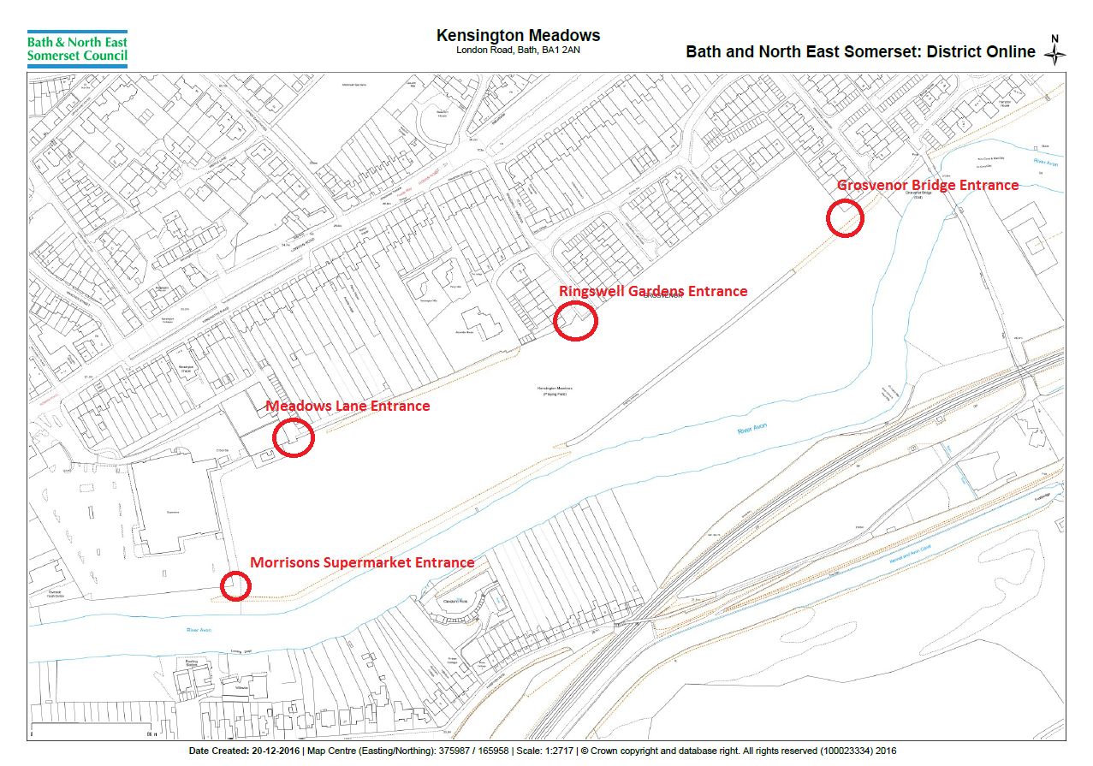
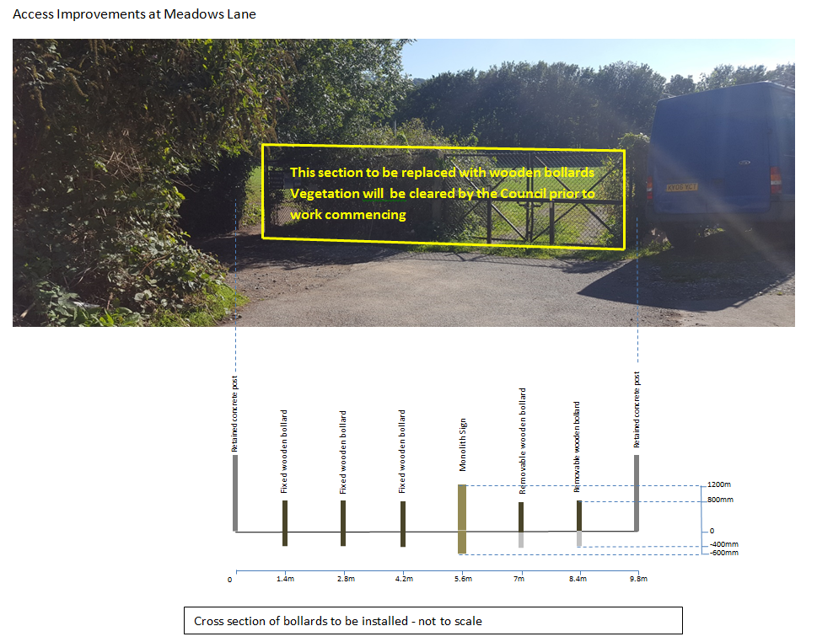
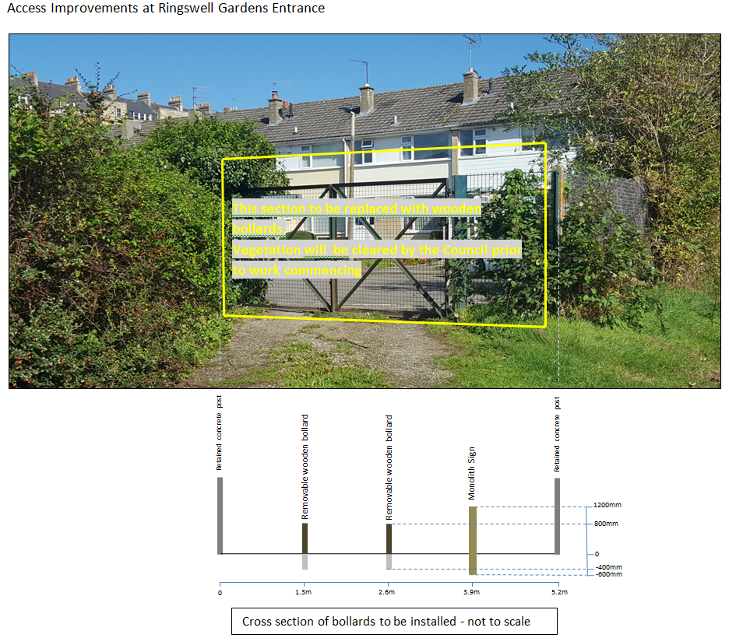
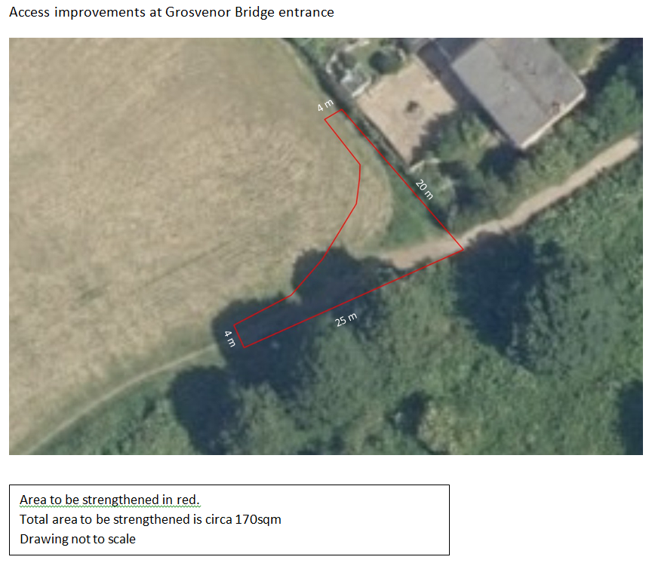
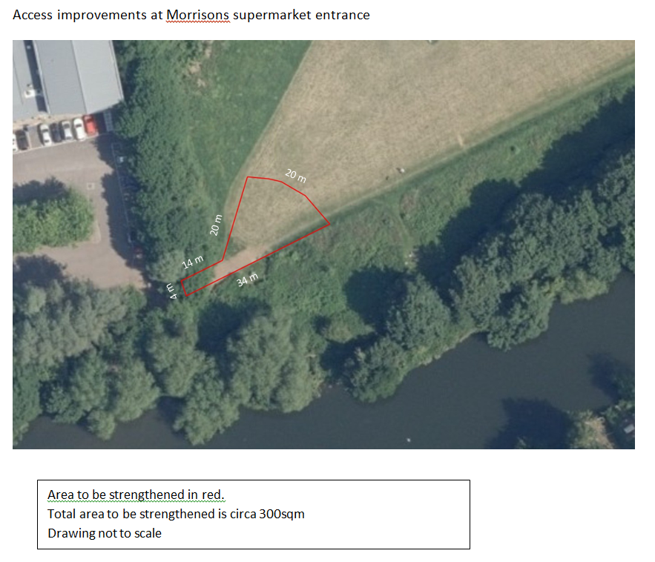
APPENDIX 4: TERMS & CONDITIONS

CONDITIONS OF CONTRACT FOR SERVICES

No terms or conditions submitted at any time by the Contractor shall form any part of the Contract.

1. DEFINITIONS

1.1 In these Conditions:

'Charges' means the Charges for the services as agreed between the parties;

'Council' means Bath and North East Somerset Council as named in the Purchase Order;

'Contract' means the contract between the Council and the Contractor consisting of the Purchase Order, these Conditions, and any other documents (or parts thereof) specified in the Purchase Order;

'Contractor' means the person, firm or company who is to provide the Service under the Contract, as detailed in the Purchase Order;

‘FOIA’ the Freedom of Information Act 2000 and any subordinate legislation made under this Act from time to time together with any guidance and/or codes of practice issued by the Information Commissioner or relevant Government Department in relation to such legislation;

'Premises' means the location where the Services are to be performed, as specified in the Purchase Order;

‘Property’ means the property, other than real property, issued or made available to the Contractor by the Council in connection with the Contract.

'Purchase' means the document setting out the Council’s
‘Order’ requirements for the Contract;

‘Request’ a request for information or an apparent request under
‘for’ the Code of Practice on Access to Government
‘Information’ Information, FOIA or the Environmental Information
Regulations;

'Services' means the services to be provided as specified in the Purchase Order and shall, where the context requires, include any and all materials, articles and goods to be supplied under the Contract; and

'Staff' means the Contractor and its employees, agents, representatives and sub-contractors.

‘Working’ any day other than a Saturday, Sunday or public
‘Day’ holiday in England and Wales.

1.2 The headings in these Conditions are for convenience only and shall not affect its construction or interpretation.

2. VARIATION OF THE SERVICES

2.1 These Conditions may only be varied with the written agreement of the Council

2.2 The performance of Services by the Contractor pursuant to the Purchase Order shall constitute acceptance of these Conditions where acceptance has not previously been communicated.

2.3 The Council reserves the right by notice to the Contractor to vary the Services and any alteration to the Contract price or the completion date arising by reason of such modification shall be agreed between the parties and evidenced in writing.

3. INSPECTION OF PREMISES AND NATURE OF SERVICES

3.1 The Contractor is deemed to have inspected the Premises before tendering so as to have understood the nature and extent of the Services to be carried out and satisfied itself in relation to all matters connected with the Services and Premises.

3.2 The Council shall, at the request of the Contractor, grant such access to the Premises as it may deem to be reasonable for the purpose of the Services.

3.3 The Contractor shall not in any way be relieved from any of its obligations under the Contract on the ground that information is incorrect or insufficient and the Contractor shall make its own assessment as to the accuracy and adequacy of the information provided in relation to the Contract.

4. CONTRACTOR'S STATUS

In carrying out the Services the Contractor shall act as an independent Contractor, and as principal and not as the agent of the Council and nothing in the Contract shall create the relationship of employer and employee, principal and agent or a partnership. Accordingly:

5. CONTRACTOR‘S PERSONNEL

5.1 The Contractor shall take all reasonable steps to satisfy itself that its employees or sub-contractors (or their employees) are suitable in all respects to perform the Services.

5.2 The Contractor shall immediately notify the Council if they have any concerns regarding the propriety of any of its sub-contractors in respect of work/services rendered in connection with this Contract.

5.3 The Contractor, its employees and sub-contractors (or their employees), whilst on the Council’s premises, shall comply with such rules, regulations and requirements (including those relating to security arrangements) as may be in force from time to time.

5.4 The Contractor shall ensure the security of all the Property whilst in its possession, during the supply of the Services, in accordance with the Council’s reasonable security requirements as required from time to time.

6. MANNER OF CARRYING OUT THE SERVICES

6.1 The Contractor shall make no delivery of materials, plant or other equipment to nor commence any work on the Premises without obtaining the prior consent of the Council.

6.2 Access to the Premises shall not be exclusive to the Contractor but only such as shall enable it to carry out the Services concurrently with the execution of work by others. The Contractor shall co-operate with such others as the Council may reasonably require.

6.3 The Council shall have the power at any time during the progress of the Services to order in writing:

6.3.1 the removal from the Premises of any materials which in the opinion of the Council are either hazardous, noxious or not in accordance with the Contract; and/or

6.3.2 substitution of proper and suitable materials; and/or

6.3.3 the removal and proper re-execution, notwithstanding any previous test of any work of interim payment for such work which, in respect of material or workmanship, is not in the sole opinion of the Council in accordance with the Contract.

7. TIME OF PERFORMANCE

7.1 The Contractor shall begin performing the Services on the date stated in the Purchase Order and shall complete or continue to perform the Services for the period stated in the Purchase Order. Time for performance of the Services shall be of the essence for the purposes of the Contract. The Council may by written notice require the Contractor to execute the Services in such order as the Council may decide. In the absence of such notice the Contractor shall submit such detailed programmes of work and progress reports as the Council may from time to time require.

7.2 Failure by the Contractor to adhere to any provision as to time contained in the Purchase Order shall entitle the Council at its option to terminate the Services (in whole or in part) under the Contract. The Council shall be entitled to exercise its option at any time notwithstanding that it has waived any delay, unless a written extension of time has been given to the Contractor by the Council and the time of any extension has not elapsed. Failure by the Council to exercise its option to terminate in respect of any part of the Contract shall not be deemed to constitute a waiver with respect to any subsequent part.

8. WARRANTIES

8.1 The Contractor warrants and represents to the Council that the Contractor and its Staff:

8.1.1 are properly trained, qualified, and adequately skilled and competent to the levels necessary to undertake the Services; and

8.1.2 shall undertake the Services in a workmanlike manner using reasonable skill, care and expertise to be expected on a competent Contractor using good industry practice.

8.2 The Council will be relying upon the Contractor's skill, expertise and experience in the performance of the Services and also upon the accuracy of all representations or statements made and any advice given by the Contractor in connection with the performance of the Services.

8.3 The Contractor shall ensure that any goods procured for the purposes of the Services shall be of satisfactory quality, fit for their purpose and be free from defects in materials and workmanship.

9. PAYMENT

9.1 The Council undertakes to pay valid invoices within 30 days of receipt from the day of physical or electronic arrival at the nominated address of the Council.

9.2 A valid invoice is one that is:
- delivered in timing in accordance with the contract;
- that is for the correct sum;
- in respect of goods / services supplied or delivered to the required quality (or are expected to be at the required quality);
- which quote the relevant purchase order / contract reference
- which has been delivered to the nominated address .

9.3 Value Added Tax, where applicable, shall be shown separately on all invoices as a strictly net extra charge.

9.4 The Council specifically reserves the right to withhold or deduct by way of set-off or otherwise due or to become due to the Contractor any monies due to the Council from the Contractor, arising under the Contract or any other agreement between the Council and the Contractor.

9.5 The Council shall not be liable for any Charges relating to changes to the Services or additional Services other than those issued or confirmed on the Purchase Order or by agreed written variations signed by the duly authorised representatives of either party.

9.6 No payment of or on account of the Charges shall constitute any admission by the Council as to proper performance by the Contractor of its obligations.

9.7 The Contractor shall be exclusively responsible for the discharge of any income tax in relation to its Staff or such similar liability arising out of remuneration of the performance of the Services under the Contract.

10. FREE ISSUE MATERIALS

Where the Council for the purpose of the Contract issues materials free of charge to the Contractor such materials shall be and remain the property of the Council. The Contractor shall maintain all such materials in good order and condition and shall use such materials solely in connection with the Contract. The Contractor shall notify the Council of any surplus materials remaining after completion of the Services and shall dispose of them as the Council may direct. Waste of such materials arising from defective workmanship or negligence of the Contractor or its Staff shall be made good at the Contractor's expense. Without prejudice to any other of the rights of the Council, the Contractor shall deliver up such materials whether processed or not to the Council on demand.

11. AUDIT

The Contractor shall keep and maintain, until two years after the Contract has been completed, records to the satisfaction of the Council of all expenditure which are reimbursable by the Council and of the hours worked and costs incurred in connection with any of the Contractor's Staff paid for by the Council on a time charge basis. The Contractor shall on request afford the Council or its representatives such access to those records as may be required by the Council in connection with the Contract.

12. COPYRIGHT

Copyright in all reports and other documents and materials arising out of the performance by the Contractor of their duties under this Contract are to be assigned to and shall vest in the Council absolutely. This condition shall apply during the continuance of this Contract and after its termination howsoever arising.

13. INDEMNITY AND INSURANCE

13.1 The Contractor shall indemnify and keep indemnified the Council against any and all actions, claims, demands, costs and expenses (including legal expenses and disbursements) incurred by or made against the Council in respect of any loss or damage or personal injury (including death) which arises out of or in connection with the Contract except to the extent that such loss, damage or injury is caused by the negligence or wilful default of the Council.

13.2 The Contractor shall have in force and shall require any sub-contractor to have in force with an insurer of good repute:

13.2.1 employer's liability insurance in accordance with any legal requirements for the time being in force;

13.2.2 public liability insurance for such sum and range of cover as the Contractor deems to be appropriate but covering at least all matters which are the subject of indemnities or compensation obligations under these Conditions in the sum of not less than £500,000 for any one incident and unlimited in total, unless otherwise agreed by the Council in writing; and

13.2.3 such other adequate and suitable insurance as required under contracts of the nature of the Contract.

13.3 The policy or policies of insurance referred to in Condition 13.2 shall be shown to the Council whenever it requests, together with satisfactory evidence of payment of premiums.

13.4 Nothing in the Contract shall exclude or limit the liability of either party for death or personal injury caused by its negligence or for fraudulent misrepresentation.

14. CONFIDENTIALITY & DATA PROTECTION

14.1 The Contractor shall and shall procure that its staff keep secret and do not disclose any information of a confidential nature obtained by reason of the Contract except information which is in the public domain otherwise than as required to be by reason of a breach of this Condition 14 or disclosed by law.

14.2 The provision of this Condition 14 shall apply during the continuance of the Contract and after its termination howsoever arising without limitation in time.

14.3 The Contractor shall comply with any and all requirements under the Data Protection Act 1998 and any subordinate legislation ("DPA") as amended from time to time as though it were the Data Controller (as defined under the DPA) and shall not disclose or allow access to any Personal Data (as defined under the DPA) provided or acquired during the term of the Contract.

14.4 The Contractor shall use, disclose or allow access to any data produced as a result of the Contract in accordance with the Council s strict instructions and only to the extent that is specifically necessary for the purposes of the Contract.

14.5 The Contractor shall store or process such Personal Data provided as a result of the Contract only at site specifically agreed by the parties in writing in advance and shall take appropriate technical and organisational measures against the unauthorised or unlawful processing of Personal Data and against accidental loss or destruction of, or damage to, Personal Data.

15. TERMINATION

15.1 The Contract may be terminated by the Council giving to the Contractor at least 30 days’ notice in writing.

15.2 In the event of any breach of the Contract by either party, the non-breaching party may serve a notice on the party in breach requiring the breach to be remedied within a period specified in the notice which shall be reasonable in all the circumstances. If the breach has not been remedied by the expiry of the specified period, the non-breaching party may terminate the Contract with immediate effect by notice in writing.

15.3 In the event of a material breach of the Contract by either party, the non-breaching party may terminate the Contract with immediate effect by notice in writing.

15.4 The Council may terminate the Contract with immediate effect by notice in writing to the Contractor if at any time:-

15.4.1 the Contractor passes a resolution that it be wound-up or that an application be made for an administration order or the Contractor applies to enter into a voluntary arrangement with its creditors;

15.4.2 a receiver, liquidator, administrator, supervisor or administrative receiver be appointed in respect of the Contractor's property, assets or any part thereof;

15.4.3 the court orders that the Contractor be wound-up or a receiver of all or any part of the Contractor's assets be appointed;

15.4.4 the Contractor is unable to pay its debts in accordance with Section 123 of the Insolvency Act 1986;

15.4.5 the Contractor (being an individual or partnership) is declared or adjudicated bankrupt or enters into any arrangement or composition with its creditors; there is a change in the legal or beneficial ownership of 50% or more of the Contractor's share capital issued at the date of the Contract or there is a change in the control of the Contractor. For the purpose of this Sub-Condition 15.4.5 “control” means the power of a person to secure that the affairs of the Contractor are conducted in accordance with the wishes of that person by means of the holding of shares or the possession of voting power;

15.4.6 the Contractor is convicted (or being a company, any officers or representatives of the Contractor are convicted) of a criminal offence related to the business or professional conduct;

15.4.7 the Contractor commits (or being a company, any officers or representatives of the Contractor commit) an act of grave misconduct in the course of the business;

15.4.8 the Contractor fails (or being a company, any officers or representatives of the Contractor fail) to disclose any serious misrepresentation in supplying information required by the Council in or pursuant to the Contract.

15.5 Nothing in this Condition 15 shall affect the coming into, or continuance in force of any provision of the Contract which is expressly or by implication intended to come into force or continue in force upon termination of the Contract.

15.6 On termination of the Contract for any reason whatsoever, the Contractor shall:

15.6.1 cease to have any right to use any intellectual property rights owned by the Council;

15.6.2 return any and all documents or information (in a tangible or intangible form) belonging to the Council and shall destroy all copies of such documentation or information relating to or supplied by the Council to the Contractor for the purposes of the Contract and being in the Contractor's possession, power or control.

16. ASSIGNMENT AND SUB-CONTRACTING

16.1 The Contractor shall not assign, transfer or sub-contract any portion of the Contract without the prior written consent of the Council. Sub-contracting any part of the Contract shall not relieve the Contractor of any of its obligations duly attributable under the Contract.

16.2 Where the Council has consented to the placing of sub-contracts, copies of each sub-contract shall be sent by the Contractor to the Council immediately when it is issued. Any authority given by the Council for the Contractor to sub-contract the Contract (or any part of it) shall not impose any duty on the Council to enquire as to the competency of any authorised sub-contractor but that the Contractor shall ensure that any authorised sub-contractor is competent and that the work is properly done.

17. NOTICES

Any notices to be given under the Contract shall be delivered personally or sent by post or by facsimile transmission to the Services Manager (in the case of the Council) or to the address set out in the Contract (in the case of the Contractor). Any such notice shall be deemed to be served, if delivered personally, at the time of delivery, if sent by post, 48 hours after posting or, if sent by facsimile transmission, 12 hours after proper transmission.

18. THIRD PARTY RIGHTS

The Contract is not intended to create any rights of any kind whatsoever enforceable by any person who is not a party to the Contract (including any rights enforceable under the Contracts (Rights of Third Parties) Act 1999).

19. SEVERABILITY

If any provision under the Contract is or becomes unenforceable, void or invalid, such provision shall not take effect and shall be deemed to be severed from the remainder of the Contract to the extent that the remainder of the Contract and the unaffected part of the provision shall continue to be fully enforceable.

20. WAIVER

No delay or omission by the Council in exercising any of its rights under the Contract shall constitute a waiver of that right and any partial exercise of any such right shall not prevent any future exercise of the right

21 DISCRIMINATION

21.1 The Contractor shall not unlawfully discriminate within the meaning and scope of any law, enactment, order, or regulation relating to discrimination (whether in race, gender, religion, disability, sexual orientation or otherwise) in employment.

21.2 The Contractor shall take all reasonable steps to secure the observance of Clause 22.1 by all servants, employees or agents of the Contractor and all suppliers and sub-contractors employed in the execution of the Contract.

22 FREEDOM OF INFORMATION

22.1 The Contractor acknowledges that the Council is subject to the requirements of the Code of Practice on Government Information, FOIA and the Environmental Information Regulations and shall assist and cooperate with the Council to enable the Council to comply with its Information disclosure obligations.

22.2 The Contractor shall and shall procure that its Sub-contractors shall:

22.2.1 transfer to the Council all Requests for Information that it receives as soon as practicable and in any event within two Working Days of receiving a Request for Information;

22.2.2 provide the Council with a copy of all Information in its possession, or power in the form that the Council requires within five Working Days (or such other period as the Council may specify) of the Council s request; and

22.2.3 provide all necessary assistance as reasonably requested by the Council to enable the Council to respond to the Request for Information within the time for compliance set out in section 10 of the FOIA or regulation 5 of the Environmental Information Regulations.

22.3 The Council shall be responsible for determining in its absolute discretion and notwithstanding any other provision in this Agreement or any other agreement whether any Information is exempt from disclosure in accordance with the provisions of the Code of Practice on Government Information, FOIA or the Environmental Information Regulations.

22.4 In no event shall the Contractor respond directly to a Request for Information unless expressly authorised to do so by the Council.

22.5 The Contractor acknowledges that (notwithstanding the provisions of Clause 23) the Council may, acting in accordance with the Council of Constitutional Affairs’ Code of Practice on the Discharge of the Functions of Public Authorities under Part 1 of the Freedom of Information Act 2000 (“the Code”), be obliged under the FOIA, or the Environmental Information Regulations to disclose information concerning the Contractor or the Project:

22.5.1 in certain circumstances without consulting the Contractor; or

22.5.2 following consultation with the Contractor and having taken their views into account;

22.5.3 provided always that where 23.5.1 applies the Council shall, in accordance with any recommendations of the Code, take reasonable steps, where appropriate, to give the Contractor advanced notice, or failing that, to draw the disclosure to the Contractor’s attention after any such disclosure.

22.6 The Contractor shall ensure that all Information is retained for disclosure and shall permit the Council to inspect such records as requested from time to time.

23. LAW AND JURISDICTION

The Contract and any dispute arising under or in any way connected with the subject matter of the Contract (whether of a contractual or tortious nature or otherwise) shall be governed by and interpreted in accordance with English Law and the parties submit to the jurisdiction of the English courts only except that the Council may seek injunctive relief outside such jurisdiction.

Addition clauses:

CONSULTANTS OBLIGATIONS

During the contract the consultant shall devote such of his time attention and abilities to the Council as may be necessary for the proper exercise of his duties as the Consultant (provided that nothing contained in the Contract shall preclude the Consultant from acting in a similar or any other capacity for any other person firm or company).

The Consultant shall carry out the Service to the highest standard and to conform with the Play Industry Safety Standards: BSEN 1176 and BSEN 1177.

The Consultant shall advise and assist the Council as required.

The Consultant shall comply with the reasonable directions of the Council and use its best endeavours to carry out the Service within the period of the Contract.

Timely provision of the Service shall be of the essence of this Contract including in relation to commencing the provision of the Service within the time agreed or on a specified date.

The Consultant shall be responsible for the accuracy of the Product of the Service and all other information supplied to the Council by the Consultant in connection with the performance of the Service and shall pay to the Council any reasonable extra costs occasioned by any discrepancies, errors or omissions therein.

The Council relies on the skill and judgment of the Consultant in carrying out the Consultant’s obligations under this Contract.

CONTRACTOR’S STATUS

Nothing in this Contract shall be construed as creating a partnership, contract of employment or a relationship of principal and agent between the Council and the Consultant.

CONTRACTOR’S PERSONNEL

The Service shall be carried out by the Consultant’s Key Personnel as named {insert name and contact details here}

At the commencement of the Contract the Consultant shall supply the Council with such details of the Key Personnel as the Council may reasonably require.

The Consultant shall not make changes to Key Personnel except with the prior written approval of the Council which shall not be unreasonably withheld or refused.

If the Consultant wishes to change any of the Key Personnel the Consultant shall supply such details as the Council may reasonably require such as professional qualifications, experience and work history.

Any replacement of Key personnel shall:

be of least equal status and experience to the key personnel being replaced;

be appropriate for the responsibilities of that person in relation to the Service;

be subject to the approval of the Council.

If there are no satisfactory replacements in the reasonable opinion of the Council, the Contract may be terminated by the Council.

All personnel of the Consultant shall be suitably trained to perform the tasks set by the Consultant to ensure the Service is provided in accordance with the Specification. Furthermore, all employees shall be made fully aware of the Consultant’s obligations under the Contract as it affects them in the performance of their tasks.

Where the Project is being carried out at Premises owned or occupied by the Council:

the Consultant shall comply and shall ensure that its staff, sub-contractors and agents comply with any rules or regulations applied by the Council in relation to security at its premises;

if the Council gives the Consultant notice that any person is not to be admitted to or is to be removed from its land or premises or is not to become involved in or is to be removed from involvement in the Project, the Consultant shall take all reasonable steps to comply with such notice and shall bear the cost of any such notice. The Consultant shall ensure that any person who is removed is replaced by someone of equivalent qualifications and experience.

REPORTING REQUIREMENTS

The Specification details the Product of the Service and other information and reports that are to be produced during and on completion of the Service.

The Consultant shall provide regular progress reports (including reports of time taken against the timings given in the Specification) at the frequency and in the format requested by the Council.

The Consultant shall, in accordance with the Specification, prepare and consult on such Product of the Service and other information and reports and shall supply the Council with sufficient copies as the Council may reasonably require.

The Consultant shall attend review meetings with the Council at its own expense in accordance with the Specification.

WARRANTIES

The Consultant warrants, represents and undertakes that:

it will carry out the work within the Contract Period;

it has the full capacity and Council and all necessary consents, licences and permits to enter into and perform this Contract and that the Contract is executed by a duly authorised representative of the Consultant;

it will perform the Service using reasonable care, skill and diligence, using suitably qualified personnel and in accordance with generally accepted industry standards and practice;

the Service shall be performed in accordance with all applicable statutes, enactments, orders, regulations or other similar instruments as amended from time to time during Contract Period;

the Consultant’s personnel and agents will have the necessary skills, professional qualifications and experience to perform the Service in accordance with the Specification and industry standards and practice (being responsible for all costs, fees, expenses, and charges for training necessary or required for the Consultant’s personnel and agents to perform the Service);

the Service and the Product of the Service shall not infringe any third party Intellectual Property Rights;

as at the date of this Contract it is not in default in the payment of any due and payable taxes or in the filing, registration or recording or any document or under any legal or statutory obligation or requirement which default might have a material adverse effect on its business, assets or financial condition or its ability to observe or perform its obligations under this Contract.

CONFLICT OF INTEREST

The Consultant shall use reasonable endeavours to ensure that the Consultant and any of its employees, servants, agents, suppliers or sub-contractors are not placed in a position where in the reasonable opinion of the Council there is or may be an actual or potential conflict, between the pecuniary or personal interests of the Consultant and others and the duties owed to the Council under the provisions of the Contract. The Consultant will immediately disclose to the Council full particulars of any such conflict of interest which may arise.

Where such a conflict does arise the Consultant shall take any reasonable steps as are required by the Council for ending or avoiding the actual or potential conflict of interest or alleviating its effect. If the Consultant fails to comply or is unable to comply with such measures, then the Council shall have the right by notice in writing to terminate forthwith the Contract. If the Council terminates the Contract in accordance with this Condition, it shall reimburse the Consultant against any commitments, liabilities or expenditure incurred or to be incurred which are reasonably and properly payable by the Consultant in connection with the provision of the Service. However, it is expressly agreed that the Council shall not be liable to pay any severance payment or compensation to the Consultant for loss of profits.

CONSEQUENCES OF TERMINATION

Where the Contract is terminated by the Council due to the Consultant’s default, the Council shall:

cease to be under any obligation to make further payment until the cost loss and/or damage arising out of the termination of the Contract shall have been calculated and provided such calculation shows an amount due to the Consultant;

have full and unlimited licence over all drawings details, descriptive schedules and other documents or data for use in connection with the Service;

be entitled to employ and pay other persons to provide and complete the provision of the Service or any part thereof and to use all such drawings details, descriptive schedules or other documents for the purpose thereof;

be entitled in respect of any costs, loss or damage to the Council arising out of the termination of the Consultant’s employment to deduct the same from any amount which would, but for Clause 30.1.1 have been due from the Council to the Consultant under the Contract or be entitled to recover the same from the Consultant as a debt. Such loss or damage shall include the reasonable costs to the Council of the time spent by its officers in terminating the Contract and in making alternative arrangements for the provision of the Service or any part of it.

When the total cost, loss and damage resulting from the termination of the Contract has been calculated and after taking into account any deduction made or to be made by the Council from any sum or sums which would but for Clause [Insert clause number of first clause .1] have been due to the Consultant, any balance shown as due to the Council shall be recoverable as a debt or alternatively the Council subject to Clause [Insert clause number of first clause .1.4] shall pay to the Consultant any balance as due to the Consultant.

On termination of this Contract (however such termination may arise) the Consultant shall immediately deliver up to the Council any Product of the Service, all working papers, computer disks and tapes or other material and copies provided by the Council, or prepared by the Consultant pursuant to this Contract in its possession or under its control or in the possession or control of any permitted agents, sub-contractors or assigns.

The provisions of this clause shall survive the termination or expiry of this Contract.

TIME OF PERFORMANCE

The Consultant shall carry out the Project by the date or in accordance with the timescales set out in the Purchase Order or in accordance with any timescales reasonably notified to the Consultant by the Council.

The Consultant shall submit such detailed programmes of work and progress reports as the Council may from time to time require.

The Consultant shall notify the Council immediately if it becomes aware of any event that it believes is likely to delay or impede the Project.

In the event that the Consultant fails to meet a date or dates set out in the Invitation to Quote document or comply with the timescales contained in the above document it shall, on the request of the Council, and without prejudice to the Council’s other rights and remedies, arrange to provide all such additional resources as are necessary to fulfil its obligations at no additional cost to the Council.

REJECTION OF PROJECT

The Council may at any time reject anything delivered or provided as part of the Project which, in the reasonable view of the Council, does not comply with the Contract in any material way.

If the Council rejects all or part of the Project under Condition [insert number of clause above] above, it shall serve a notice on the Consultant stating the reasons for such rejection.

Following receipt of a notice of rejection of the Services, the Consultant shall have 5 (five) working days (or such other period as the Parties may agree in writing) during which the Consultant shall correct the faults which caused the notice of rejection to be issued.

Without prejudice to the Council’s other rights under this Contract, if the Consultant fails to correct the faults which caused the notice of rejection to be issued to the reasonable satisfaction of the Council within 5 (five) working days (or such longer period as the Parties have agreed), the Council shall be entitled to terminate this Contract

See EU definition of SME: http://ec.europa.eu/enterprise/policies/sme/facts-figures-analysis/sme-definition/

