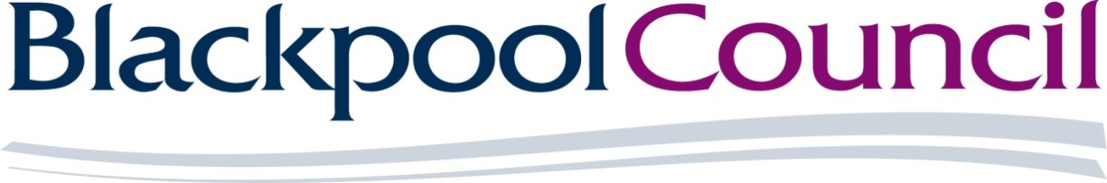

The Provision of Advertisement Services for Statutory Public Notices

Reference: DN652086

SPECIFICATION

Contract Duration:
One Year (commencing 1st April 2023) with an option to extend for up to a further 2 years (1+1) subject to contract review and budget consideration.

Background and Description of Services required:
The Council has a statutory duty to publish Public Notices. A high proportion of these notices are placed in the local newspaper (Blackpool Gazette).

The Council is seeking to appoint a Media Advertising Agency to act as a broker to produce and place the public notice advertisement on its behalf. The Council will provide a draft of the content for publication and authorise a final version with the Agency before the advertisement is placed.

The Agency must be able to manage the process of production and interface with the Council and the media through electronic means.

Deliveries/Timescales/Volumes:
Over the last three financial years the Council has placed:

2019/20 - 95 notices
2020/21 - 61 notices
2021/22 - 65 notices

The above information is historical and is provided for information only. The number of notices may increase or decrease accordingly. The Council therefore does not guarantee these volumes.

For your information:
- the largest size notice is typically = (full page) 34 x 9 columns
- the smallest size notice is typically = 3 x 2 columns

When Blackpool Council submits an advert the proof must be received back within two working days.

Blackpool Council will endeavour to give five working days’ notice before an advert needs to be placed.

In exceptional circumstances these timescales may be shorter.

Quality Control:
The Agency must fully comply with the General Data Protection Regulation.

The Agency must guarantee the quality of the printed advert to ensure it matches the size and appearance of the approved advert in accordance with the instructions provided by the Council’s Authorised Representative.

Prices:
Prices must be confirmed with the Council prior to an advertisement being placed in the media.

The Council reserves the right to reject the advertisement or to require amendment at no additional cost.

Advertisements must not be placed without full consent and approval from the Council.

The Agency will be expected to negotiate the best possible rate with the Blackpool Gazette and any other publications that the Council instructs the Agency to use, and the rate should be fixed for the full 12 month period of the contract.

Insurances:
Blackpool Council requires the successful bidder to have the following levels of insurance for the duration of the contract.

You will be required to provide evidence of insurance prior to contract signing.

Public liability - £5 million
Employers liability - £5 million
Professional indemnity - £2 million

Corporate Social Responsibility:
Bidders will be expected to outline in their submission how social value benefits could be introduced through the delivery of this contract, and the successful bidder will be expected to adopt the principles laid down in the Council’s Suppliers Charter (Section 7 Tender Return Document).

Additional Information:
The successful bidder will be expected to provide the service in accordance with the Council’s Terms and Conditions (draft copy enclosed) and will be expected to enter into a formal Agreement.

The Council reserves the right to accept all or part of any offer, or to reject all offers. All costs in relation to you submitting your offer will be entirely your responsibility.

