Request for quotation
Diesel and AdBlu Storage and Refuelling Facility for Council Depot

- Context
  - Rushcliffe Borough Council in Nottingham is looking to relocate some of its depot functions to a brownfield site in Bingham, Nottingham. The site is currently a warehouse with integrated offices with hardstanding and car parking to the exterior.
  - As a depot site, the council will be siting 6 refuse vehicles at the site along with 20-30 small to medium sized vehicles such as panel vans, beaver tails and LGVs as well as ride on mowers.
  - A refuelling facility will be required for these vehicles and, as the vehicles are all run on diesel, it is also proposed to provide AdBlu dispensing in addition to diesel dispensing.
  - There is no provision on site for below ground tanks, therefore the solution proposed must be above ground fully bunded tank(s), preferably with integrated dispenser pumps.
  - As a minimum it is expected that the provided tank(s) will come with flow meter, content gauge and bund alarm
  - The council currently use TriScan software on their existing fuel tank at its current depot. It is intended to retain TriScan monitoring software therefore the solution proposed will need to be compatible with this.
  - The volume of Diesel we wish to be able to store is 18,000-20,000 litres
  - The volume of AdBlue we wish to be able to store is 2,000-3,000 litres.
  - Due to the proposed location for the fuel tank on the site there may be occasions when the filler caps on the large HGV refuse freighters are on the wrong side of the vehicle for the dispensing pump. Therefore a solution is required that will enable the fuelling hose to reach around a vehicle that is 11.3m long, 2.8m wide and 3.8m high.
  - The council is currently in the process of obtaining planning permission for the site and, assuming granted, will be looking to move / install early in 2019.
  - A clear site plan, the proposed site layout showing the predetermined location of the fuelling facility and a dwg CAD file of the site is provided with this quotation document.

- Quote requirements.

Being a user of a depot but not having not designed a depot facility previously Rushcliffe Borough Council are looking to the industry to propose a solution that will meet its requirements as outlined above.
  - Please provide an explanation of the solution you are proposing, why it is applicable to the scope requested and include a marked up drawing showing the position and size of the units proposed on the site map provided.

  - Please provide your total price for the works, excluding VAT, separated out, as a minimum, into the following lines items, to enable the Council to understand how much each element of the scheme costs:

Scheme element | Price excl VAT
18-20,000 litre bunded diesel fuel storage and dispensing solution for small vehicles and LGV;s

Add on solution for diesel dispensing for large HGV refuse freighters when the filler caps are on the wrong side of the vehicle to the pump

2,000-3,000 litre AdBlue storage and dispensing solution

Delivery and install

  - Please confirm what preliminary works the Council will need to undertake prior to install, for example, the size/location/depth of any concrete base, positioning and spec of electrical supply…

  - Please confirm the duration of any warranty periods for the items supplied and installed.

- Further details

  - For further details please send a message via the east-midlands procurement portal.

  - Only quotes returned via the east-midlands procurement portal will be considered.

- Facility photographs

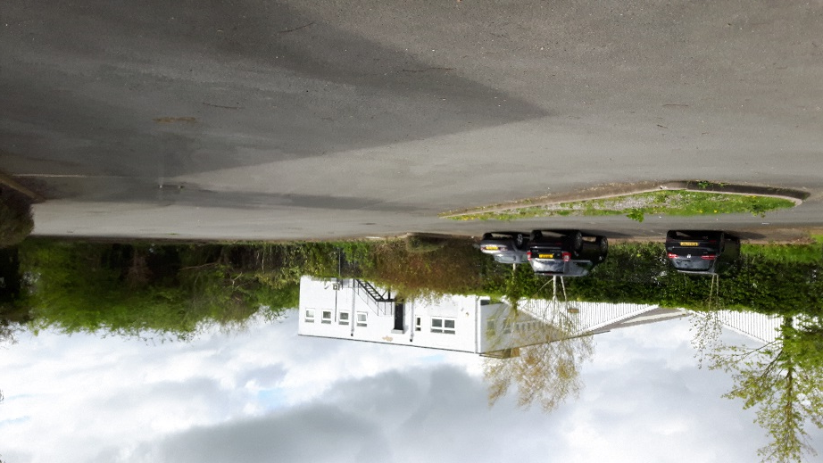

Proposed position of fuelling station (note landscaping and kerbing will be removed)

